FINAL REPORT

LAB INTERNAL 2

NAME: KANALA BHUVANA REDDY

USN : 1BM19CS069

BATCH: 4B B2 BATCH

LAB PROGRAM 6:

MOVIE DATABASE

Consider the schema for Movie Database:

ACTOR(Act_id, Act_Name, Act_Gender)

DIRECTOR(Dir_id, Dir_Name, Dir_Phone)

MOVIES(Mov_id, Mov_Title, Mov_Year, Mov_Lang, Dir_id)

MOVIE_CAST(Act_id, Mov_id, Role)

RATING(Mov_id, Rev_Stars)

Write SQL queries to

i. List the titles of all movies directed by ‘Hitchcock’.

ii. Find the movie names where one or more actors acted in two or more movies.

iii. List all actors who acted in a movie before 2000 and also in a movie after 2015 (use JOIN operation).

iv. Find the title of movies and number of stars for each movie that has at least one rating and find the highest

number of stars that movie received. Sort the result by movie title.

v. Update rating of all movies directed by ‘Steven Spielberg’ to 5.

**CODE:**

create database movie;

use movie;

CREATE TABLE ACTOR (

ACT_ID INT,

ACT_NAME VARCHAR (20),

ACT_GENDER CHAR (1),

PRIMARY KEY (ACT_ID));

CREATE TABLE DIRECTOR (

DIR_ID INT,

DIR_NAME VARCHAR (20),

DIR_PHONE real,

PRIMARY KEY (DIR_ID));

CREATE TABLE MOVIES (

MOV_ID INT,

MOV_TITLE VARCHAR (25),

MOV_YEAR INT,

MOV_LANG VARCHAR (12),

DIR_ID INT,

PRIMARY KEY (MOV_ID),

FOREIGN KEY (DIR_ID) REFERENCES DIRECTOR (DIR_ID));

CREATE TABLE MOVIE_CAST (

ACT_ID INT,

MOV_ID INT,

ROLE VARCHAR(10),

PRIMARY KEY (ACT_ID, MOV_ID),

FOREIGN KEY (ACT_ID) REFERENCES ACTOR (ACT_ID),

FOREIGN KEY (MOV_ID) REFERENCES MOVIES (MOV_ID));

CREATE TABLE RATING (

MOV_ID INT,

REV_STARS VARCHAR (25),

PRIMARY KEY (MOV_ID),

FOREIGN KEY (MOV_ID) REFERENCES MOVIES (MOV_ID));

show tables;

INSERT INTO ACTOR VALUES (301,'ANUSHKA','F');

INSERT INTO ACTOR VALUES (302,'PRABHAS','M');

INSERT INTO ACTOR VALUES (303,'PUNITH','M');

INSERT INTO ACTOR VALUES (304,'JERMY','M');

SELECT * FROM ACTOR;

INSERT INTO DIRECTOR VALUES (60,'RAJAMOULI', 8751611001);

INSERT INTO DIRECTOR VALUES (61,'HITCHCOCK', 7766138911);

INSERT INTO DIRECTOR VALUES (62,'FARAN', 9986776531);

INSERT INTO DIRECTOR VALUES (63,'STEVEN SPIELBERG', 8989776530);

SELECT * FROM DIRECTOR;

INSERT INTO MOVIES VALUES (1001,'BAHUBALI-2', 2017, 'TELUGU', 60);

INSERT INTO MOVIES VALUES (1002,'BAHUBALI-1', 2015,'TELUGU', 60);

INSERT INTO MOVIES VALUES (1003,'AKASH', 2008,'KANNADA', 61);

INSERT INTO MOVIES VALUES (1004,'WAR HORSE', 2011, 'ENGLISH', 63);

SELECT * FROM MOVIES;

INSERT INTO MOVIE_CAST VALUES (301, 1002, 'HEROINE');

INSERT INTO MOVIE_CAST VALUES (301, 1001, 'HEROINE');

INSERT INTO MOVIE_CAST VALUES (303, 1003, 'HERO');

INSERT INTO MOVIE_CAST VALUES (303, 1002,'GUEST');

INSERT INTO MOVIE_CAST VALUES (304, 1004, 'HERO');

SELECT * FROM MOVIE_CAST;

INSERT INTO RATING VALUES (1001,'4');

INSERT INTO RATING VALUES (1002,'2');

INSERT INTO RATING VALUES (1003, '5');

INSERT INTO RATING VALUES (1004, '4');

SELECT * FROM RATING;

/*1. List the titles of all movies directed by‘Hitchcock’.*/

SELECT MOV_TITLE

FROM MOVIES

WHERE DIR_ID IN (SELECT DIR_ID

FROM DIRECTOR

WHERE DIR_NAME = 'HITCHCOCK');

/*2. Find the movie names where one or more actors acted in two or more movies.*/

SELECT MOV_TITLE

FROM MOVIES M, MOVIE_CAST MV

WHERE M.MOV_ID=MV.MOV_ID AND ACT_ID IN (SELECT ACT_ID

FROM MOVIE_CAST GROUP BY ACT_ID HAVING

COUNT(ACT_ID)>1)

GROUP BY MOV_TITLE HAVING COUNT(MOV_TITLE)>1;

/*3. List all actors who acted in a movie before 2000 and also in a movie after

2015 (use JOIN operation).*/

SELECT ACT_NAME, MOV_TITLE, MOV_YEAR

FROM ACTOR A JOIN

MOVIE_CAST C

ON A.ACT_ID=C.ACT_ID

JOIN MOVIES M

ON C.MOV_ID=M.MOV_ID

WHERE M.MOV_YEAR NOT BETWEEN 2000 AND 2015;

/*4. Find the title of movies and number of stars for each movie that has at least

one rating and find the highest number of stars that movie received. Sort the

result by movie title. */

SELECT MOV_TITLE, MAX(REV_STARS) FROM MOVIES

INNER JOIN RATING USING (MOV_ID) GROUP

BY MOV_TITLE

HAVING MAX(REV_STARS)>0

ORDER BY MOV_TITLE;

/*5. Update rating of all movies directed by ‘Steven Spielberg’ to 5*/

UPDATE RATING

SET REV_STARS='5'

WHERE MOV_ID = (SELECT MOV_ID FROM MOVIES

WHERE DIR_ID = (SELECT DIR_ID FROM DIRECTOR

WHERE DIR_NAME ='STEVEN

SPIELBERG'));

SELECT * FROM RATING;

**Output:** Tables: 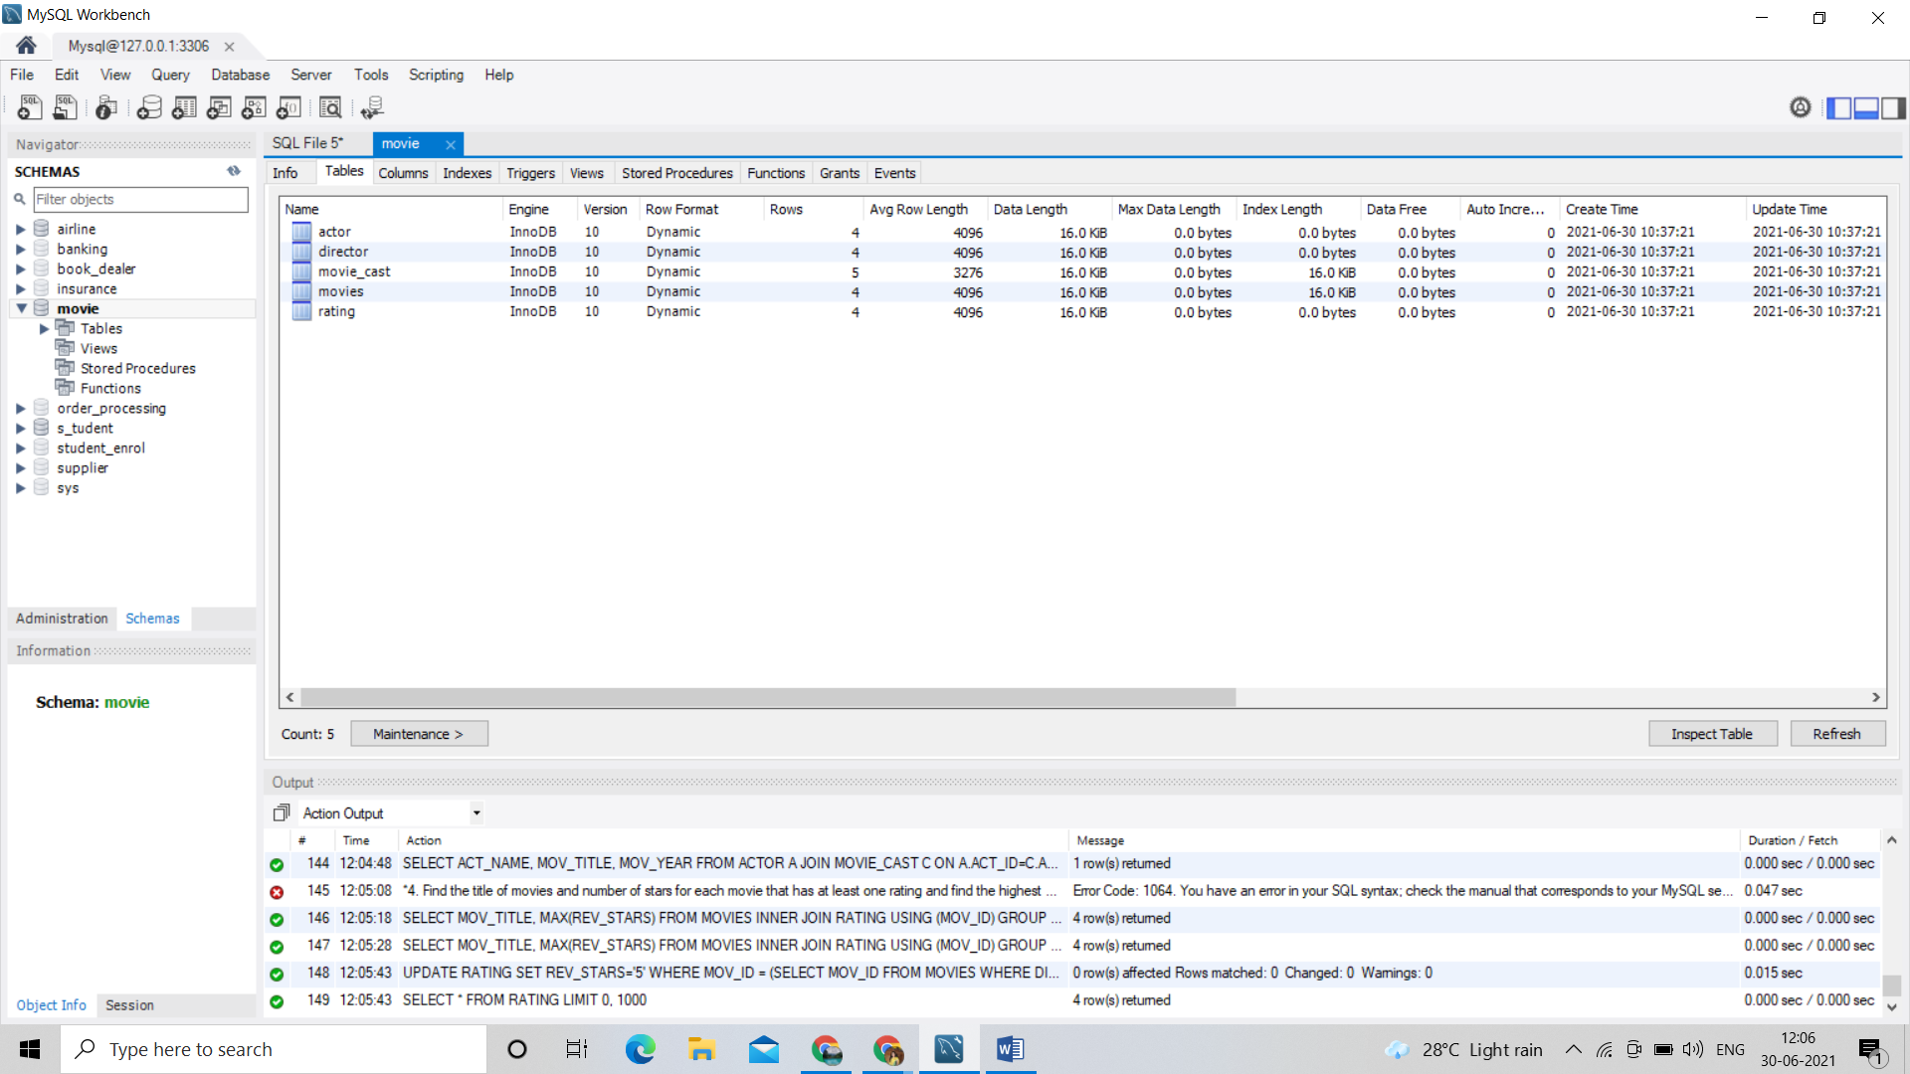

Columns:

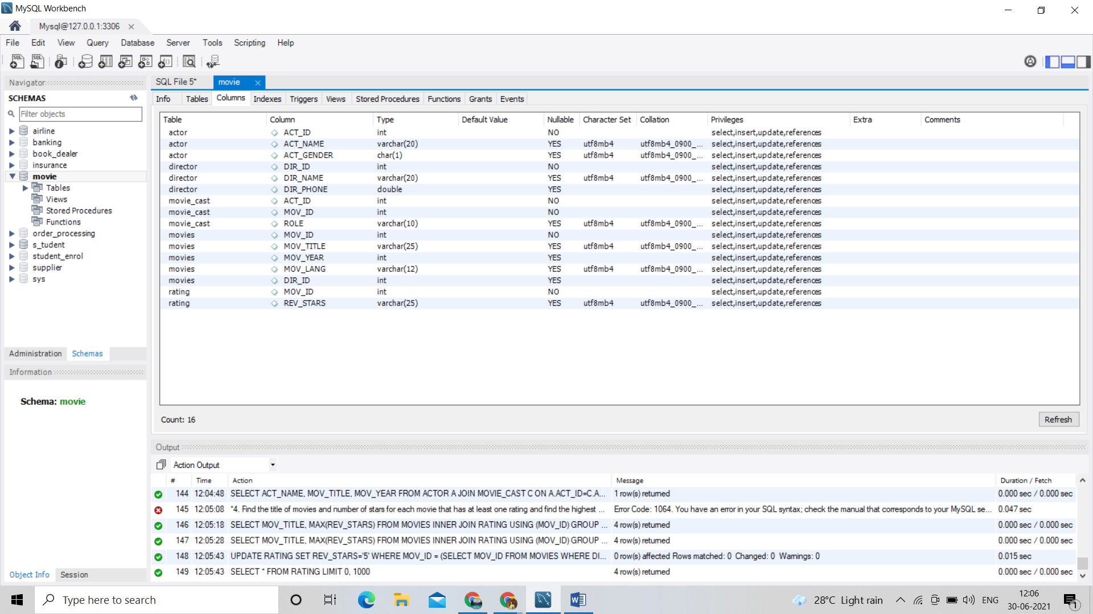

Result 1:

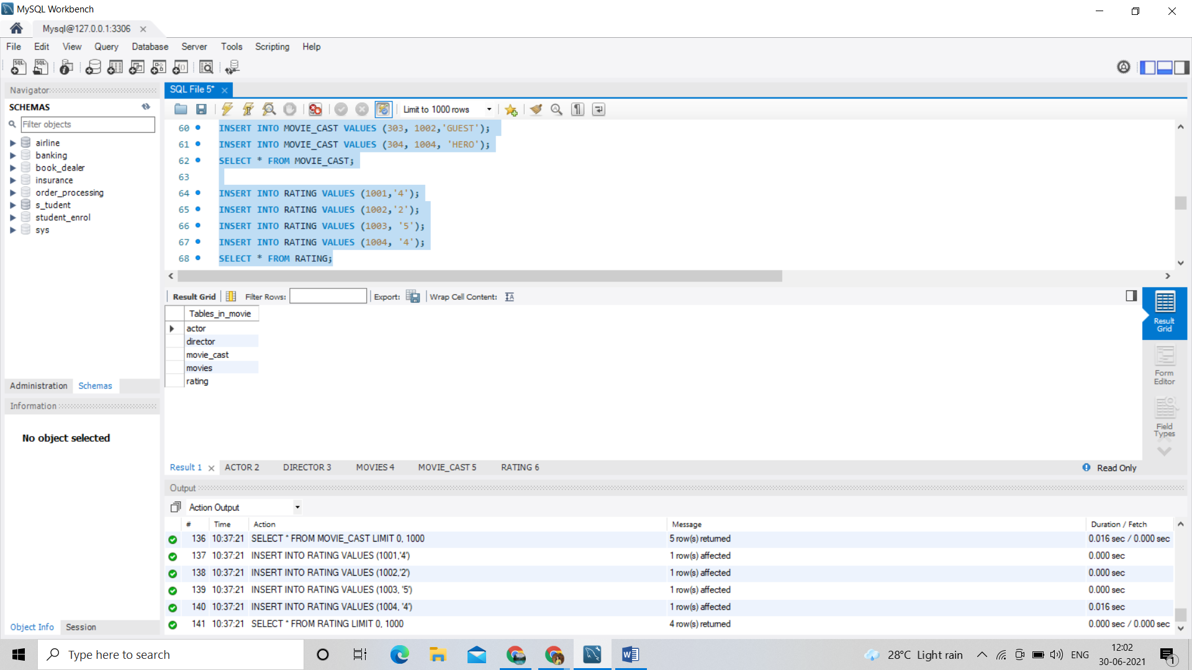

Actor 2:

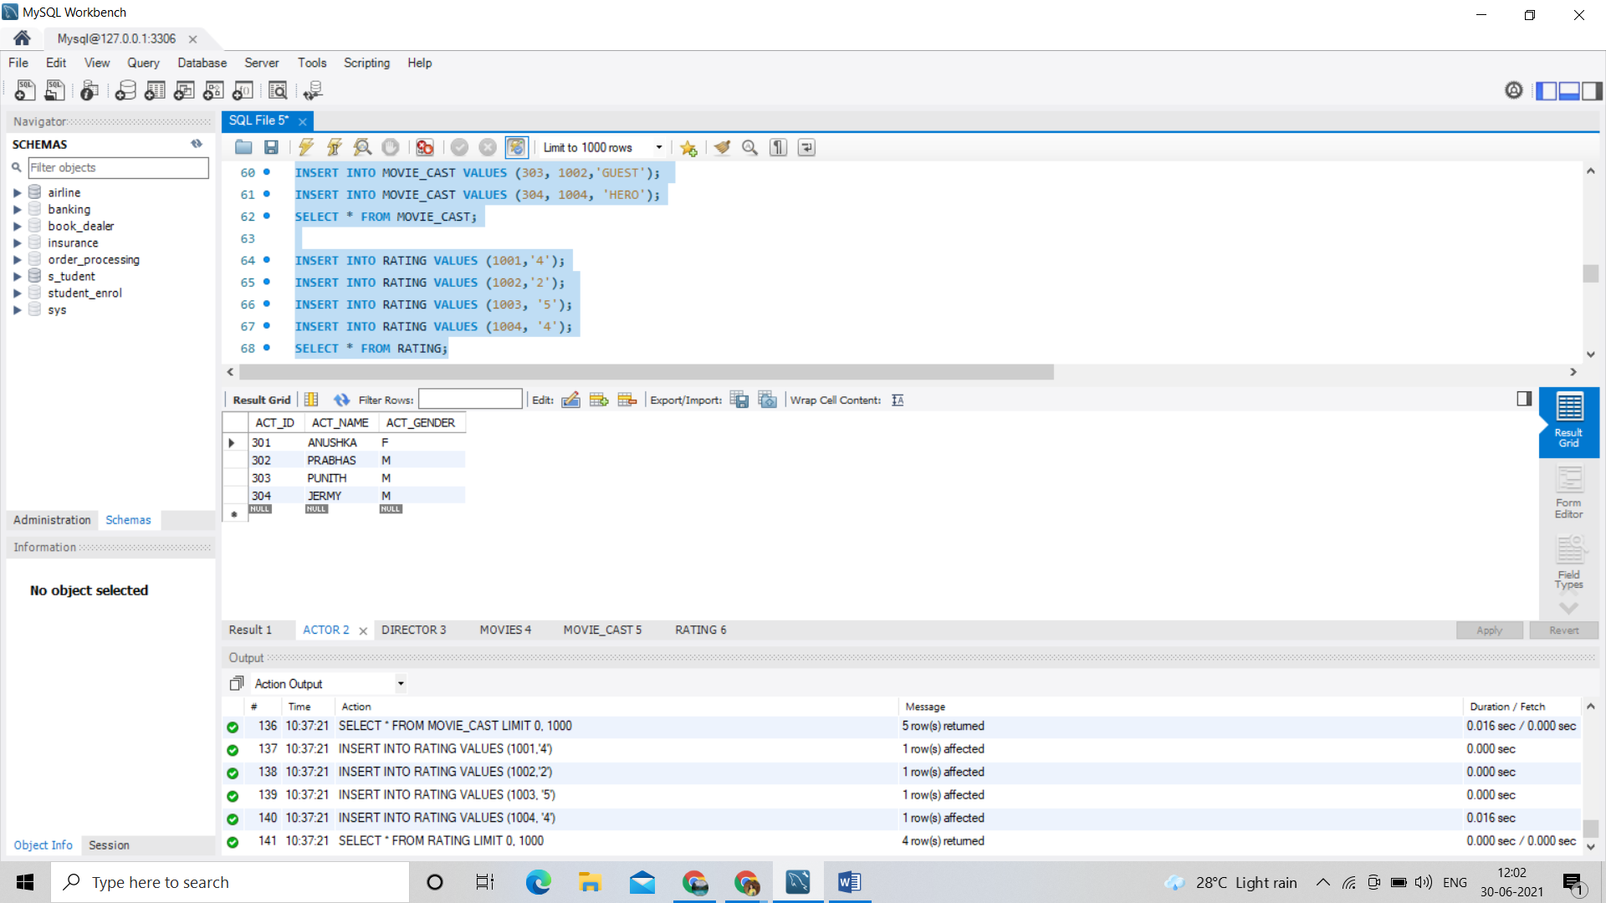

Director 3:

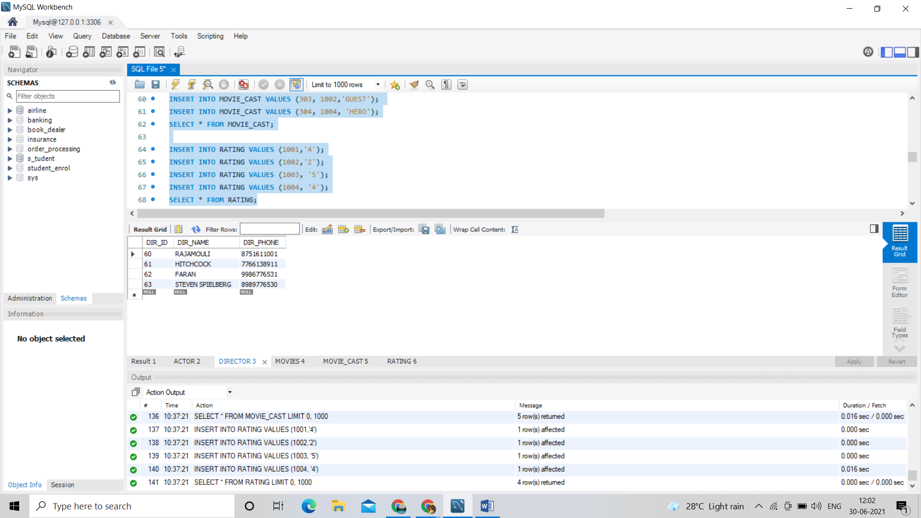

Movies 4:

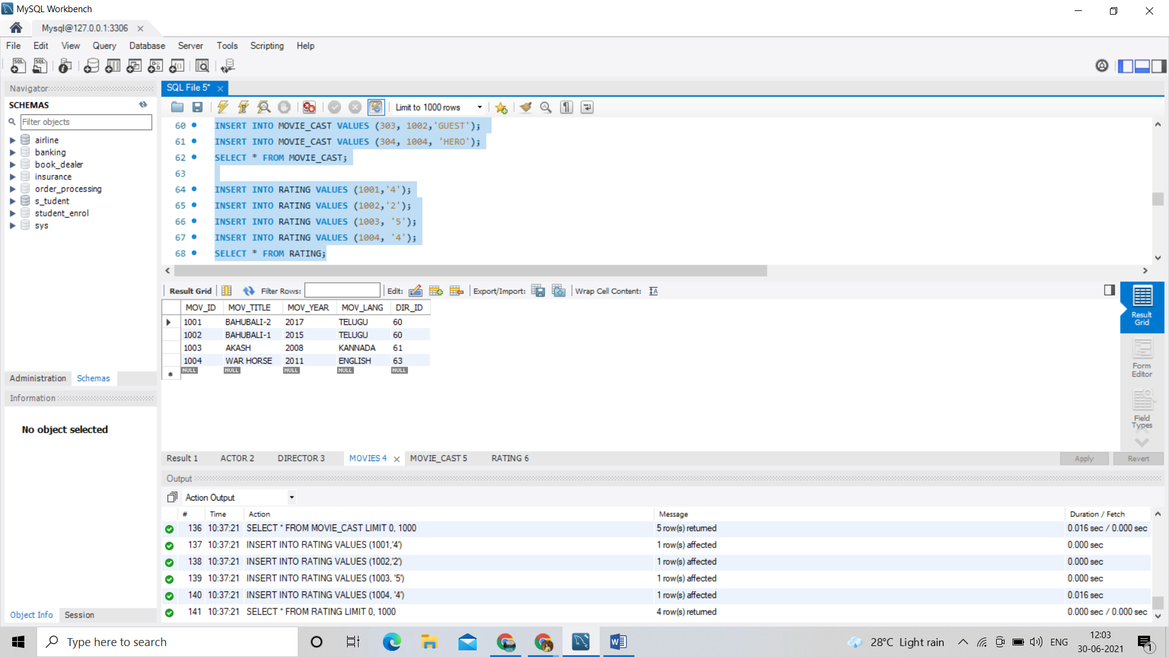

Movie_cast 5:

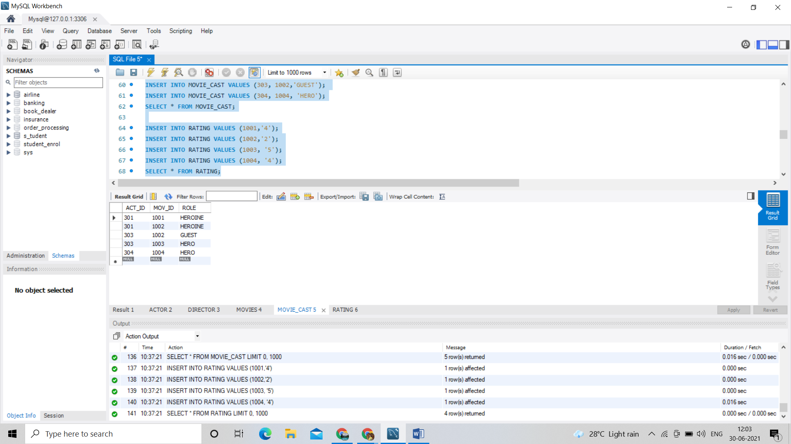

Rating 6:

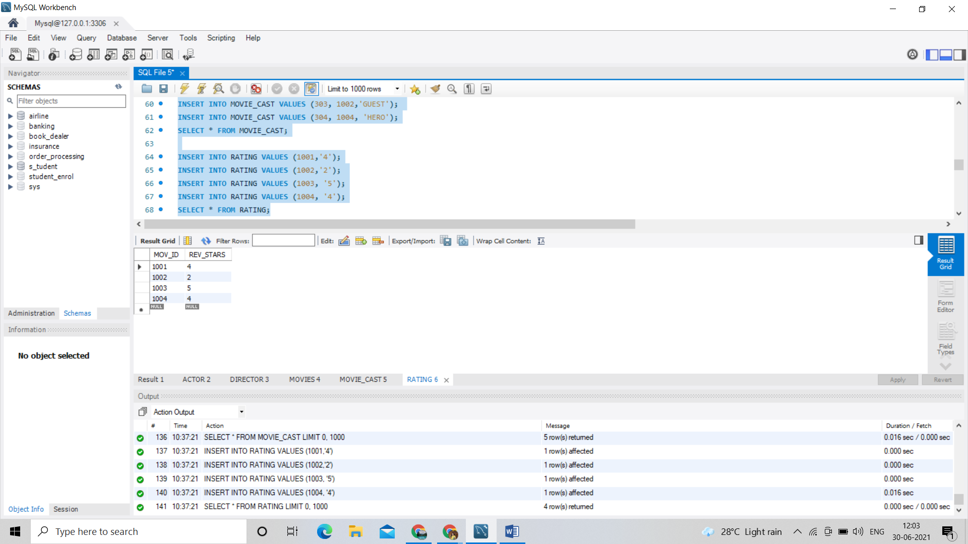

/*1. List the titles of all movies directed by‘Hitchcock’.*/

SELECT MOV_TITLE

FROM MOVIES

WHERE DIR_ID IN (SELECT DIR_ID

FROM DIRECTOR

WHERE DIR_NAME = 'HITCHCOCK');

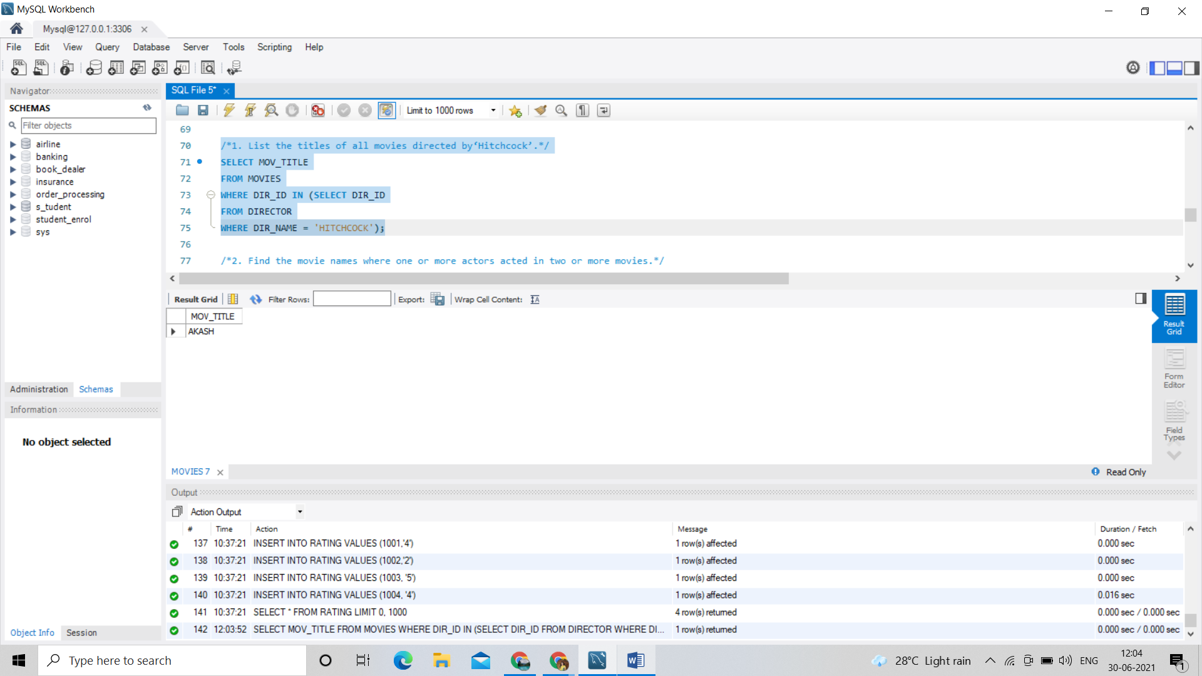

/*2. Find the movie names where one or more actors acted in two or more movies.*/

SELECT MOV_TITLE

FROM MOVIES M, MOVIE_CAST MV

WHERE M.MOV_ID=MV.MOV_ID AND ACT_ID IN (SELECT ACT_ID

FROM MOVIE_CAST GROUP BY ACT_ID HAVING

COUNT(ACT_ID)>1)

GROUP BY MOV_TITLE HAVING COUNT(MOV_TITLE)>1;

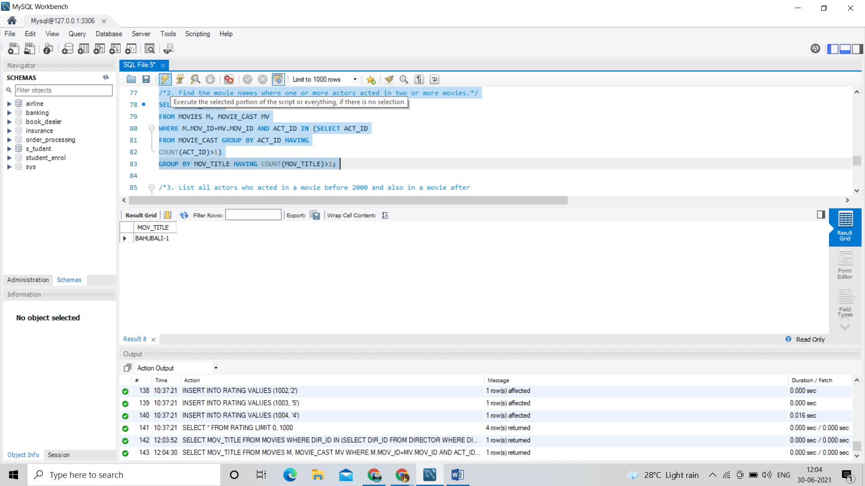

/*3. List all actors who acted in a movie before 2000 and also in a movie after

2015 (use JOIN operation).*/

SELECT ACT_NAME, MOV_TITLE, MOV_YEAR

FROM ACTOR A JOIN

MOVIE_CAST C

ON A.ACT_ID=C.ACT_ID

JOIN MOVIES M

ON C.MOV_ID=M.MOV_ID

WHERE M.MOV_YEAR NOT BETWEEN 2000 AND 2015; 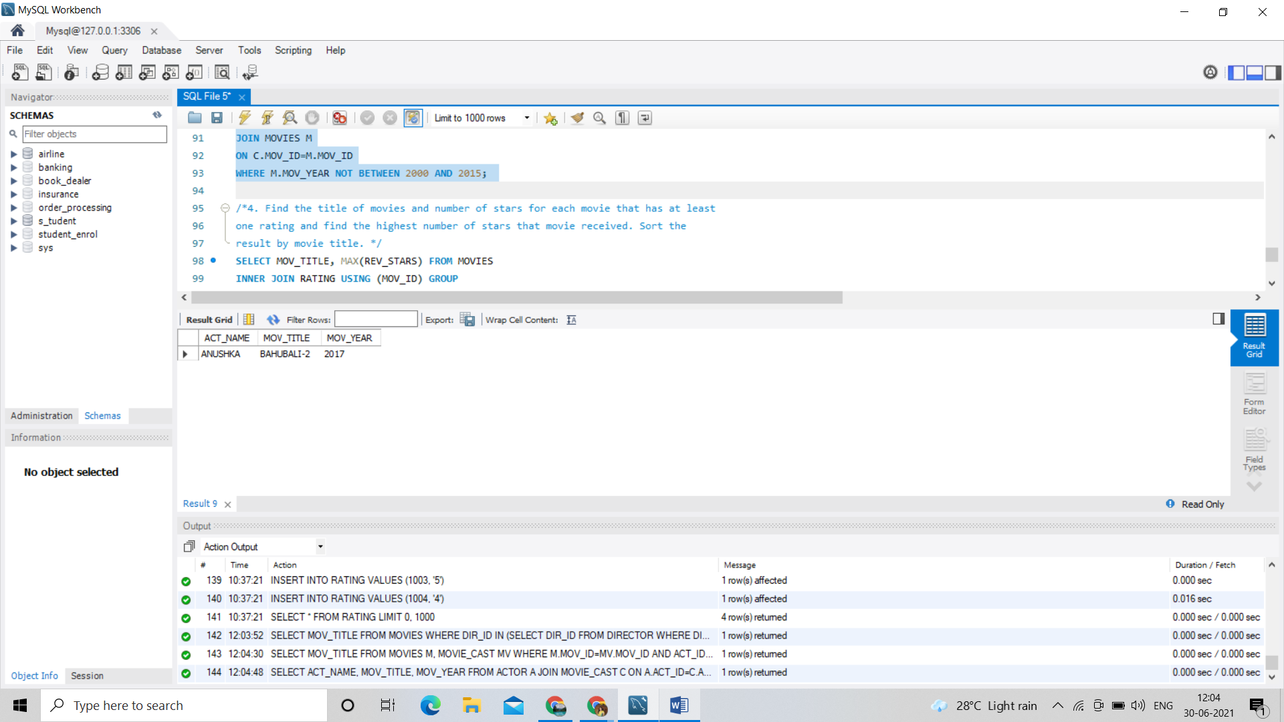

/*4. Find the title of movies and number of stars for each movie that has at least

one rating and find the highest number of stars that movie received. Sort the

result by movie title. */

SELECT MOV_TITLE, MAX(REV_STARS) FROM MOVIES

INNER JOIN RATING USING (MOV_ID) GROUP

BY MOV_TITLE

HAVING MAX(REV_STARS)>0

ORDER BY MOV_TITLE; 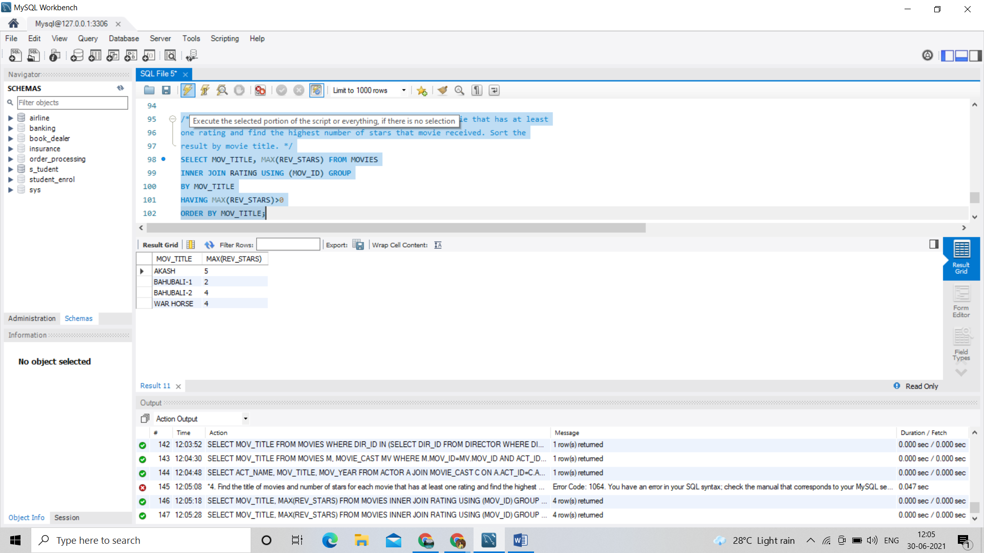

/*5. Update rating of all movies directed by ‘Steven Spielberg’ to 5*/

UPDATE RATING

SET REV_STARS='5'

WHERE MOV_ID = (SELECT MOV_ID FROM MOVIES

WHERE DIR_ID = (SELECT DIR_ID FROM DIRECTOR

WHERE DIR_NAME ='STEVEN

SPIELBERG'));

SELECT * FROM RATING;

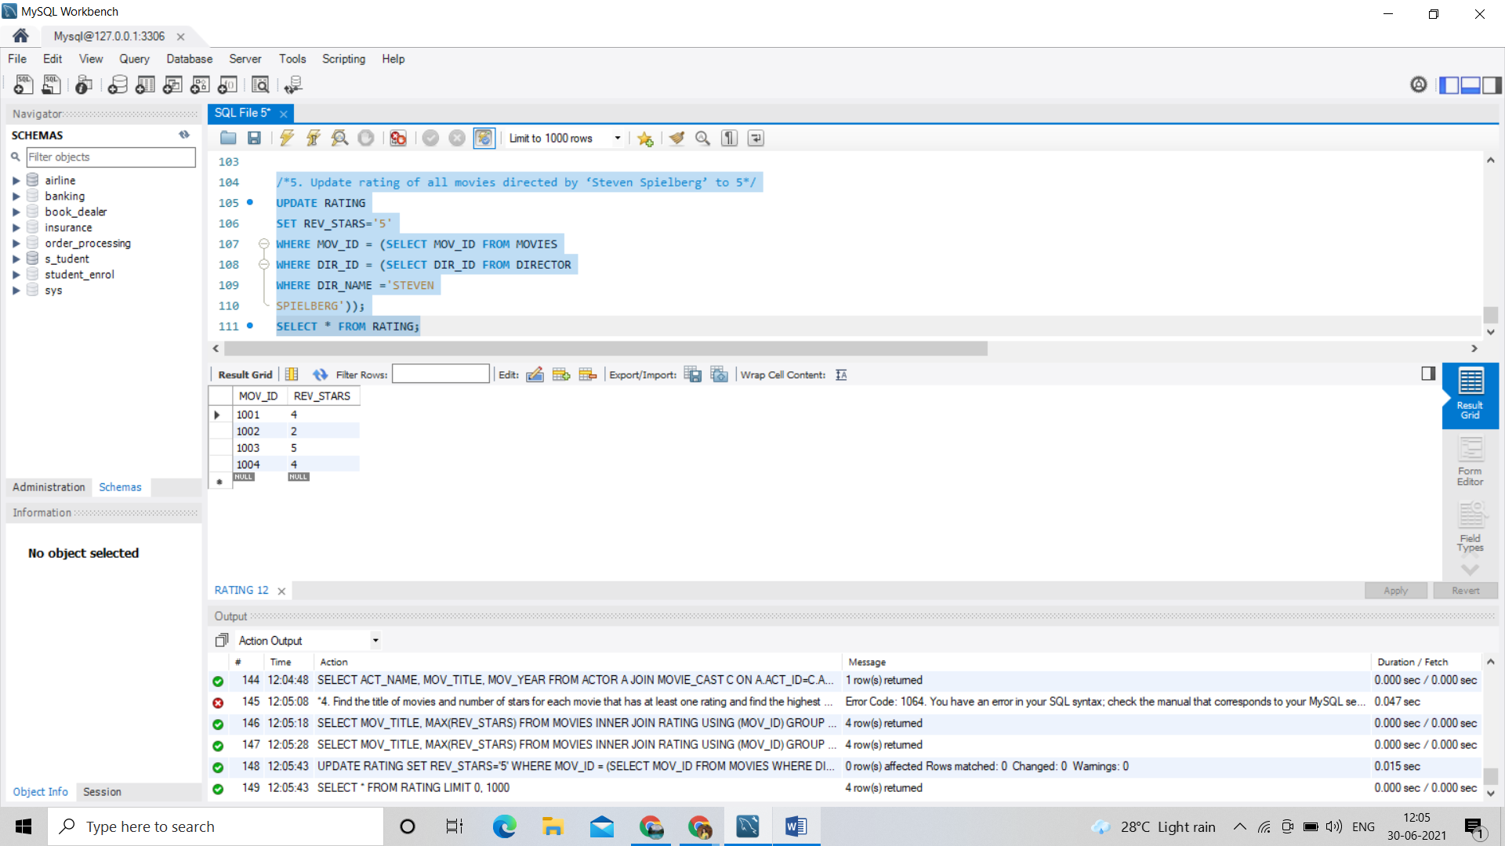

**PROGRAM 7:**

**AIRLINE FLIGHT DATABASE**

Consider the following database that keeps track of airline flight information:

FLIGHTS (flno: integer, from: string, to: string, distance: integer, departs: time, arrives: time, price: integer)

AIRCRAFT (aid: integer, aname: string, cruisingrange: integer)

CERTIFIED (eid: integer, aid: integer)

EMPLOYEE (eid: integer, ename: string, salary: integer)

Note that the Employees relation describes pilots and other kinds of employees as well; Every pilot is certified

for some aircraft, and only pilots are certified to fly.

Write each of the following queries in SQL.

i. Find the names of aircraft such that all pilots certified to operate them have salaries more than Rs.80,000.

ii. For each pilot who is certified for more than three aircrafts, find the eid and the maximum cruising range of

the aircraft for which she or he is certified.

iii. Find the names of pilots whose salary is less than the price of the cheapest route from Bengaluru to

Frankfurt.

iv. For all aircraft with cruising range over 1000 Kms, find the name of the aircraft and the average salary of

all pilots certified for this aircraft.

v. Find the names of pilots certified for some Boeing aircraft.

vi. Find the aids of all aircraft that can be used on routes from Bengaluru to New Delhi.

vii. A customer wants to travel from Madison to New York with no more than two changes of flight. List the

choice of departure times from Madison if the customer wants to arrive in New York by 6 p.m.

viii. Print the name and salary of every non-pilot whose salary is more than the average salary for pilots.

**Code:** create database airline;

use airline;

CREATE TABLE flights(

flno Int,

`from` Varchar(20),

`to` Varchar(20),

distance INT,

departs time,

arrives time,

price Int,

PRIMARY KEY(flno) );

CREATE TABLE aircraft(

aid INT,

aname VARCHAR(20),

cruisingrange INT,

PRIMARY KEY (aid) );

CREATE TABLE employees(

eid INT,

ename Varchar(20),

salary INT,

PRIMARY KEY (eid) );

CREATE TABLE certified(

eid INT,

aid INT,

PRIMARY KEY (eid,aid),

FOREIGN KEY (eid) REFERENCES employees (eid),

FOREIGN KEY (aid) REFERENCES aircraft (aid) );

show tables;

INSERT INTO flights (flno,`from`,`to`,distance,departs,arrives,price) VALUES

(1,'Bangalore','Chennai',360,'08:45','10:00',10000),

(2,'Bangalore','Delhi',1700,'12:15','15:00',37000),

(3,'Bangalore','Kolkata',1500,'15:15','05:25',30000),

(4,'Mumbai','Delhi',1200,'10:30','12:30',28000),

(5,'Bangalore','New york',14000,'05:45','02:30',90000),

(6,'Delhi','Chicago',12000,'10:00','05:45',95000),

(7,'Bangalore','Frankfurt',15000,'12:00','06:30',98000),

(8,'Madison','New york',1500,'10:15','14:25',30000);

SELECT * FROM flights;

INSERT INTO aircraft (aid,aname,cruisingrange) values

(1,'Airbus 380',1000),

(2,'Boeing 737',4000),

(3,'Lockheed',5500),

(4,'Airbus A220',9500),

(5,'Boeing 747',800),

(6,'Douglas DC3',900);

SELECT * FROM aircraft;

INSERT INTO employees (eid,ename,salary) VALUES

(1,'Zoya',95000),

(2,'Akshay',65000),

(3,'Niveditha',70000),

(4,'Safan',45000),

(5,'Peter',95000),

(6,'Nayan',100000),

(7,'Ajay',50000);

SELECT * FROM employees;

INSERT INTO certified (eid,aid) VALUES

(1,1),

(1,3),

(1,4),

(5,4),

(5,3),

(1,2),

(2,6),

(2,5),

(4,5),

(6,4),

(6,3),

(3,6),

(3,2);

SELECT * FROM certified;

#i. Find the names of aircraft such that all pilots certified to operate them have salaries more than Rs.80,000.

SELECT DISTINCT A.aname

FROM Aircraft A

WHERE A.Aid IN (SELECT C.aid

FROM Certified C, Employees E

WHERE C.eid = E.eid AND

NOT EXISTS ( SELECT *

FROM Employees E1

WHERE E1.eid = E.eid AND E1.salary < 80000 ));

#ii. For each pilot who is certified for more than three aircrafts, find the eid and the maximum cruising range of the aircraft for which she or he is certified.

SELECT C.eid, MAX(A.cruisingrange)

FROM Certified C, Aircraft A

WHERE C.aid = A.aid

GROUP BY C.eid

HAVING COUNT(*) > 3;

#iii. Find the names of pilots whose salary is less than the price of the cheapest route from Bengaluru toFrankfurt.

SELECT DISTINCT e.ename

FROM employees e

WHERE e.salary<

(SELECT MIN(f.price)

FROM flights f

WHERE f.from='Bangalore' AND f.to='Frankfurt');

#iv. For all aircraft with cruising range over 1000 Kms, find the name of the aircraft and the average salary of all pilots certified for this aircraft.

SELECT a.aid,a.aname,AVG(e.salary)

FROM aircraft a,certified c,employees e

WHERE a.aid=c.aid

AND c.eid=e.eid

AND a.cruisingrange>1000

GROUP BY a.aid,a.aname;

#v. Find the names of pilots certified for some Boeing aircraft.

SELECT distinct e.ename

FROM employees e,aircraft a,certified c

WHERE e.eid=c.eid AND c.aid=a.aid AND a.aname like 'Boeing%';

#vi. Find the aids of all aircraft that can be used on routes from Bengaluru to New Delhi.

SELECT a.aid

FROM aircraft a

WHERE a.cruisingrange>

(SELECT MIN(f.distance)

FROM flights f

WHERE f.from='Bangalore' AND f.to='Delhi');

#vii. A customer wants to travel from Madison to New York with no more than two changes of flight. List the choice of departure times from Madison if the customer wants to arrive in New York by 6 p.m.

SELECT F.departs

FROM Flights F WHERE F.flno IN ( SELECT F0.flno

FROM Flights F0

WHERE F0.from = 'Madison' AND F0.to = 'New york' AND F0.arrives < '18:00' );

#viii. Print the name and salary of every non-pilot whose salary is more than the average salary for pilots.0

SELECT E.ename, E.salary

FROM Employees E

WHERE E.eid NOT IN ( SELECT DISTINCT C.eid

FROM Certified C )

AND E.salary > ( SELECT AVG (E1.salary)

FROM Employees E1

WHERE E1.eid IN

( SELECT DISTINCT C1.eid

FROM Certified C1 ) );

Output:

Tables:

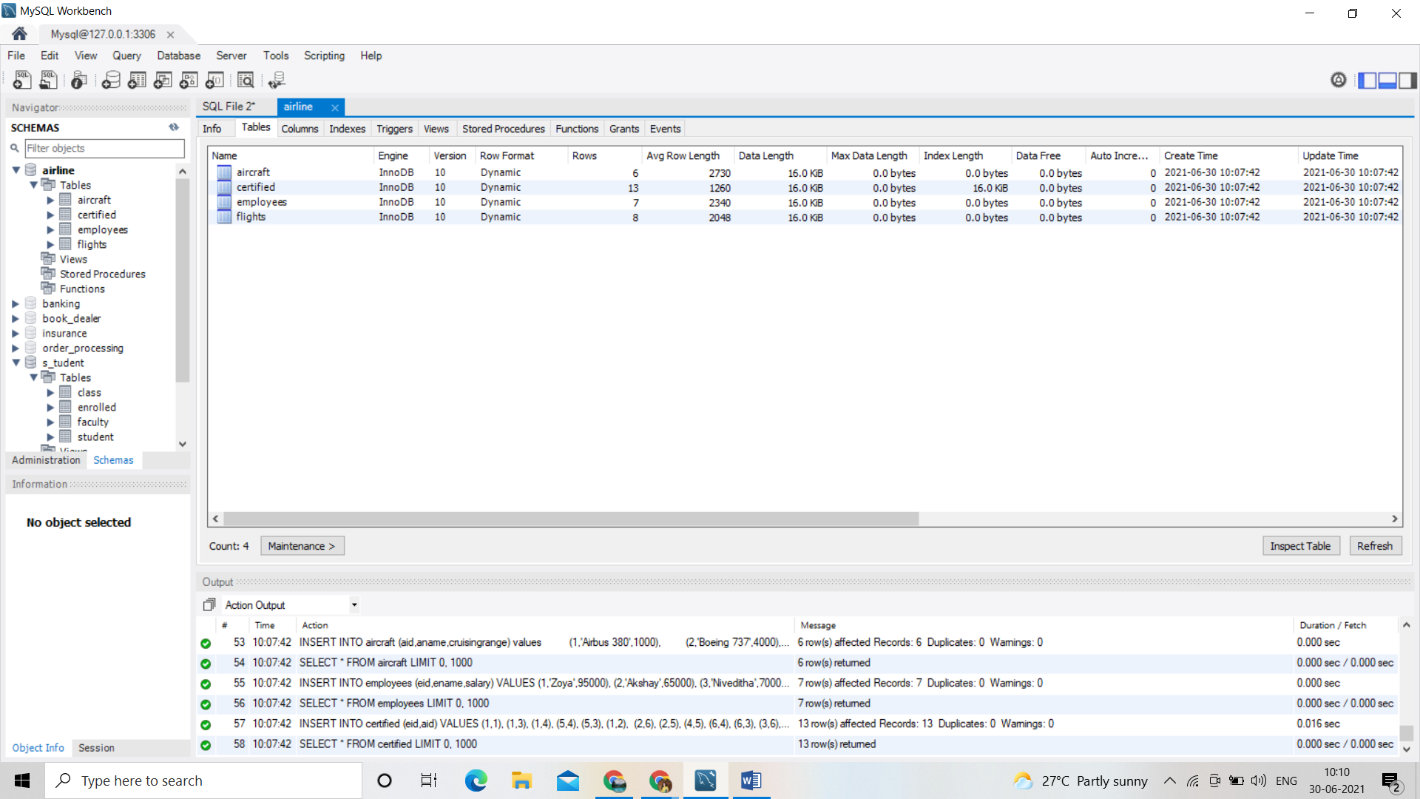

Columns:

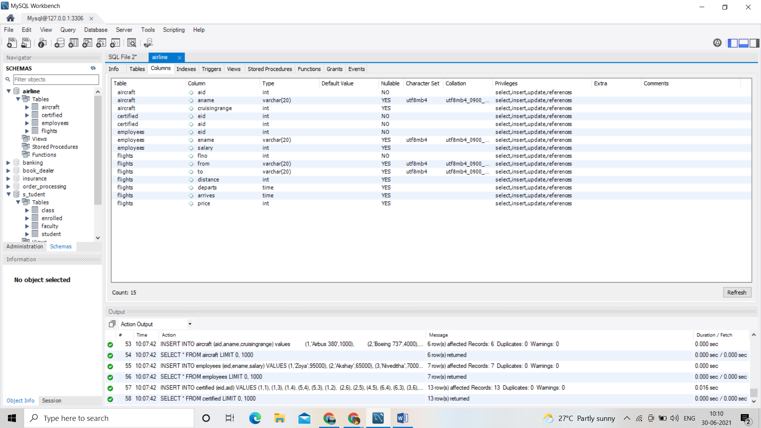

SELECT * FROM airline.aircraft;

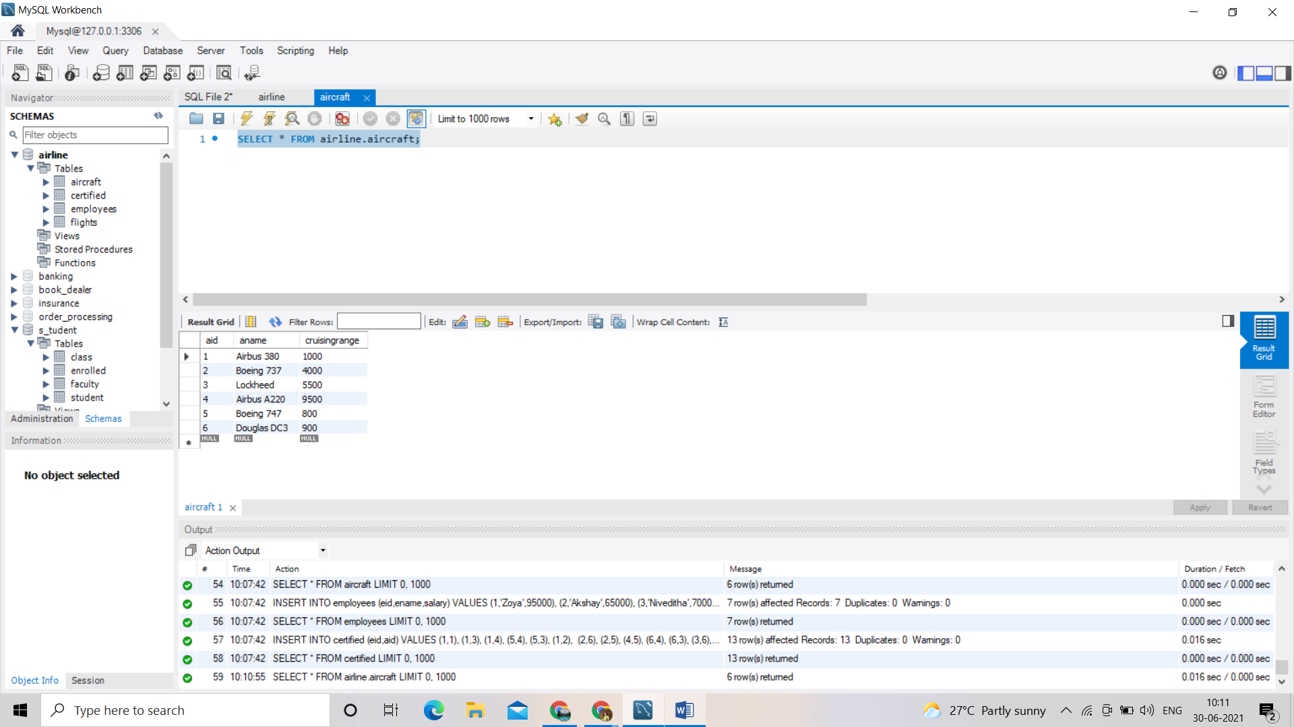

SELECT * FROM airline.certified;

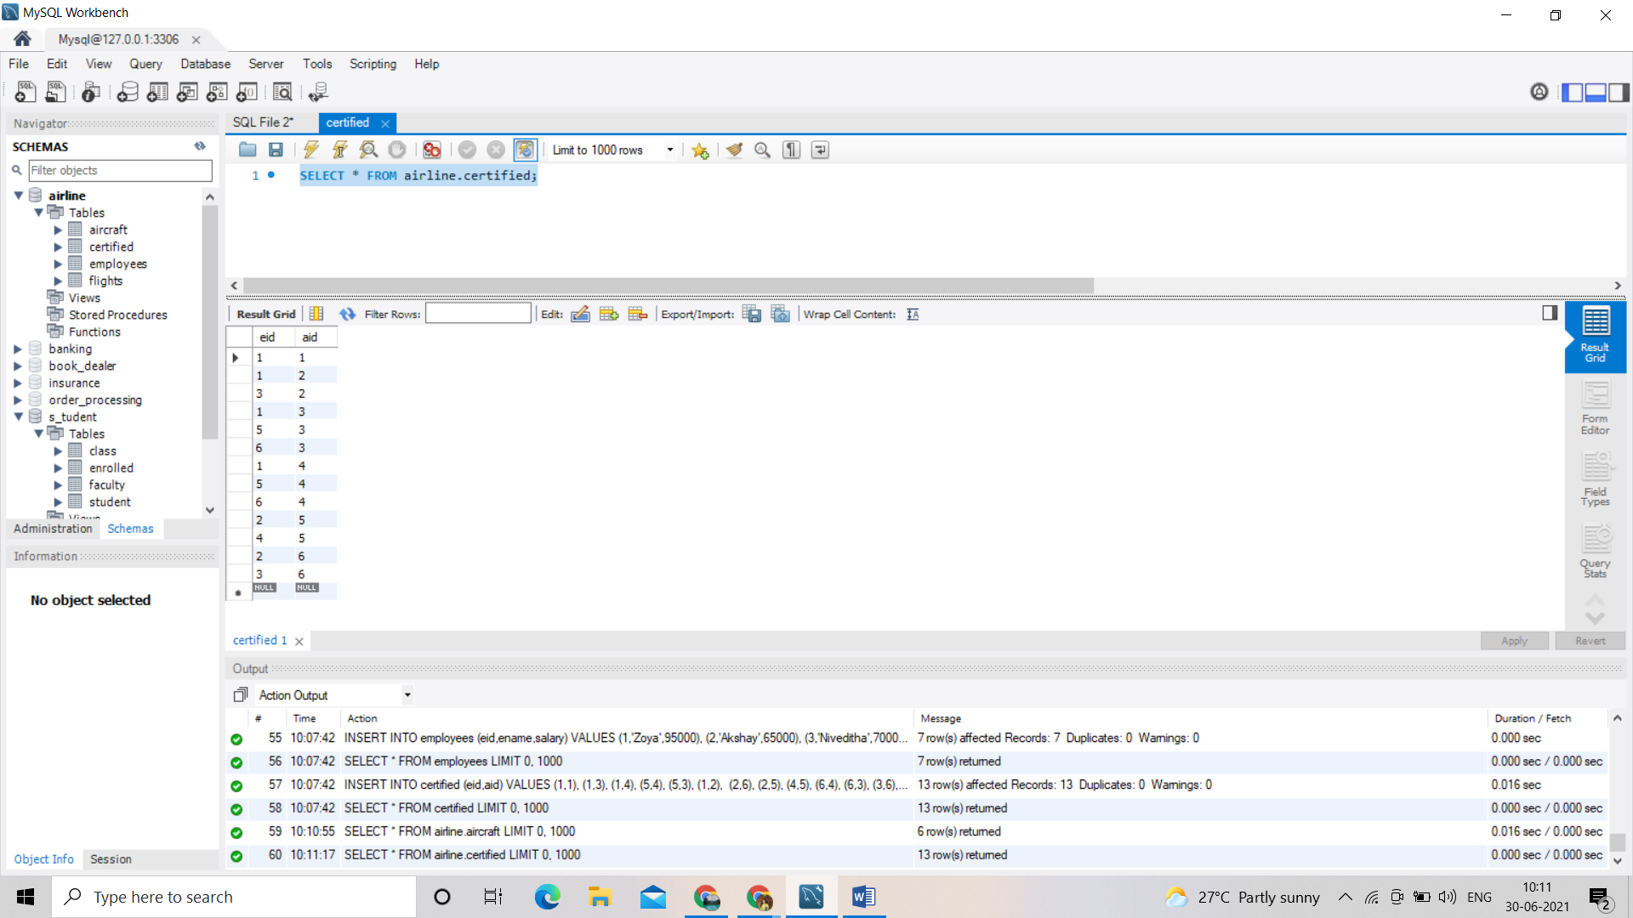

SELECT * FROM airline.employees;

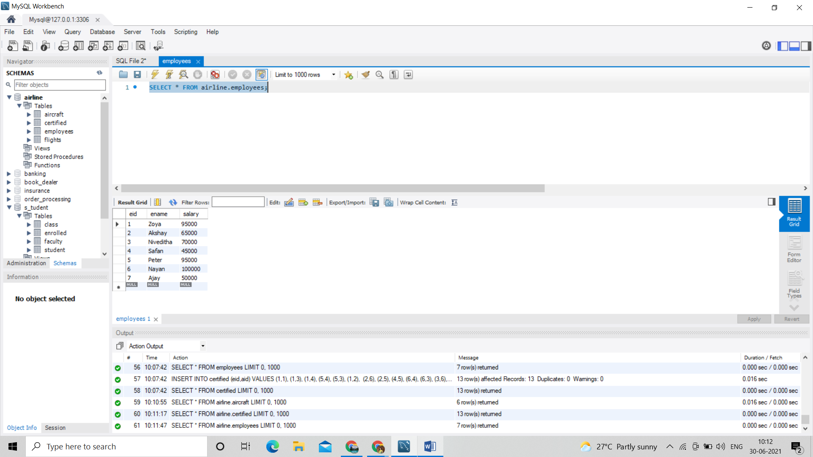

SELECT * FROM airline.flights;

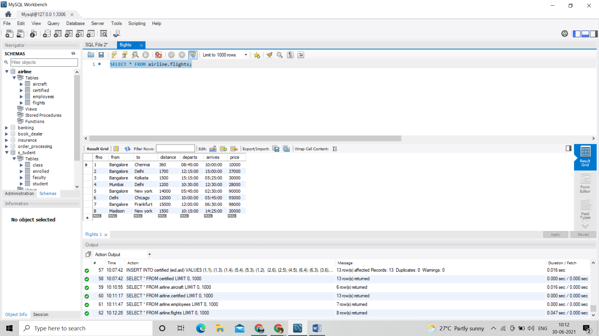

Quries:

/*i. Find the names of aircraft such that all pilots certified to operate them have salaries more than Rs.80,000.*/

SELECT DISTINCT A.aname

FROM Aircraft A

WHERE A.Aid IN (SELECT C.aid

FROM Certified C, Employees E

WHERE C.eid = E.eid AND

NOT EXISTS ( SELECT *

FROM Employees E1

WHERE E1.eid = E.eid AND E1.salary < 80000 ));

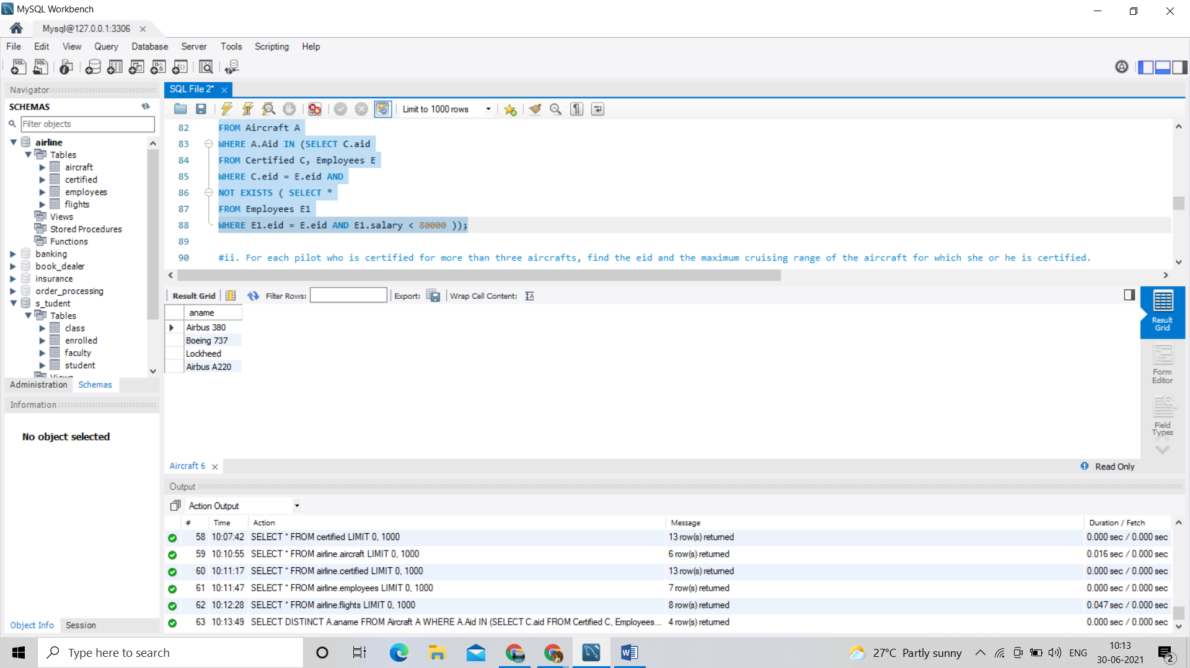

/*ii. For each pilot who is certified for more than three aircrafts, find the eid and the maximum cruising range of the aircraft for which she or he is certified.*/

SELECT C.eid, MAX(A.cruisingrange)

FROM Certified C, Aircraft A

WHERE C.aid = A.aid

GROUP BY C.eid

HAVING COUNT(*) > 3;

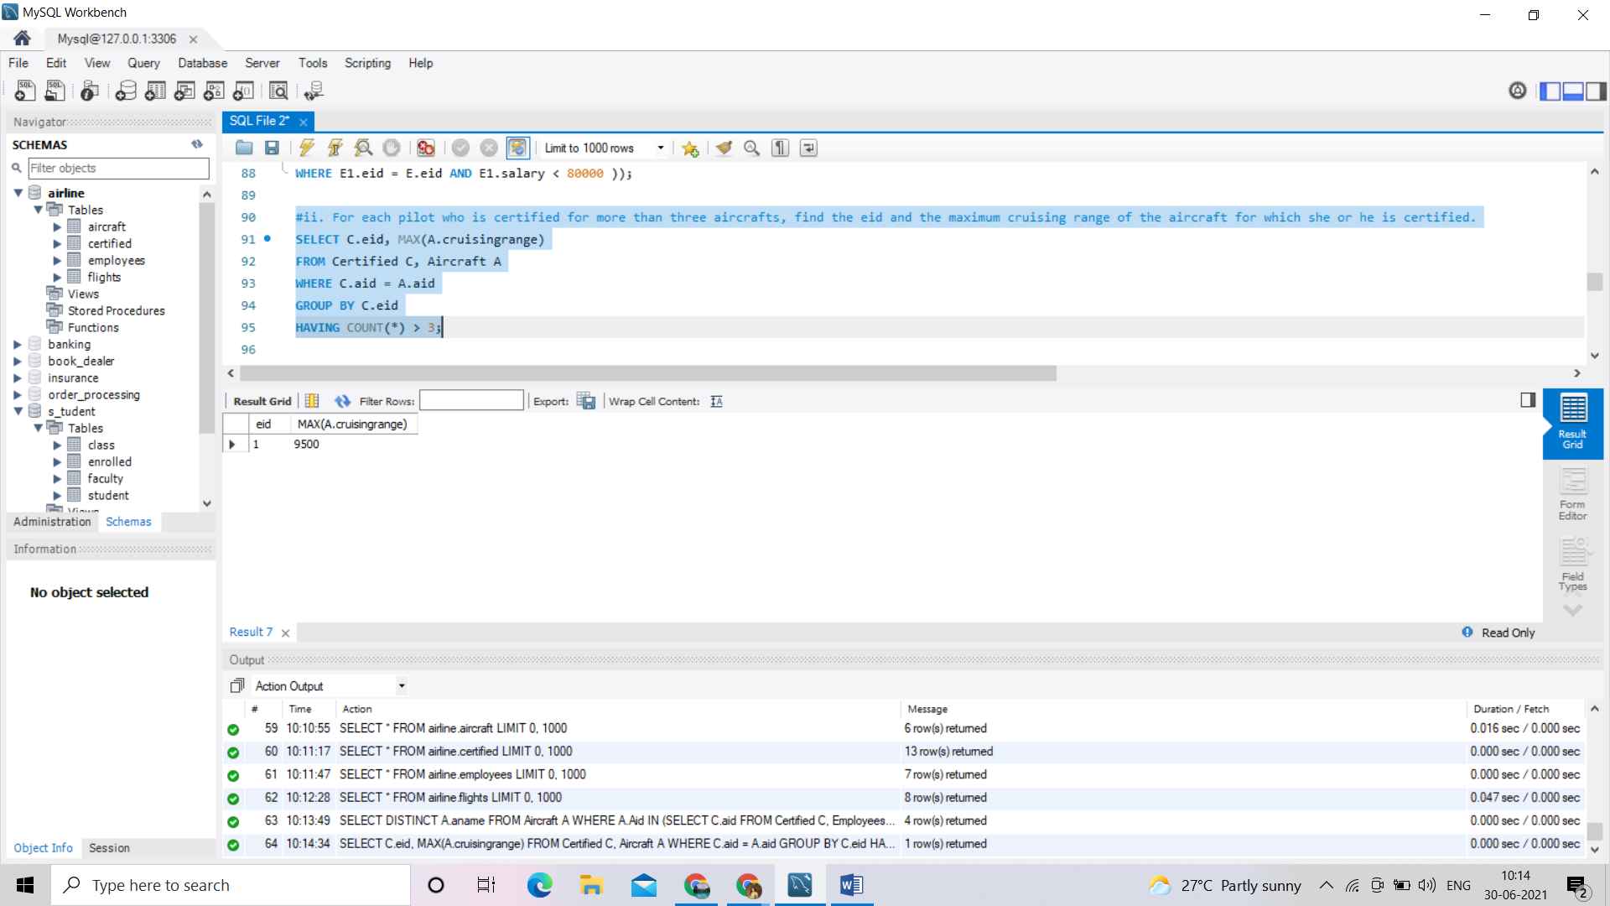

/*iii. Find the names of pilots whose salary is less than the price of the cheapest route from Bengaluru toFrankfurt.*/

SELECT DISTINCT e.ename

FROM employees e

WHERE e.salary<

(SELECT MIN(f.price)

FROM flights f

WHERE f.from='Bangalore' AND f.to='Frankfurt');

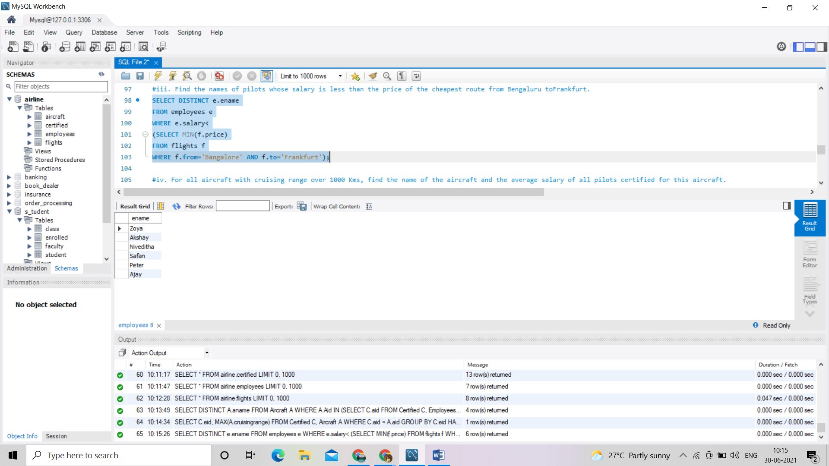

/*iv. For all aircraft with cruising range over 1000 Kms, find the name of the aircraft and the average salary of all pilots certified for this aircraft. */

SELECT a.aid,a.aname,AVG(e.salary)

FROM aircraft a,certified c,employees e

WHERE a.aid=c.aid

AND c.eid=e.eid

AND a.cruisingrange>1000

GROUP BY a.aid,a.aname;

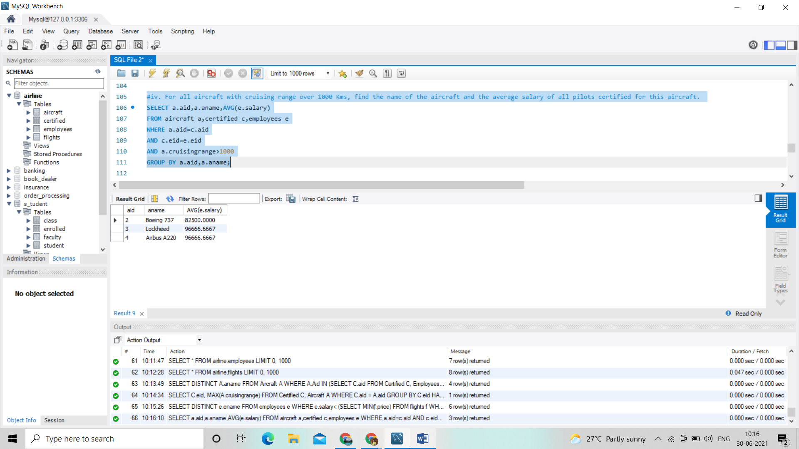

/*v. Find the names of pilots certified for some Boeing aircraft. */

SELECT distinct e.ename

FROM employees e,aircraft a,certified c

WHERE e.eid=c.eid AND c.aid=a.aid AND a.aname like 'Boeing%';

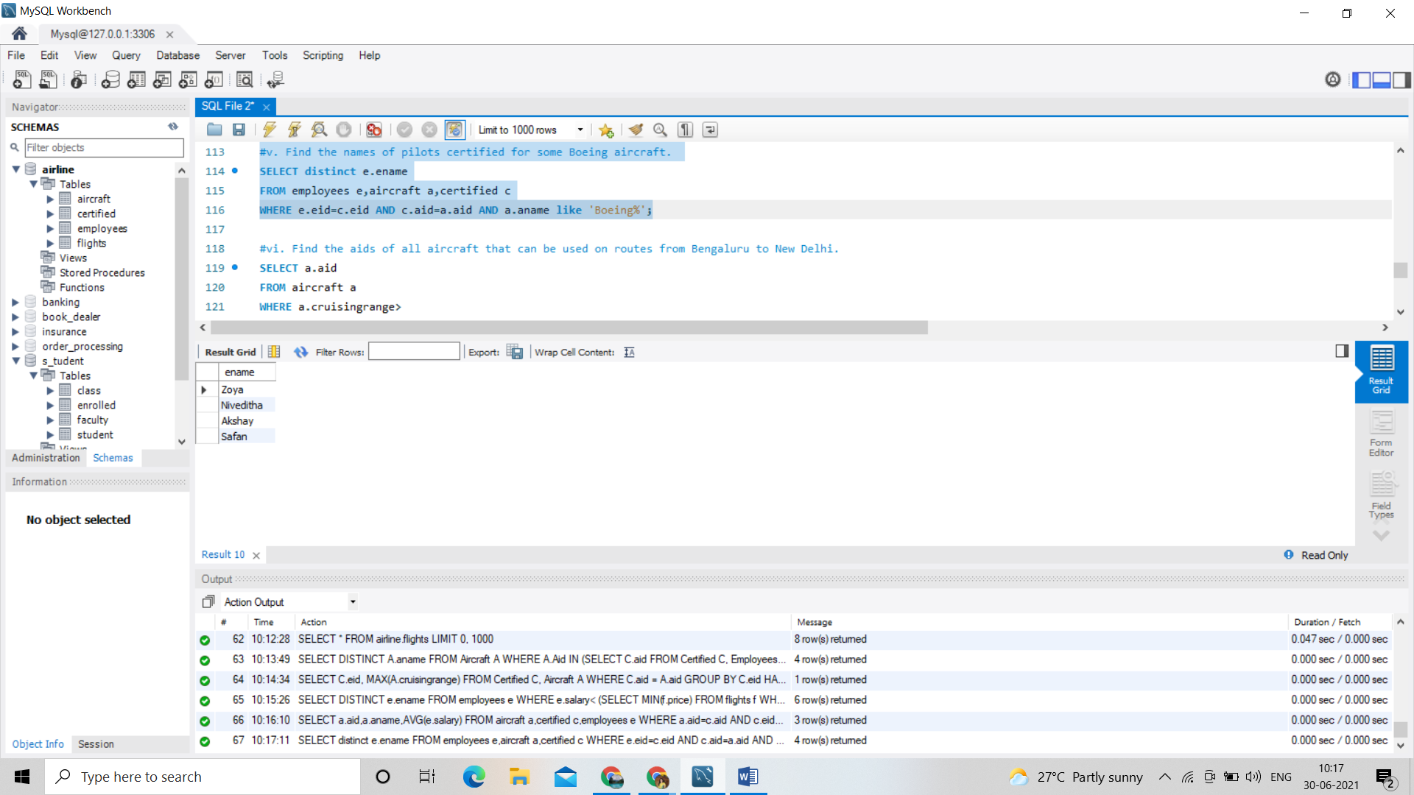

/*vi. Find the aids of all aircraft that can be used on routes from Bengaluru to New Delhi. */

SELECT a.aid

FROM aircraft a

WHERE a.cruisingrange>

(SELECT MIN(f.distance)

FROM flights f

WHERE f.from='Bangalore' AND f.to='Delhi');

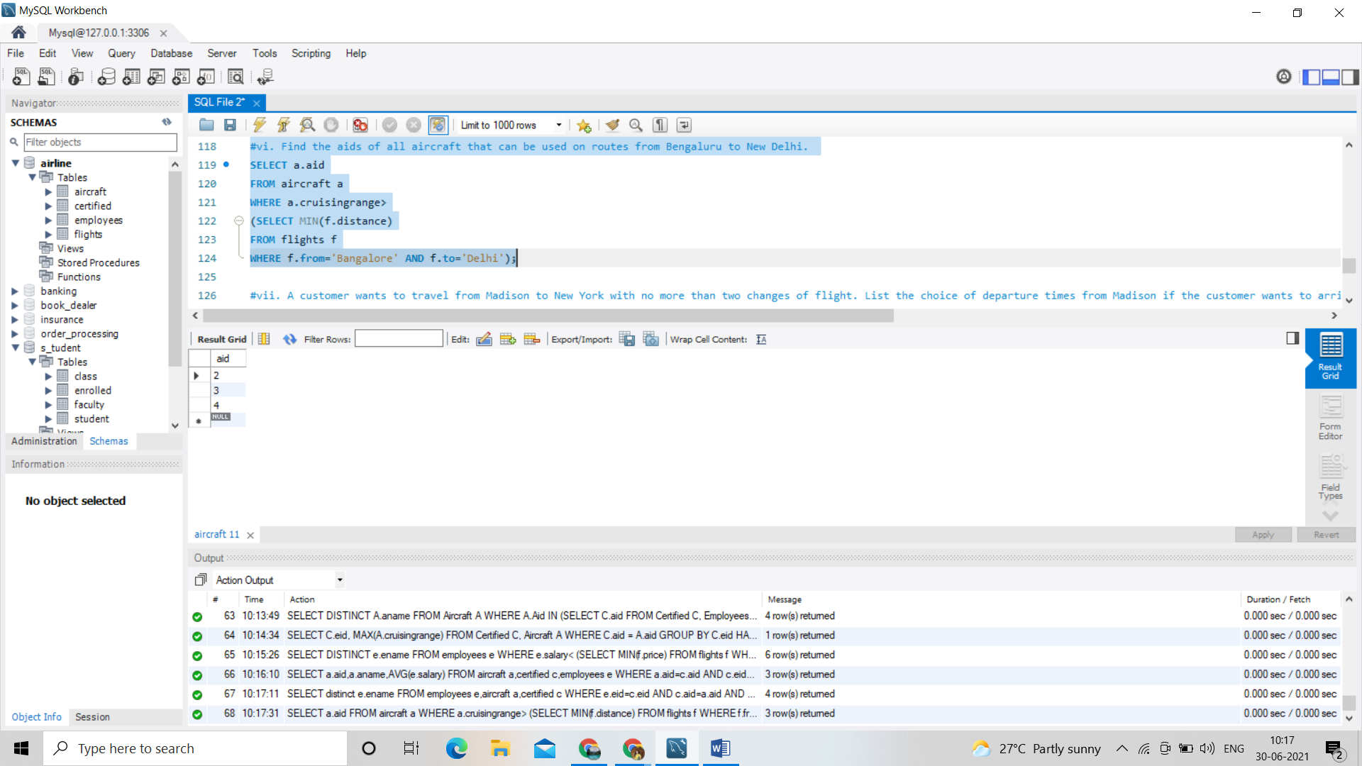

/*vii. A customer wants to travel from Madison to New York with no more than two changes of flight. List the choice of departure times from Madison if the customer wants to arrive in New York by 6 p.m. */

SELECT F.departs

FROM Flights F WHERE F.flno IN ( SELECT F0.flno

FROM Flights F0

WHERE F0.from = 'Madison' AND F0.to = 'New york' AND F0.arrives < '18:00' );

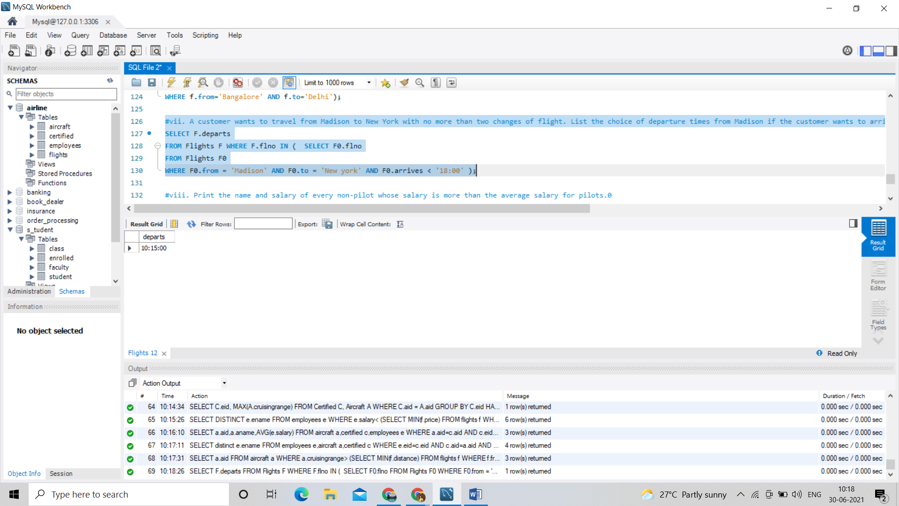

/*viii. Print the name and salary of every non-pilot whose salary is more than the average salary for pilots.0*/

SELECT E.ename, E.salary

FROM Employees E

WHERE E.eid NOT IN ( SELECT DISTINCT C.eid

FROM Certified C )

AND E.salary > ( SELECT AVG (E1.salary)

FROM Employees E1

WHERE E1.eid IN

( SELECT DISTINCT C1.eid

FROM Certified C1 ) );

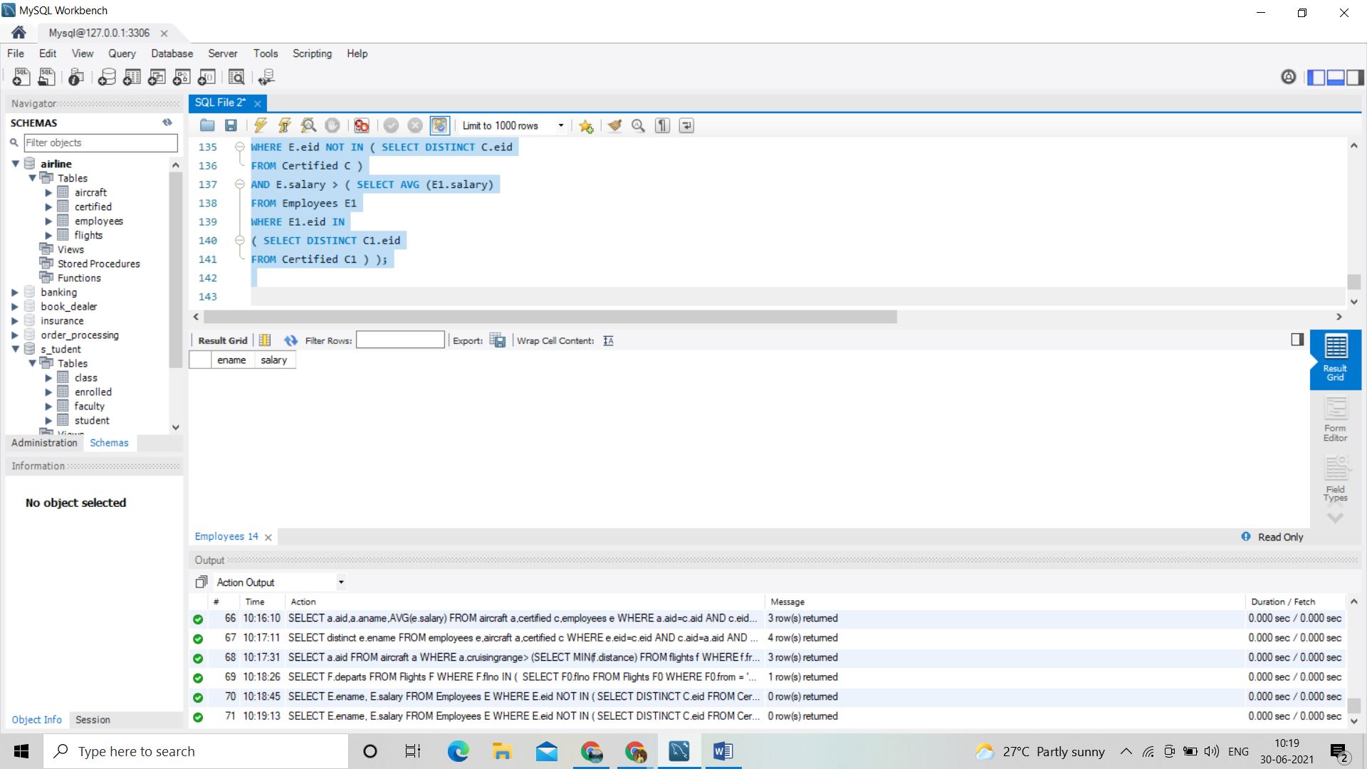

LAB PROGRAM 8:

STUDENT FACLUTY DATABASE:

Consider the following database for student enrolment for course:

STUDENT (snum: integer, sname: string, major: string, level: string, age: integer)

CLASS (name: string, meets at: time, room: string, fid: integer)

ENROLLED (snum: integer, cname: string)

FACULTY (fid: integer, fname: string, deptid: integer)

The meaning of these relations is straightforward; for example, Enrolled has one record per student-class pair

such that the student is enrolled in the class. Level is a two character code with 4 different values (example:

Junior: JR etc)

Write the following queries in SQL. No duplicates should be printed in any of the answers.

i. Find the names of all Juniors (level = JR) who are enrolled in a class taught by

ii. Find the names of all classes that either meet in room R128 or have five or more Students enrolled.

iii. Find the names of all students who are enrolled in two classes that meet at the same time.

iv. Find the names of faculty members who teach in every room in which some class is taught.

v. Find the names of faculty members for whom the combined enrolment of the courses that they teach is less

than five.

vi. Find the names of students who are not enrolled in any class.

vii. For each age value that appears in Students, find the level value that appears most often. For example, if

there are more FR level students aged 18 than SR, JR, or SO students aged 18, you should print the pair (18,

FR).

**CODE:**

create database s_tudent;

use s_tudent;

CREATE TABLE student(

snum INT,

sname VARCHAR(10),

major VARCHAR(2),

lvl VARCHAR(2),

age INT,

primary key(snum));

CREATE TABLE faculty(

fid INT,

fname VARCHAR(20),

deptid INT,

PRIMARY KEY(fid));

CREATE TABLE class(

cname VARCHAR(20),

metts_at TIMESTAMP,

room VARCHAR(10),

fid INT,

PRIMARY KEY(cname),

FOREIGN KEY(fid) REFERENCES faculty(fid));

CREATE TABLE enrolled(

snum INT,

cname VARCHAR(20),

PRIMARY KEY(snum,cname),

FOREIGN KEY(snum) REFERENCES student(snum),

FOREIGN KEY(cname) REFERENCES class(cname));

INSERT INTO STUDENT

VALUES(1,'jhon','CS','Sr',19),(2,'Smith','CS','Jr',20),(3,'Jacob','CV','Sr',20),(4,'Tom','CS','Jr',20),(5,'Rahul','CS','Jr',20),(6,'Rita','CS','Sr',21);

INSERT INTO FACULTY

VALUES (11,'Harish',1000),(12,'MV',1000),(13,'Mira',1001),(14,'Shiva',1002),(15,'Nupur',1000);

insert into class

values ('class1', '12/11/15 10:15:16', 'R1', 14),('class10', '12/11/15 10:15:16', 'R128', 14),('class2', '12/11/15 10:15:20', 'R2', 12),('class3', '12/11/15 10:15:25', 'R3', 11),('class4', '12/11/15 20:15:20', 'R4', 14),('class5', '12/11/15 20:15:20', 'R3', 15),('class6', '12/11/15 13:20:20', 'R2', 14),('class7', '12/11/15 10:10:10', 'R3', 14);

insert into enrolled

values (1, 'class1'),(2, 'class1'),(3, 'class3'),(4, 'class3'),(5, 'class4'),(1, 'class5'),(2, 'class5'),(3, 'class5'),(4, 'class5'),(5, 'class5');

select distinct s.sname

from student s, class c, enrolled e, faculty f

where s.snum = e.snum and e.cname = c.cname and c.fid = f.fid and

f.fname ='Harish' and s.lvl ='Jr';

select C.cname

from Class C

where C.room = 'R128'

or C.cname in (select E.cname

FROM Enrolled E

GROUP BY E.cname

HAVING COUNT(E.snum) >= 5);

select distinct S.sname

from Student S

where S.snum in (select E1.snum

from Enrolled E1, Enrolled E2, Class C1, Class C2

where E1.snum = E2.snum AND E1.cname <> E2.cname

AND E1.cname = C1.cname

AND E2.cname = C2.cname AND C1.metts_at = C2.metts_at);

select distinct F.fname

from Faculty F,Class C

where F.fid=C.fid

group by C.fid

having count(distinct room) = 5;

select distinct F.fname

from Faculty F

where 5 > (select COUNT(E.snum)

from Class C, Enrolled E

where C.cname = E.cname

and C.fid = F.fid);

select distinct S.sname

from Student S

where S.snum NOT IN (select E.snum

from Enrolled E );

select S.age, S.lvl

from Student S

group by S.age, S.lvl

having S.lvl IN (select S1.lvl from Student S1

where S1.age = S.age

group by S1.lvl, S1.age

having COUNT(S1.snum) >= ALL (select COUNT(S2.snum)

from Student S2

where s1.age = S2.age

group by S2.lvl, S2.age));

/*i. Find the names of all Juniors (level = JR) who are enrolled in a class taught by Harish.*/

select distinct s.sname

from student s, class c, enrolled e, faculty f

where s.snum = e.snum and e.cname = c.cname and c.fid = f.fid and

f.fname ='Harish' and s.lvl ='Jr';

/*ii. Find the names of all classes that either meet in room R128 or have five or more Students enrolled.*/

select C.cname

from Class C

where C.room = 'R128'

or C.cname in (select E.cname

FROM Enrolled E

GROUP BY E.cname

HAVING COUNT(E.snum) >= 5);

/*iii. Find the names of all students who are enrolled in two classes that meet at the same time.*/

select distinct S.sname

from Student S

where S.snum in (select E1.snum

from Enrolled E1, Enrolled E2, Class C1, Class C2

where E1.snum = E2.snum AND E1.cname <> E2.cname

AND E1.cname = C1.cname

AND E2.cname = C2.cname AND C1.metts_at = C2.metts_at);

/*iv. Find the names of faculty members who teach in every room in which some class is taught.*/

select distinct F.fname

from Faculty F,Class C

where F.fid=C.fid

group by C.fid

having count(distinct room) = 5;

/*v. Find the names of faculty members for whom the combined enrollment of the courses that they teach is less than five.*/

select distinct F.fname

from Faculty F

where 5 > (select COUNT(E.snum)

from Class C, Enrolled E

where C.cname = E.cname

and C.fid = F.fid);

/*vi. Find the names of students who are not enrolled in any class. */

select distinct S.sname

from Student S

where S.snum NOT IN (select E.snum

from Enrolled E );

/*vii. For each age value that appears in Students, find the level value that appears most often. For example, if there are more FR level students aged 18 than

SR, JR, or SO students aged 18, you should print the pair (18, FR).*/

select S.age, S.lvl

from Student S

group by S.age, S.lvl

having S.lvl IN (select S1.lvl from Student S1

where S1.age = S.age

group by S1.lvl, S1.age

having COUNT(S1.snum) >= ALL (select COUNT(S2.snum)

from Student S2

where s1.age = S2.age

group by S2.lvl, S2.age));

output:

Tables: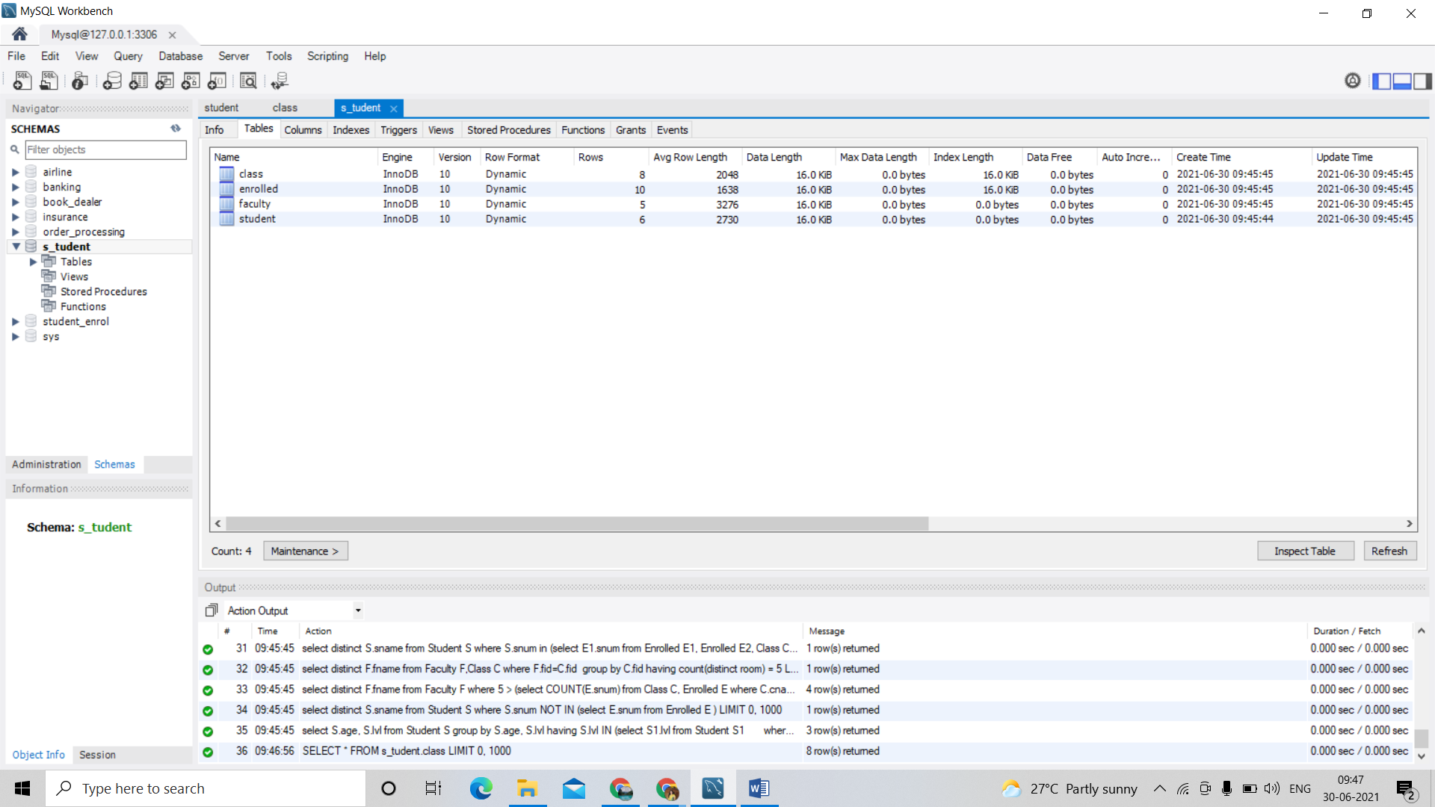

Columns:

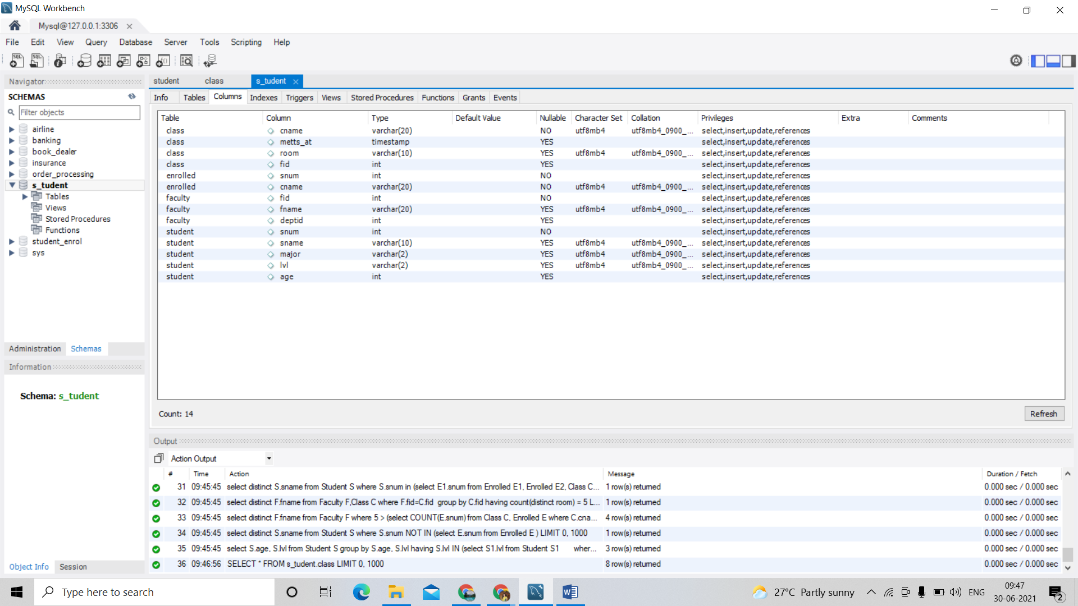

Indexes :

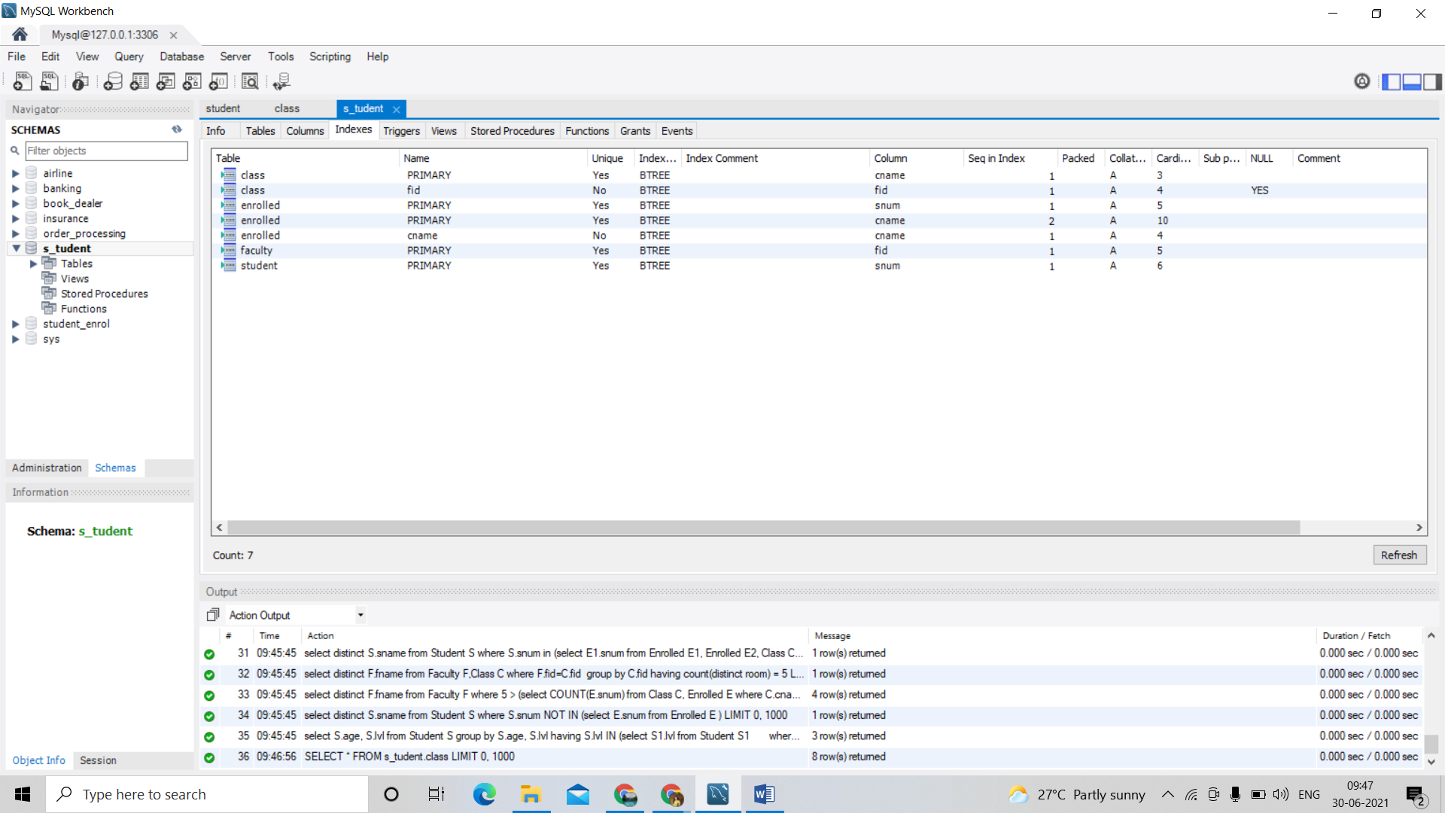

SELECT * FROM s_tudent.class; 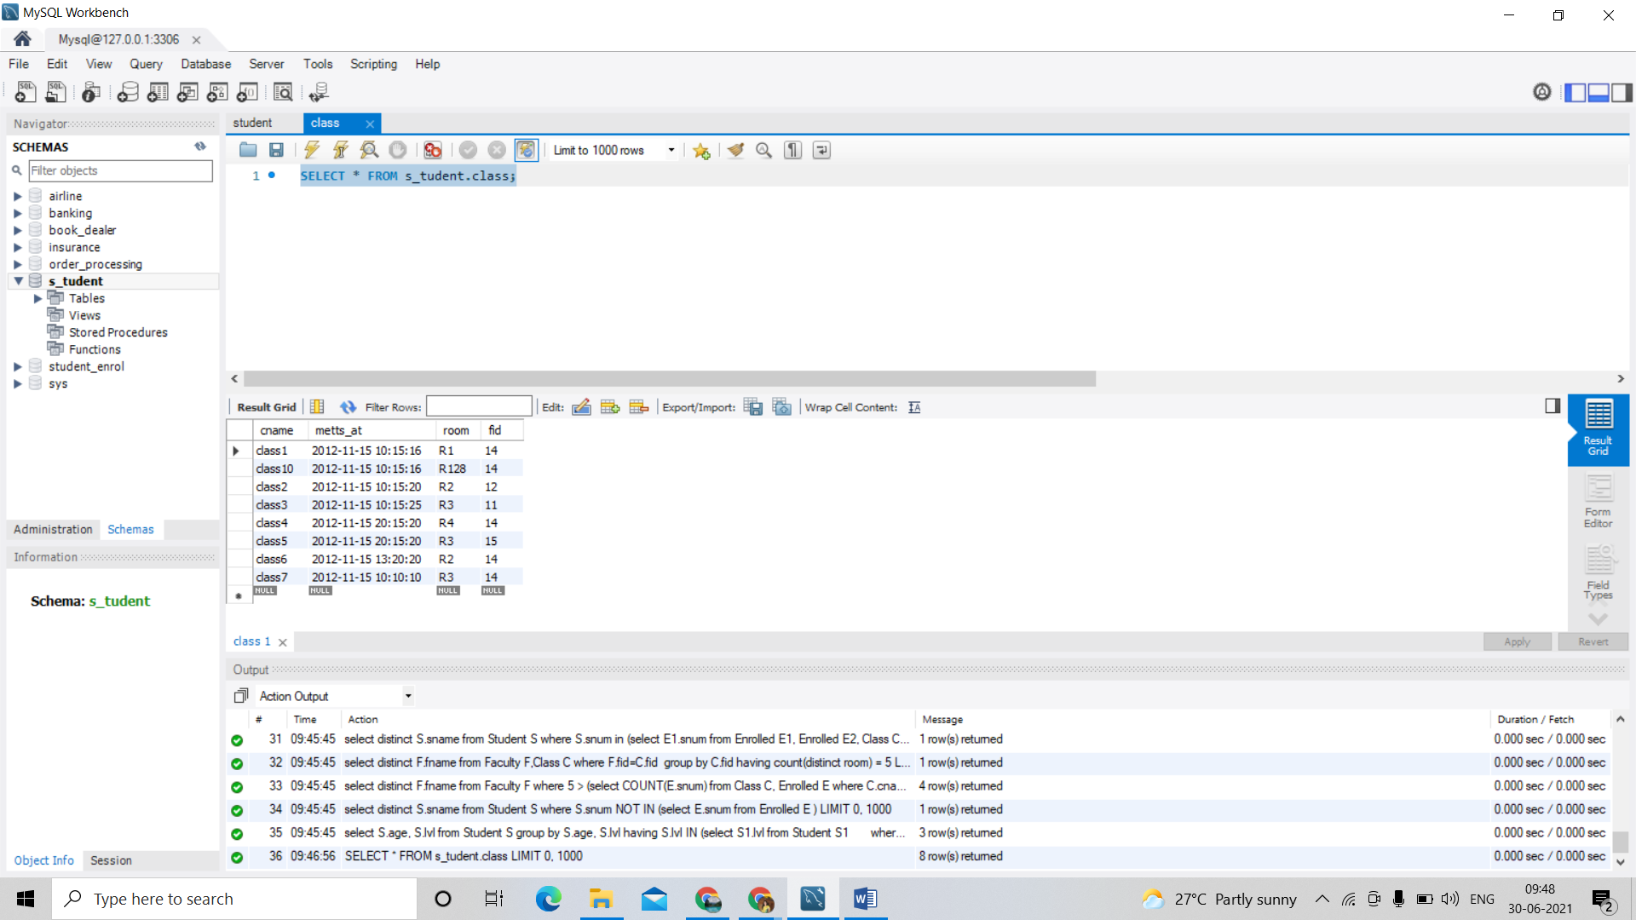

SELECT * FROM s_tudent.enrolled;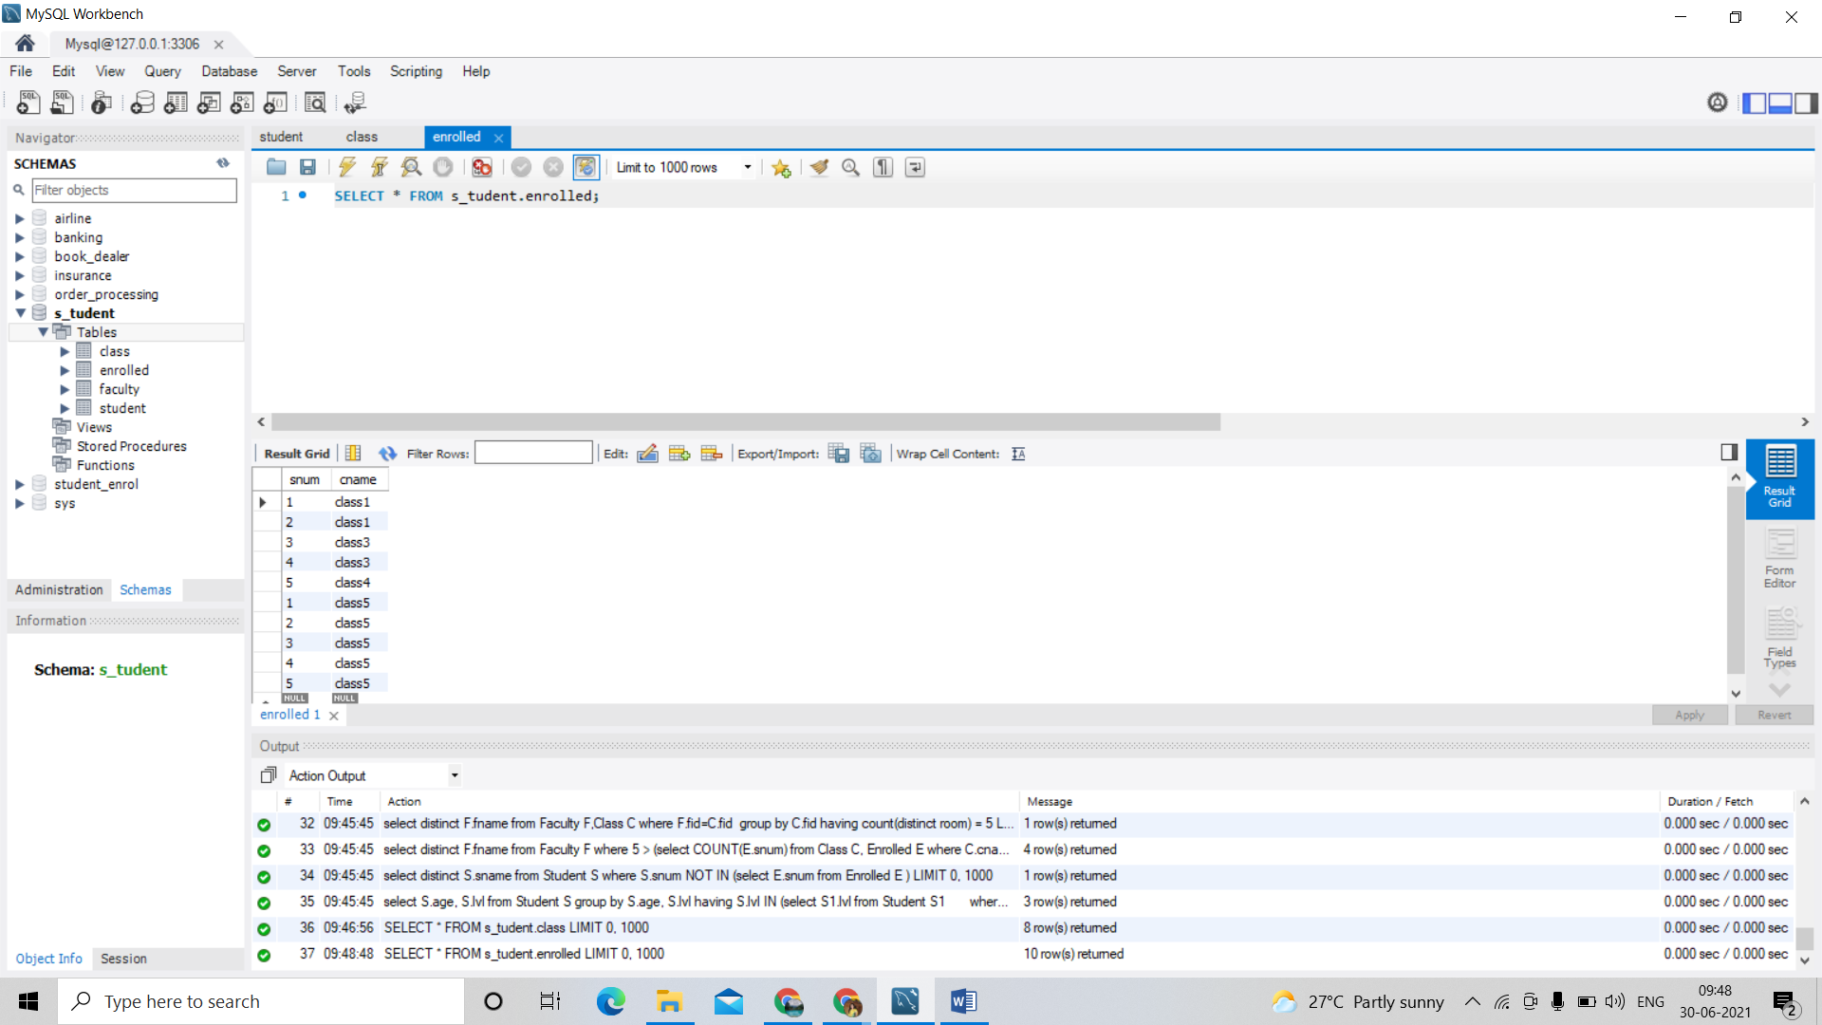

SELECT * FROM s_tudent.faculty; 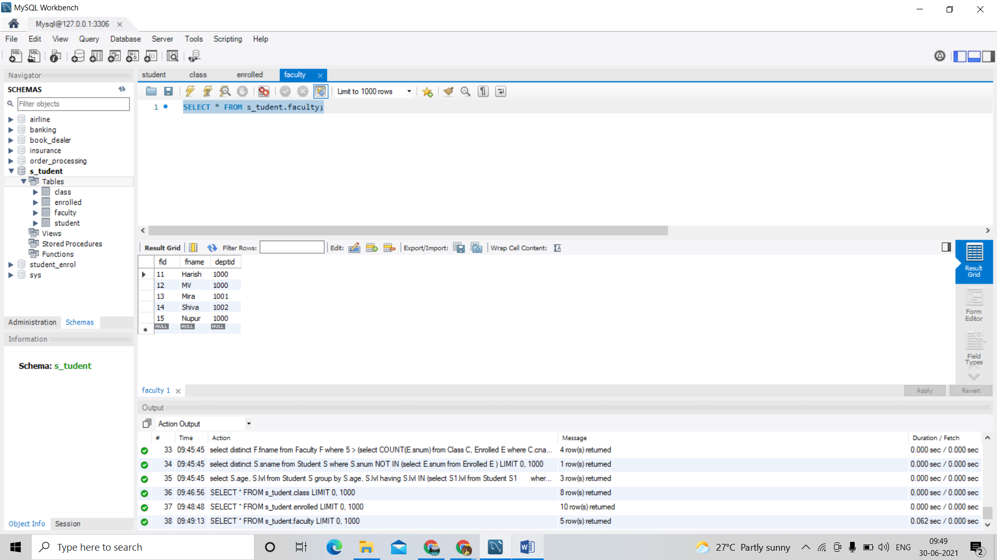

SELECT * FROM s_tudent.student;

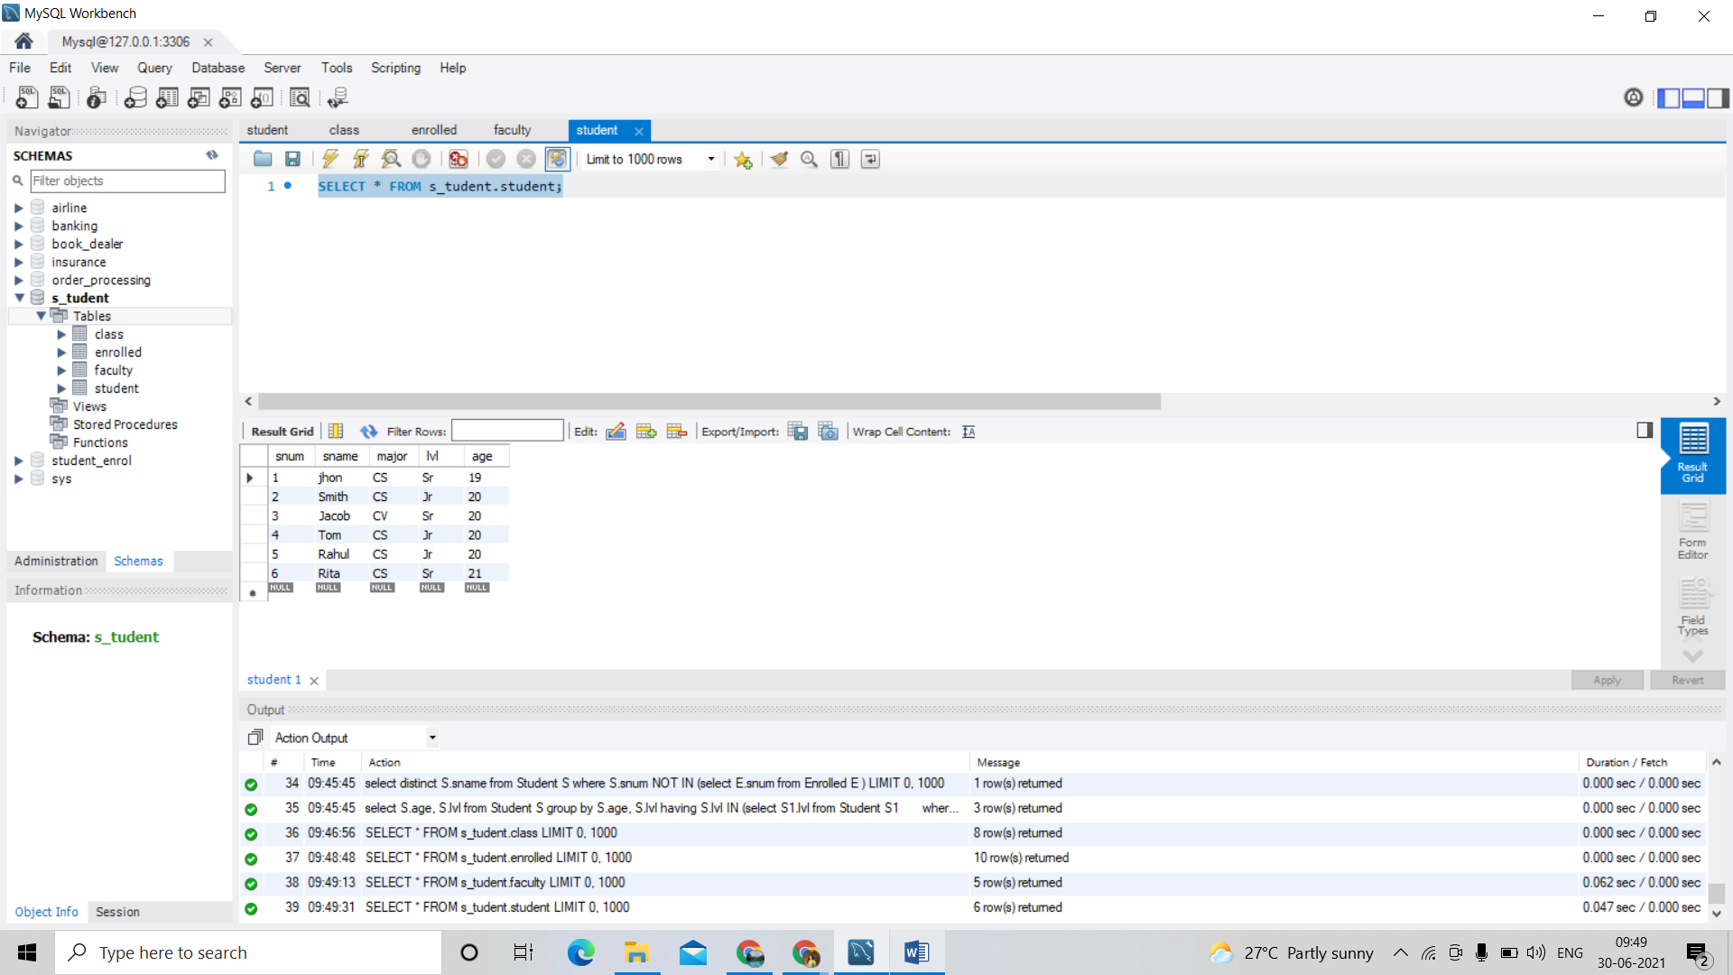

1. Find the names of all Juniors (level = JR) who are enrolled in a class taught by Harish.

select distinct s.sname

from student s, class c, enrolled e, faculty f

where s.snum = e.snum and e.cname = c.cname and c.fid = f.fid and

f.fname ='Harish' and s.lvl ='Jr';

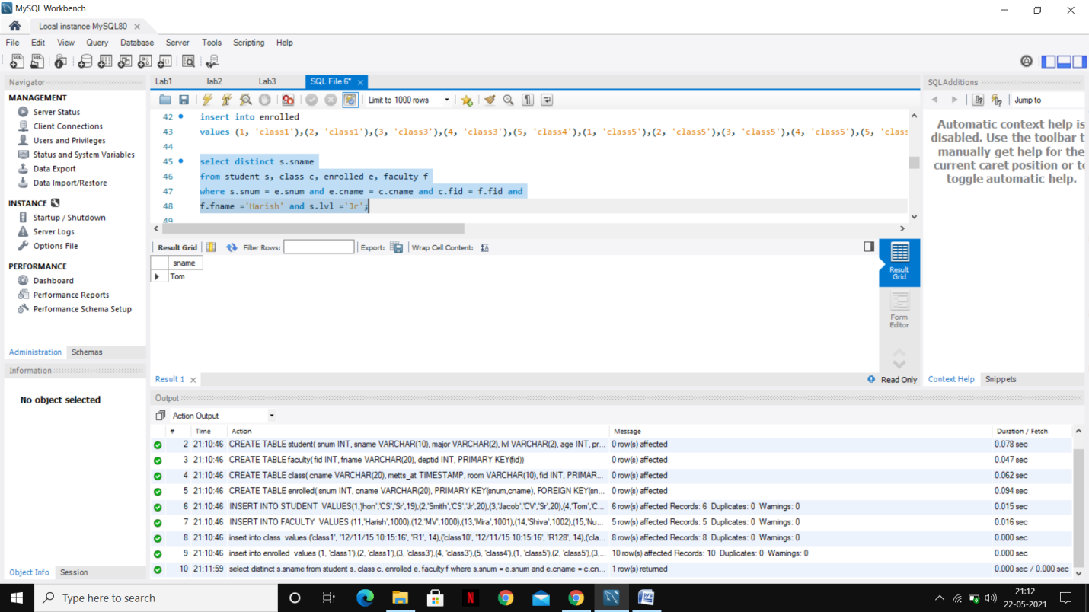

1. Find the names of all classes that either meet in room R128 or have five or more Students enrolled.

select C.cname

from Class C

where C.room = 'R128'

or C.cname in (select E.cname

FROM Enrolled E

GROUP BY E.cname

HAVING COUNT(E.snum) >= 5);

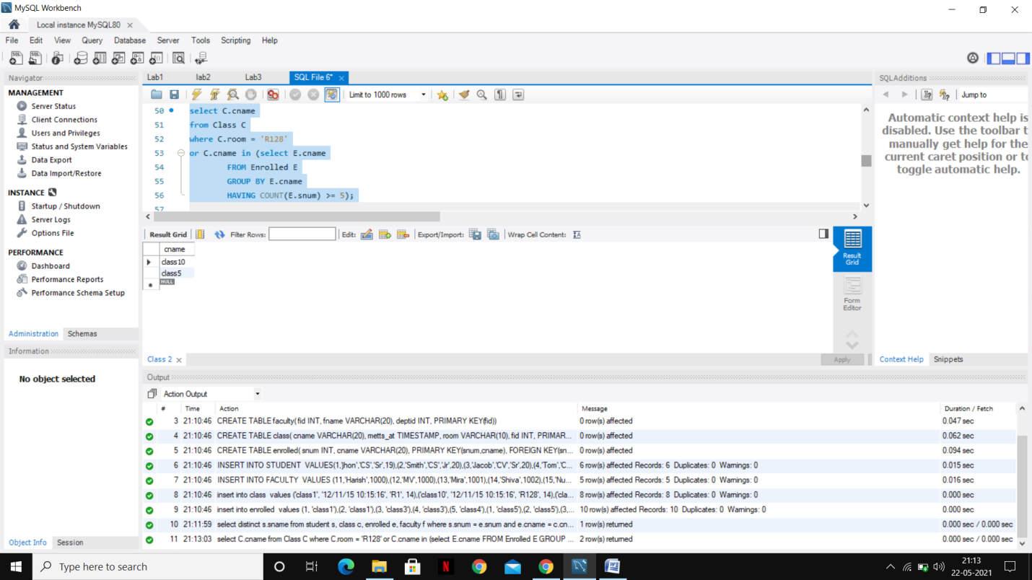

1. Find the names of all students who are enrolled in two classes that meet at the same time.

select distinct S.sname

from Student S

where S.snum in (select E1.snum

from Enrolled E1, Enrolled E2, Class C1, Class C2

where E1.snum = E2.snum AND E1.cname <> E2.cname

AND E1.cname = C1.cname

AND E2.cname = C2.cname AND C1.metts_at = C2.metts_at);

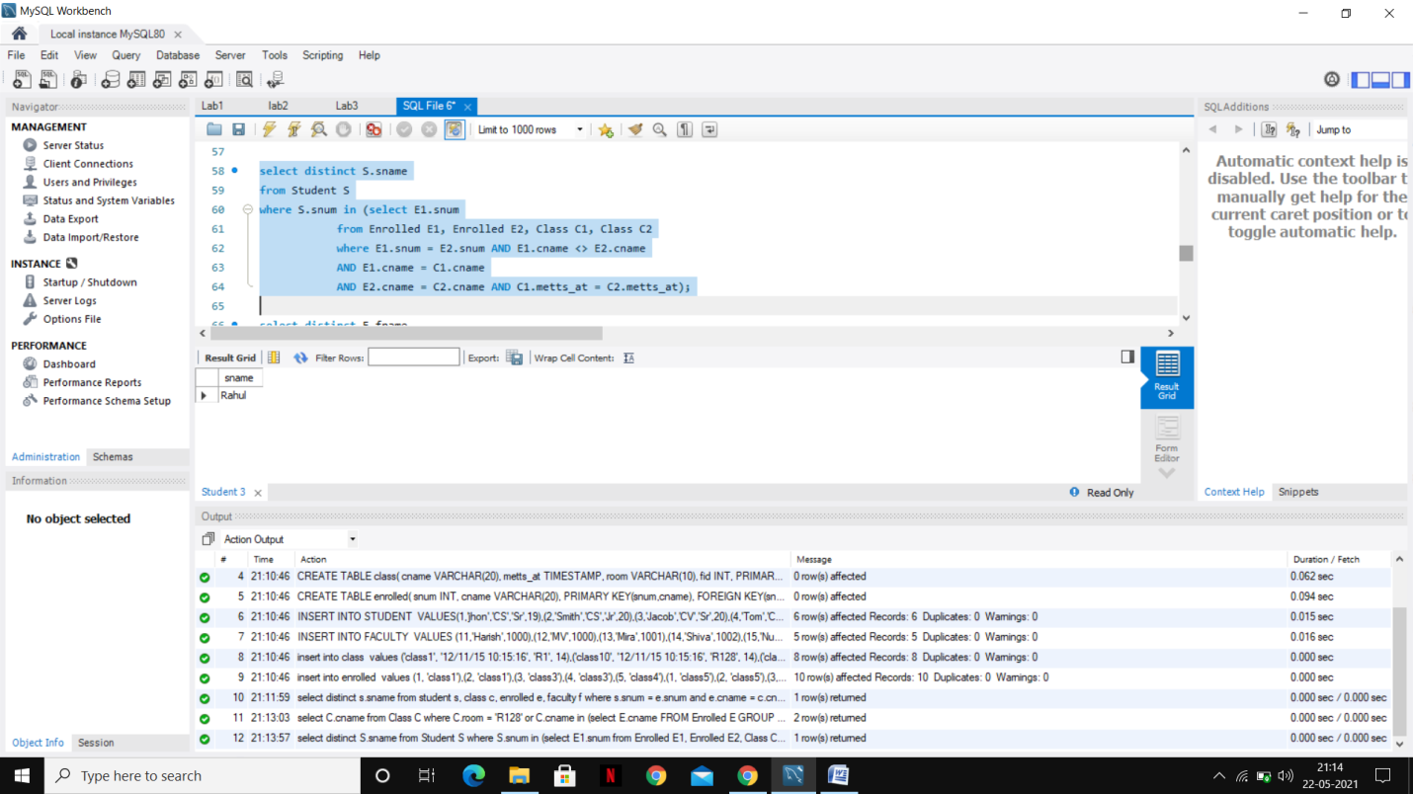

1. Find the names of faculty members who teach in every room in which some class is taught.

select distinct F.fname

from Faculty F,Class C

where F.fid=C.fid

group by C.fid

having count(distinct room) = 5;

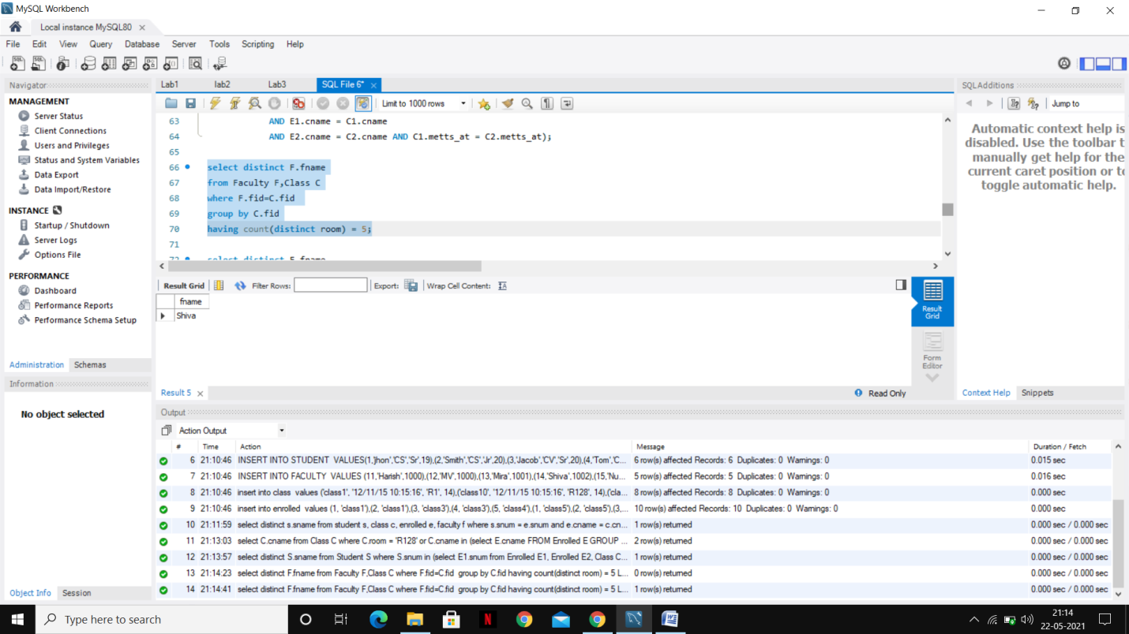

1. Find the names of faculty members for whom the combined enrollment of the courses that they teach is less than five.

select distinct F.fname

from Faculty F

where 5 > (select COUNT(E.snum)

from Class C, Enrolled E

where C.cname = E.cname

and C.fid = F.fid);

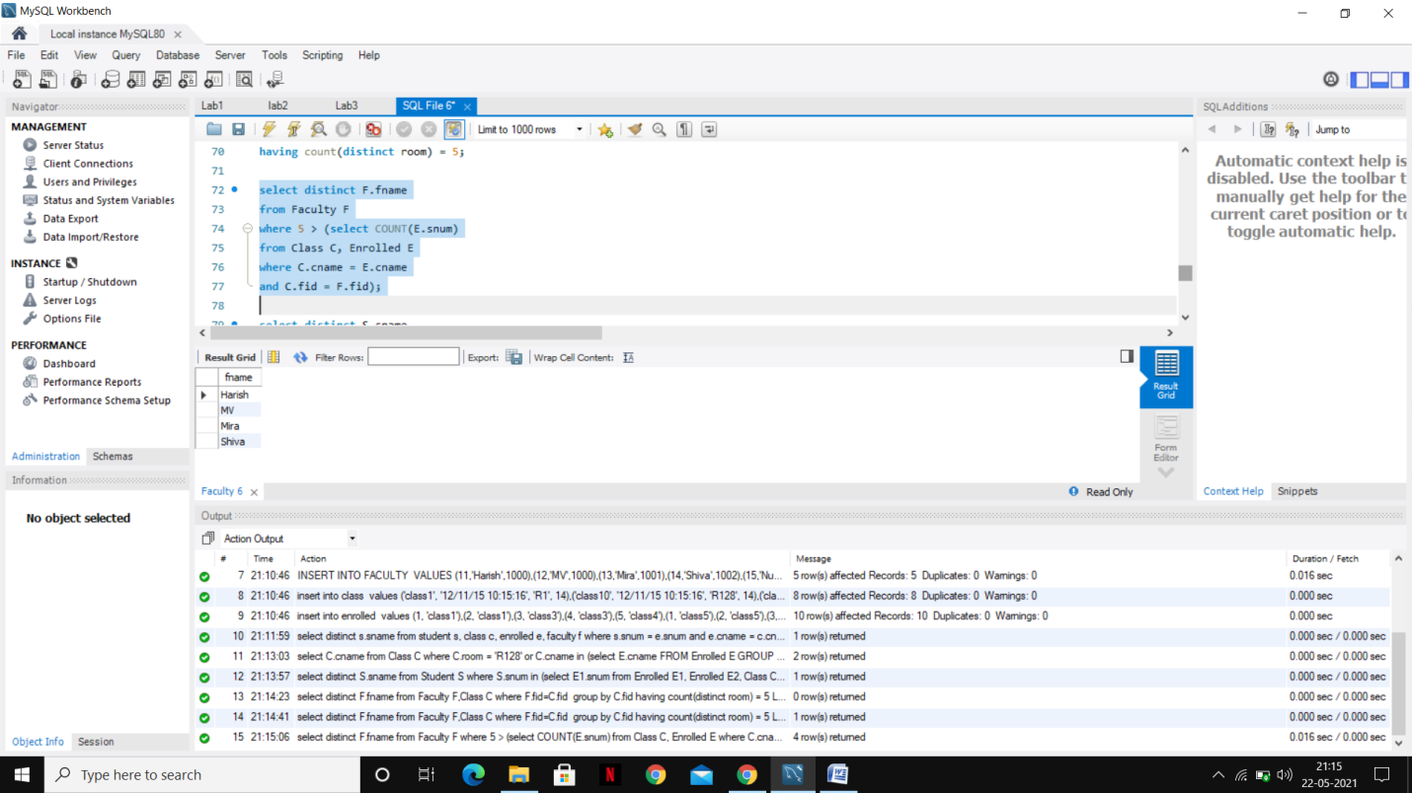

1. Find the names of students who are not enrolled in any class.

select distinct S.sname

from Student S

where S.snum NOT IN (select E.snum

from Enrolled E );

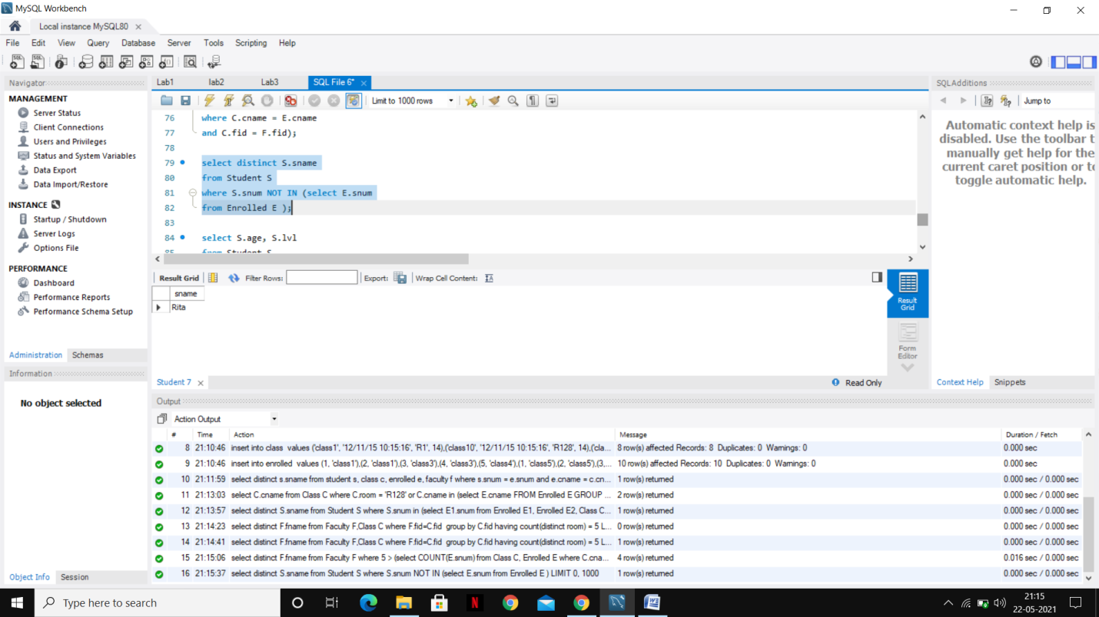

1. For each age value that appears in Students, find the level value that appears most often. For example, if there are more FR level students aged 18 than SR, JR, or SO students aged 18, you should print the pair (18, FR).

select S.age, S.lvl

from Student S

group by S.age, S.lvl

having S.lvl IN (select S1.lvl from Student S1

where S1.age = S.age

group by S1.lvl, S1.age

having COUNT(S1.snum) >= ALL (select COUNT(S2.snum)

from Student S2

where s1.age = S2.age

group by S2.lvl, S2.age));

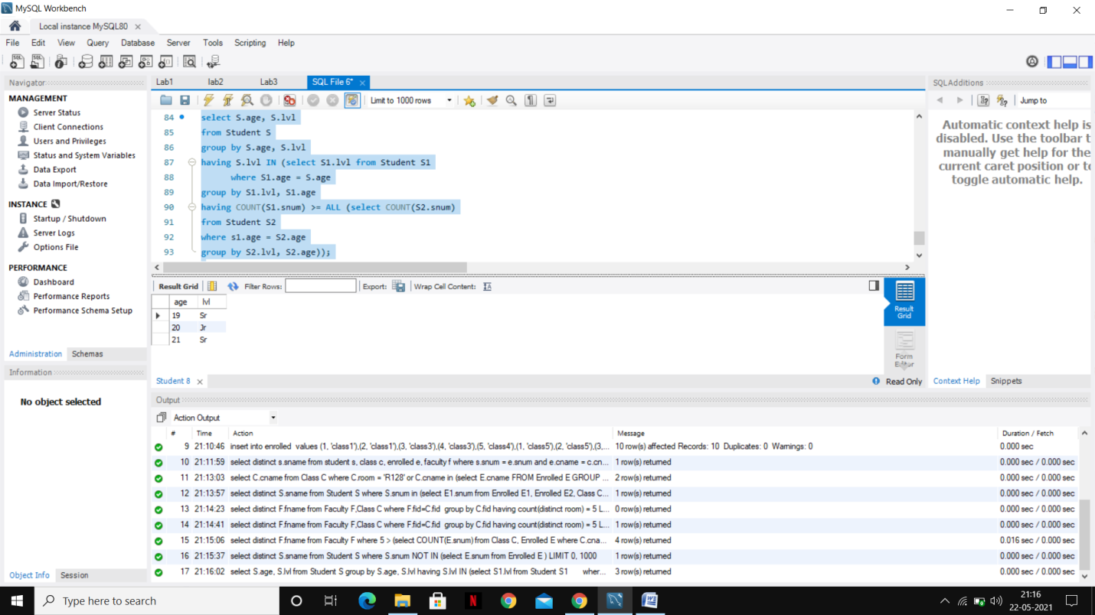

PROGRAM 9:

SUPPLIER DATABASE:

Consider the following schema:

SUPPLIERS (sid: integer, sname: string, address: string)

PARTS (pid: integer, pname: string, color: string)

CATALOG (sid: integer, pid: integer, cost: real)

The Catalog relation lists the prices charged for parts by Suppliers. Write the following queries in SQL:

i. Find the pnames of parts for which there is some supplier.

ii. Find the snames of suppliers who supply every part.

iii. Find the snames of suppliers who supply every red part.

iv. Find the pnames of parts supplied by Acme Widget Suppliers and by no one else.

v. Find the sids of suppliers who charge more for some part than the average cost of that part (averaged over

all the suppliers who supply that part).

vi. For each part, find the sname of the supplier who charges the most for that part.

vii. Find the sids of suppliers who supply only red parts.

**Code:**

CREATE DATABASE SUPPLIER;

USE SUPPLIER;

CREATE TABLE SUPPLIERS(SID BIGINT(5) PRIMARY KEY, SNAME

VARCHAR(20), CITY VARCHAR(20));

INSERT INTO SUPPLIERS VALUES(10001,'ACME WIDGET','BANGALORE');

INSERT INTO SUPPLIERS VALUES(10002,'JOHNS ','KOLKATA');

INSERT INTO SUPPLIERS VALUES(10003,'VIMAL','MUMBAI');

INSERT INTO SUPPLIERS VALUES(10004,'RELIANCE ','DELHI');

SELECT * FROM SUPPLIERS;

CREATE TABLE PARTS(PID BIGINT(5) PRIMARY KEY, PNAME VARCHAR(20),

COLOR VARCHAR(10));

INSERT INTO PARTS VALUES(20001,'BOOK','RED');

INSERT INTO PARTS VALUES(20002,'PEN','RED');

INSERT INTO PARTS VALUES(20003,'PENCIL','GREEN');

INSERT INTO PARTS VALUES(20004,'MOBILE ','GREEN');

INSERT INTO PARTS VALUES(20005,'CHARGER','BLACK');

SELECT * FROM PARTS;

CREATE TABLE CATALOG(SID BIGINT(5), PID BIGINT(5), FOREIGN KEY(SID)

REFERENCES SUPPLIERS(SID), FOREIGN KEY(PID) REFERENCES PARTS(PID),

COST FLOAT(6), PRIMARY KEY(SID, PID));

INSERT INTO CATALOG VALUES(10001,20001,10);

INSERT INTO CATALOG VALUES(10001,20002,10);

INSERT INTO CATALOG VALUES(10001,20003,30);

INSERT INTO CATALOG VALUES(10001,20004,10);

INSERT INTO CATALOG VALUES(10001,20005,10);

INSERT INTO CATALOG VALUES(10002,20001,10);

INSERT INTO CATALOG VALUES(10002,20002,20);

INSERT INTO CATALOG VALUES(10003,20003,30);

INSERT INTO CATALOG VALUES(10004,20003,40);

SELECT * FROM CATALOG;

/* 1 - FIND THE PNAMES OF PARTS FOR WHICH THERE IS SOME SUPPLIER. */

SELECT DISTINCT P.PNAME

FROM PARTS P, CATALOG C

WHERE P.PID = C.PID;

/* FIND THE SNAMES OF SUPPLIERS WHO SUPPLY EVERY PART */

SELECT S.SNAME FROM SUPPLIERS S WHERE NOT EXISTS (SELECT P.PID FROM

PARTS P WHERE NOT EXISTS (SELECT C.SID FROM CATALOG C WHERE C.SID =

S.SID AND C.PID = P.PID));

/* FIND THE SNAMES OF SUPPLIERS WHO SUPPLY EVERY RED PART. */

SELECT S.SNAME FROM SUPPLIERS S WHERE NOT EXISTS (SELECT P.PID FROM

PARTS P WHERE P.COLOR = 'RED' AND (NOT EXISTS (SELECT C.SID FROM

CATALOG C WHERE C.SID = S.SID AND C.PID = P.PID)));

/* FIND THE PNAMES OF PARTS SUPPLIED BY ACME WIDGET SUPPLIERS AND BY NO ONE ELSE */

SELECT P.PNAME FROM PARTS P, CATALOG C, SUPPLIERS S WHERE P.PID

= C.PID AND C.SID = S.SID AND S.SNAME = 'ACME WIDGET' AND NOT EXISTS

(SELECT * FROM CATALOG C1, SUPPLIERS S1 WHERE P.PID = C1.PID AND

C1.SID = S1.SID AND S1.SNAME <> 'ACME WIDGET');

/* FIND THE SIDS OF SUPPLIERS WHO CHARGE MORE FOR SOME PART THAN THE AVERAGE COST OF THAT PART (AVERAGED OVER

ALL THE SUPPLIERS WHO SUPPLY THAT PART).

*/

SELECT DISTINCT C.SID FROM CATALOG C

WHERE C.COST > ( SELECT AVG (C1.COST)

FROM CATALOG C1

WHERE C1.PID = C.PID );

/* FOR EACH PART, FIND THE SNAME OF THE SUPPLIER WHO CHARGES THE MOST FOR THAT PART.*/

SELECT P.PID, S.SNAME

FROM PARTS P, SUPPLIERS S, CATALOG C

WHERE C.PID = P.PID

AND C.SID = S.SID

AND C.COST = (SELECT MAX(C1.COST)

FROM CATALOG C1

WHERE C1.PID = P.PID);

/* FIND THE SIDS OF SUPPLIERS WHO SUPPLY ONLY RED PARTS.*/

SELECT DISTINCT C.SID

FROM CATALOG C

WHERE NOT EXISTS ( SELECT *

FROM PARTS P

WHERE P.PID = C.PID AND P.COLOR <> 'RED' );

Output:

Suppliers 1:

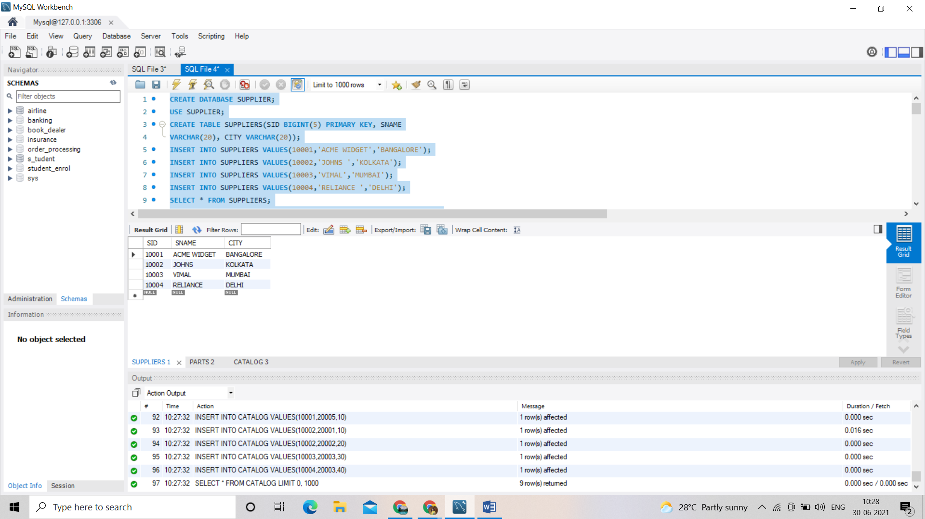

Parts 2:

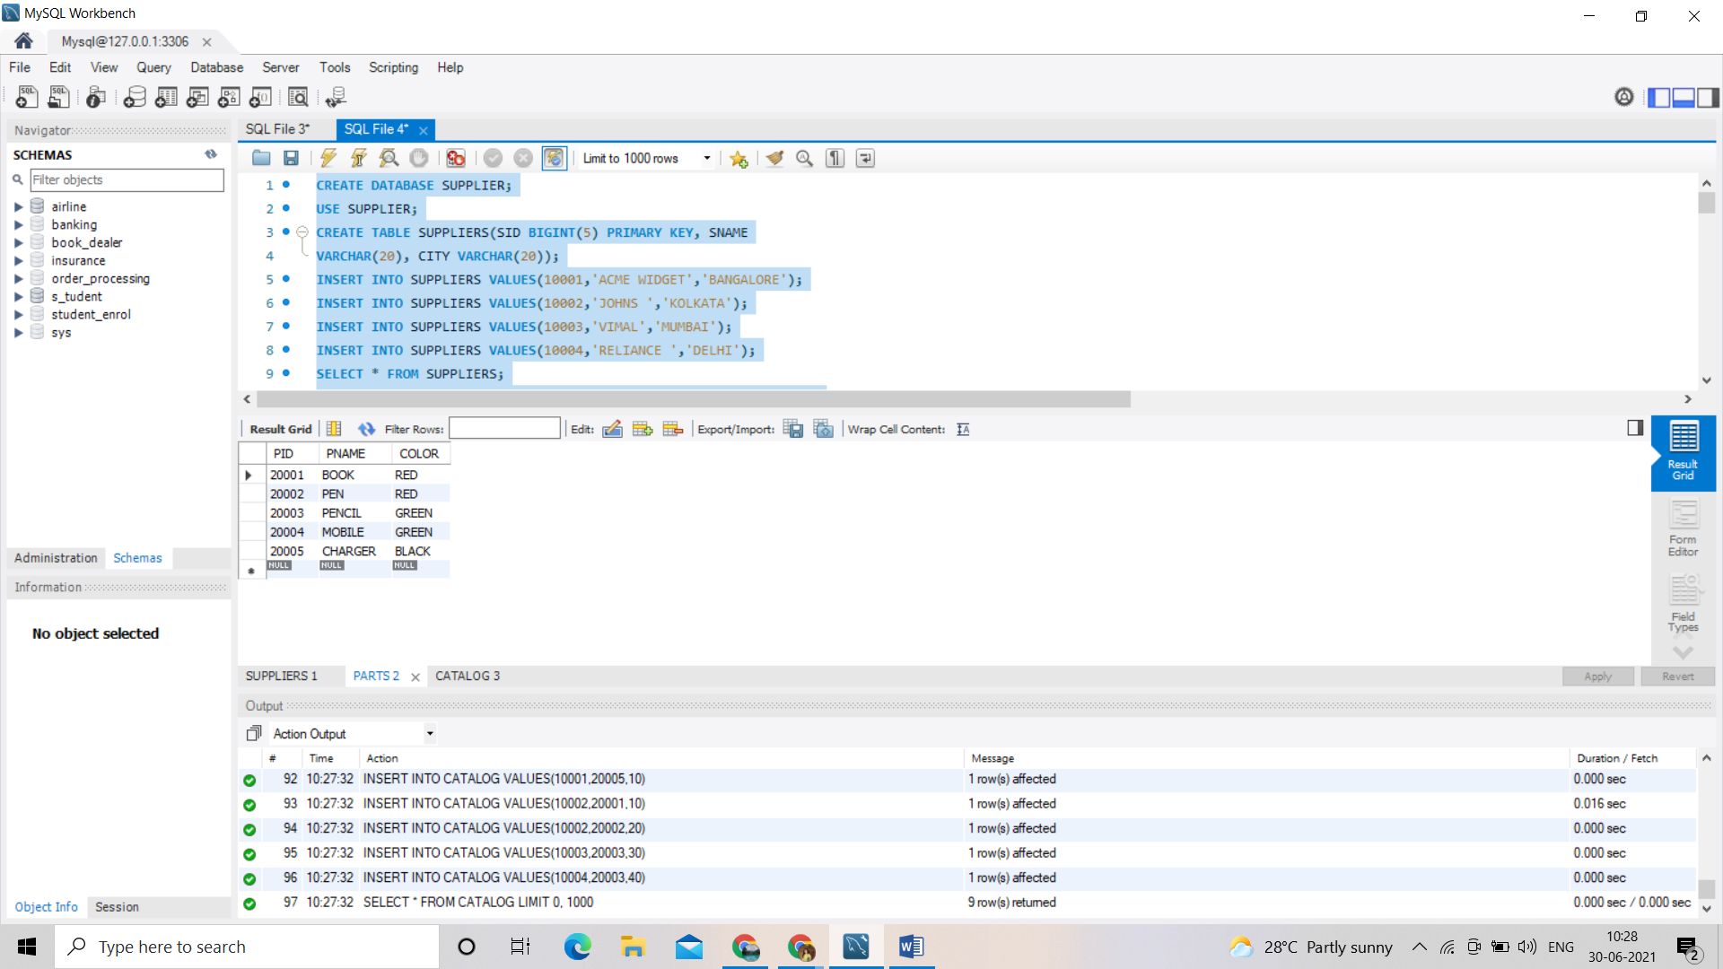

Catalog3:

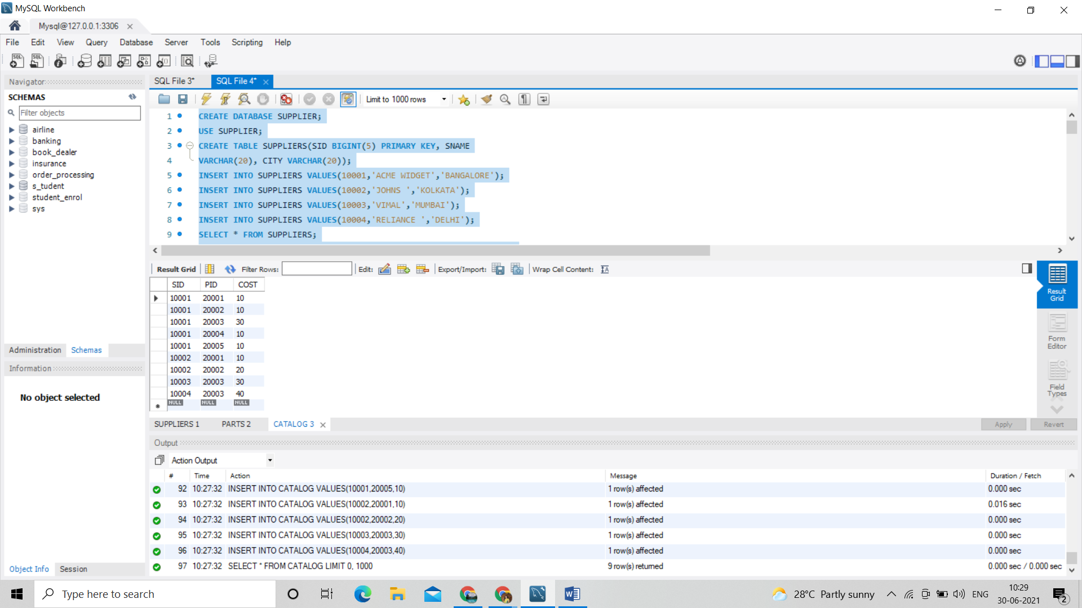

/* 1 - FIND THE PNAMES OF PARTS FOR WHICH THERE IS SOME SUPPLIER. */

SELECT DISTINCT P.PNAME

FROM PARTS P, CATALOG C

WHERE P.PID = C.PID;

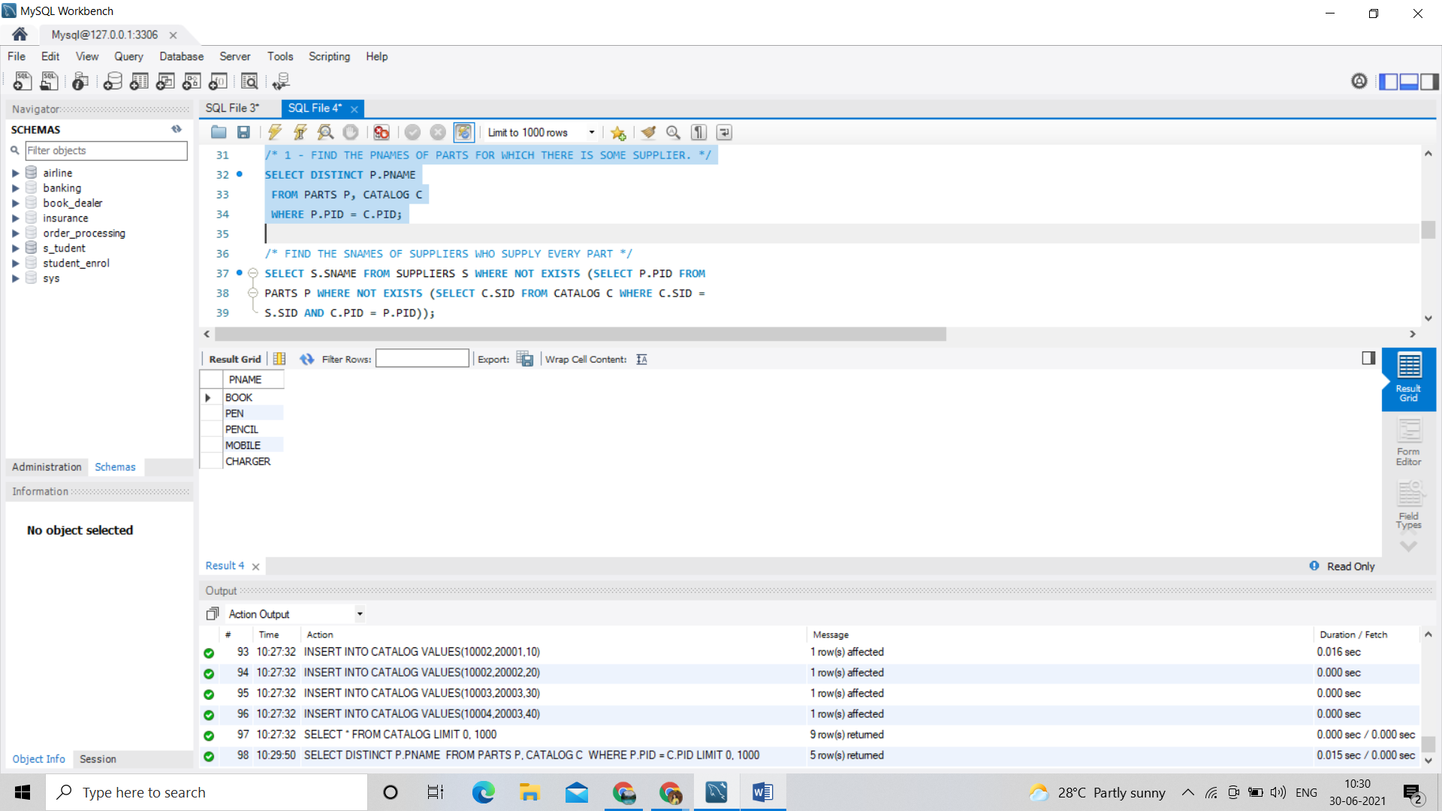

/* 2.FIND THE SNAMES OF SUPPLIERS WHO SUPPLY EVERY PART */

SELECT S.SNAME FROM SUPPLIERS S WHERE NOT EXISTS (SELECT P.PID FROM

PARTS P WHERE NOT EXISTS (SELECT C.SID FROM CATALOG C WHERE C.SID =

S.SID AND C.PID = P.PID));

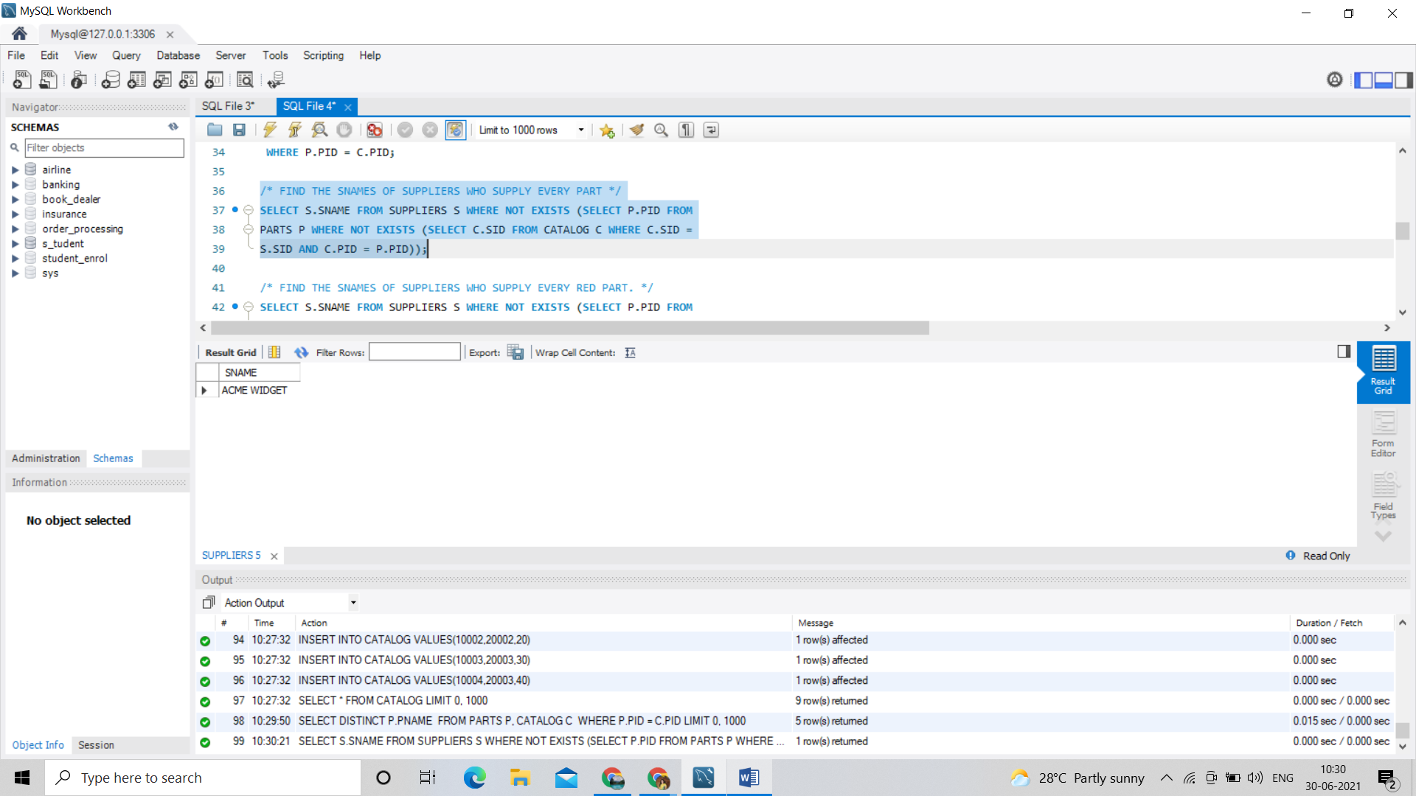

/* 3.FIND THE SNAMES OF SUPPLIERS WHO SUPPLY EVERY RED PART. */

SELECT S.SNAME FROM SUPPLIERS S WHERE NOT EXISTS (SELECT P.PID FROM

PARTS P WHERE P.COLOR = 'RED' AND (NOT EXISTS (SELECT C.SID FROM

CATALOG C WHERE C.SID = S.SID AND C.PID = P.PID)));

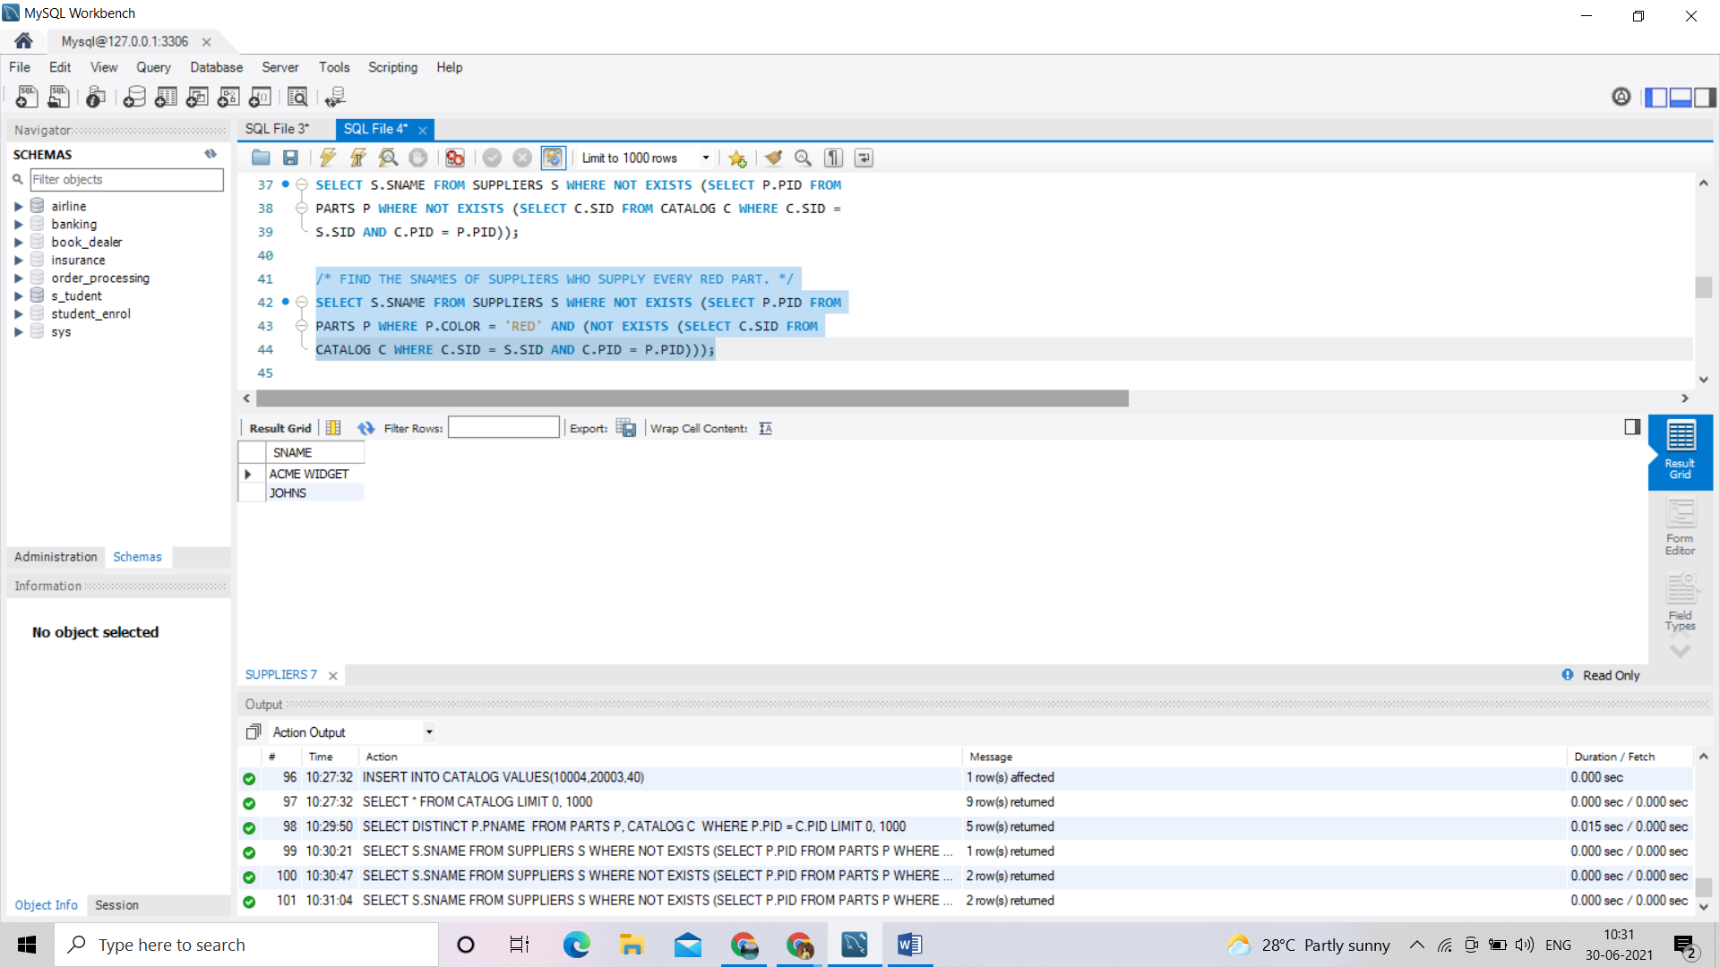

/* 4.FIND THE PNAMES OF PARTS SUPPLIED BY ACME WIDGET SUPPLIERS AND BY NO ONE ELSE */

SELECT P.PNAME FROM PARTS P, CATALOG C, SUPPLIERS S WHERE P.PID

= C.PID AND C.SID = S.SID AND S.SNAME = 'ACME WIDGET' AND NOT EXISTS

(SELECT * FROM CATALOG C1, SUPPLIERS S1 WHERE P.PID = C1.PID AND

C1.SID = S1.SID AND S1.SNAME <> 'ACME WIDGET');

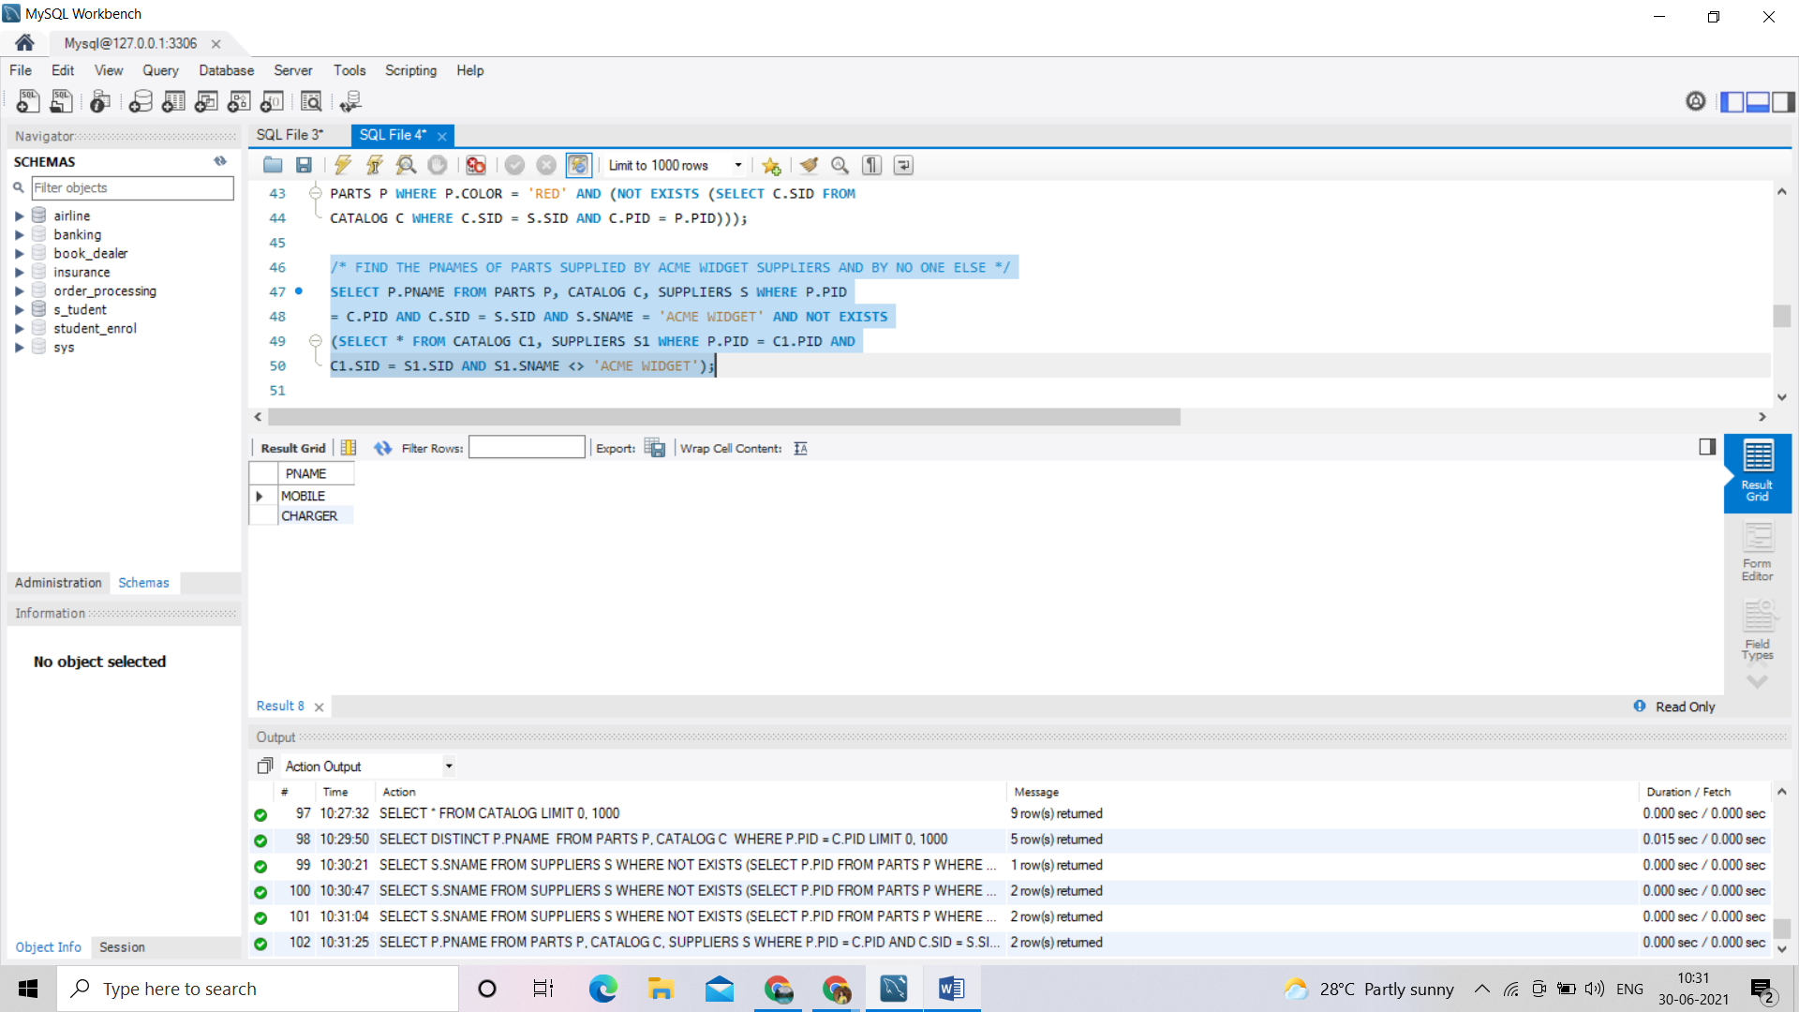

/*5. FIND THE SIDS OF SUPPLIERS WHO CHARGE MORE FOR SOME PART THAN THE AVERAGE COST OF THAT PART (AVERAGED OVER

ALL THE SUPPLIERS WHO SUPPLY THAT PART).

*/

SELECT DISTINCT C.SID FROM CATALOG C

WHERE C.COST > ( SELECT AVG (C1.COST)

FROM CATALOG C1

WHERE C1.PID = C.PID );

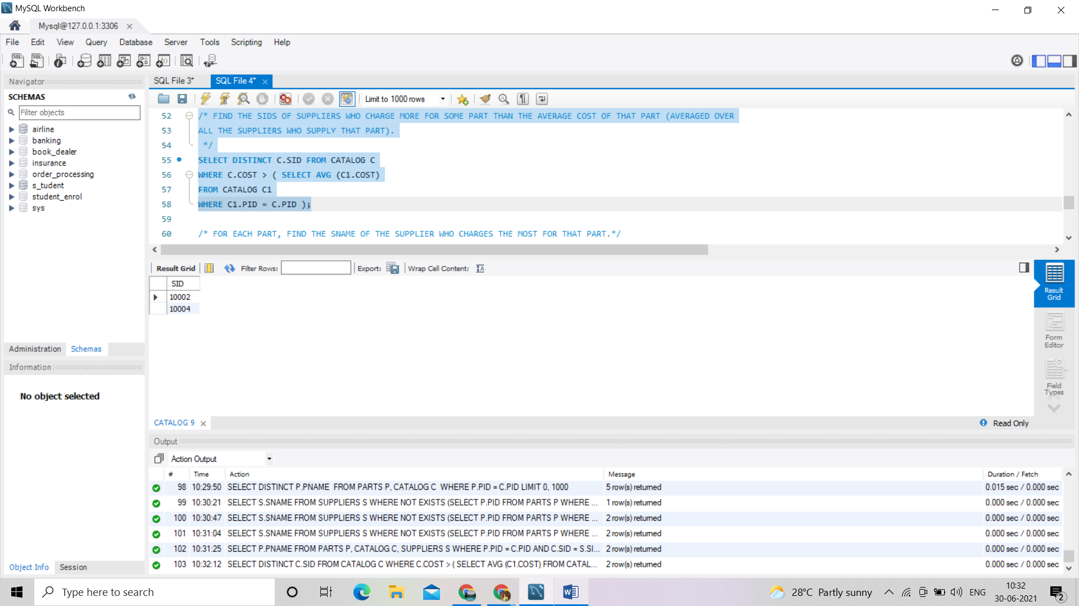

/* 6.FOR EACH PART, FIND THE SNAME OF THE SUPPLIER WHO CHARGES THE MOST FOR THAT PART.*/

SELECT P.PID, S.SNAME

FROM PARTS P, SUPPLIERS S, CATALOG C

WHERE C.PID = P.PID

AND C.SID = S.SID

AND C.COST = (SELECT MAX(C1.COST)

FROM CATALOG C1

WHERE C1.PID = P.PID);

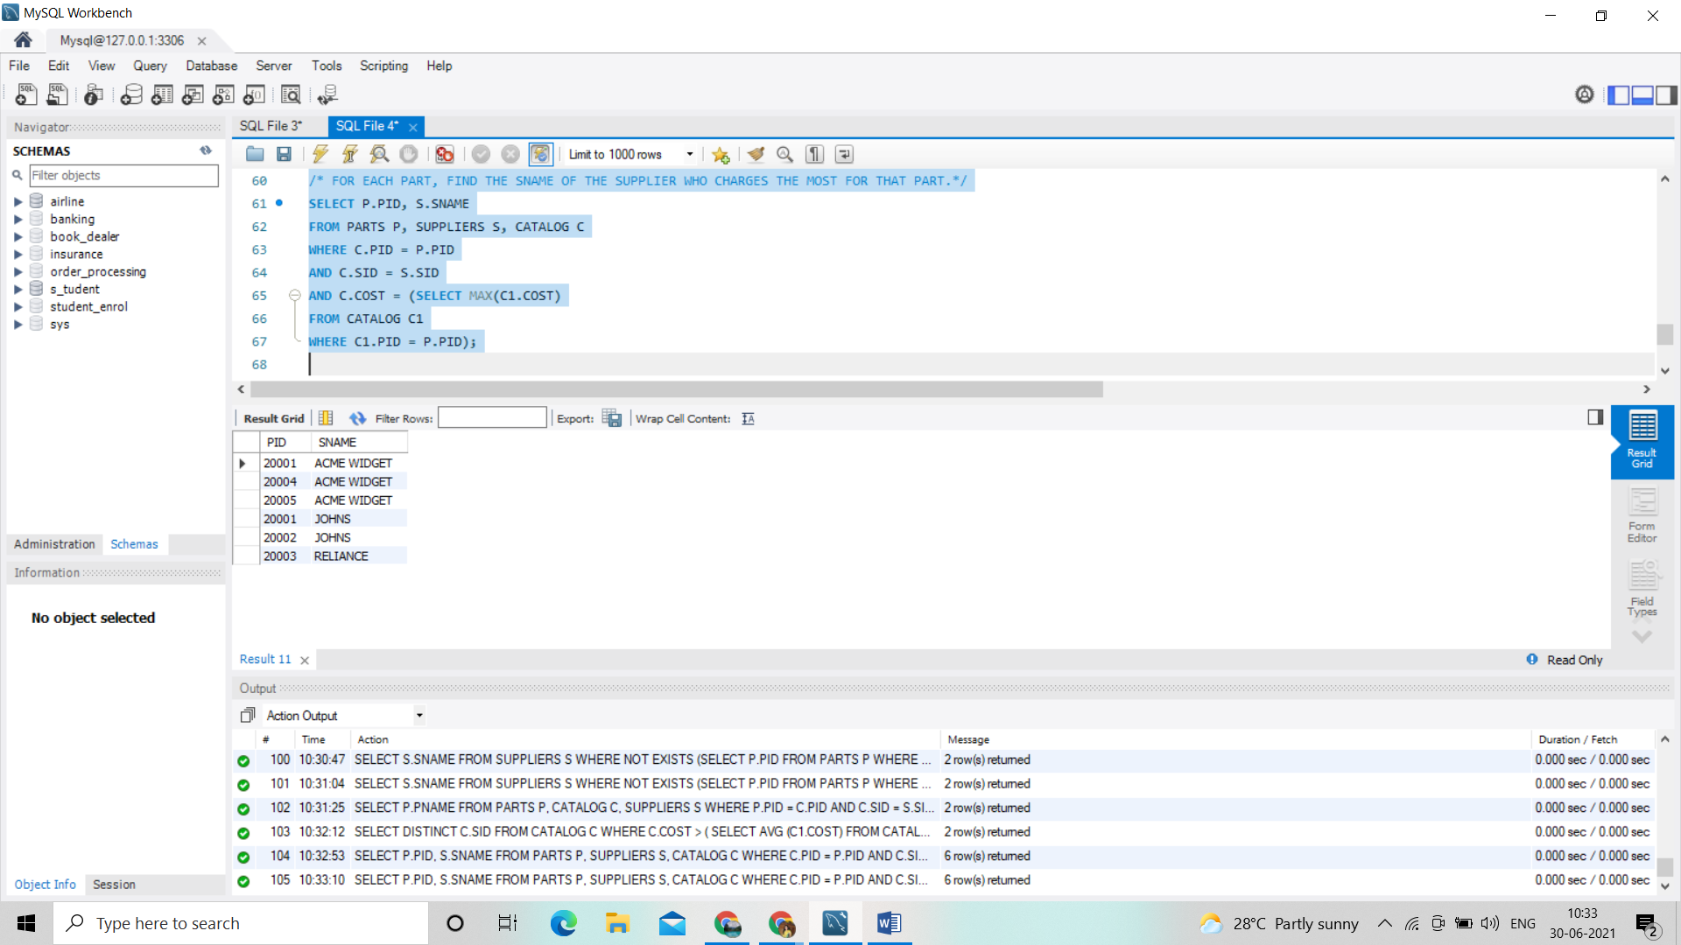

/*7. FIND THE SIDS OF SUPPLIERS WHO SUPPLY ONLY RED PARTS.*/

SELECT DISTINCT C.SID

FROM CATALOG C

WHERE NOT EXISTS ( SELECT *

FROM PARTS P

WHERE P.PID = C.PID AND P.COLOR <> 'RED' );

**PROGRAM 10:**

**10:COLLEGE DATABASE**

Consider the schema for College Database:

STUDENT(USN, SName, Address, Phone, Gender)

SEMSEC(SSID, Sem, Sec)

CLASS(USN, SSID)

SUBJECT(Subcode, Title, Sem, Credits)

IAMARKS(USN, Subcode, SSID, Test1, Test2, Test3, FinalIA)

Write SQL queries to

i. List all the student details studying in fourth semester ‘C’ section.

ii. Compute the total number of male and female students in each semester and in each section.

iii. Create a view of Test1 marks of student USN ‘1BI15CS101’ in all subjects.

iv. Calculate the FinalIA (average of best two test marks) and update the corresponding table for all students.

v. Categorize students based on the following criterion:

If FinalIA = 17 to 20 then CAT = ‘Outstanding’

If FinalIA = 12 to 16 then CAT = ‘Average’

If FinalIA< 12 then CAT = ‘Weak’

Give these details only for 8th semester A, B, and C section students.

**Code:**

CREATE DATABASE COLLEGEDB;

USE COLLEGEDB;

CREATE TABLE STUDENT (

USN VARCHAR (10),

SNAME VARCHAR (25),

ADDRESS VARCHAR (25),

PHONE LONG,

GENDER CHAR (1),

PRIMARY KEY (USN));

select * from student;

CREATE TABLE SEMSEC (

SSID VARCHAR (5),

SEM INT,

SEC CHAR (1),

PRIMARY KEY (SSID));

select * from semsec;

CREATE TABLE CLASS (

USN VARCHAR (10),

SSID VARCHAR (5),

PRIMARY KEY (USN, SSID),

FOREIGN KEY (USN) REFERENCES STUDENT (USN),

FOREIGN KEY (SSID) REFERENCES SEMSEC (SSID));

select * from class;

CREATE TABLE SUBJECT (

SUBCODE VARCHAR (8),

TITLE VARCHAR (20),

SEM INT,

CREDITS INT,

PRIMARY KEY (SUBCODE));

select * from subject;

CREATE TABLE IAMARKS (

USN VARCHAR (10),

SUBCODE VARCHAR (8),

SSID VARCHAR (5),

TEST1 INT,

TEST2 INT,

TEST3 INT,

FINALIA INT,

PRIMARY KEY (USN, SUBCODE, SSID),

FOREIGN KEY (USN) REFERENCES STUDENT (USN),

FOREIGN KEY (SUBCODE) REFERENCES SUBJECT (SUBCODE),

FOREIGN KEY (SSID) REFERENCES SEMSEC (SSID));

select * from iamarks;

INSERT INTO STUDENT VALUES ('1RN13CS020','AKSHAY','BELAGAVI', 8877881122,'M');

INSERT INTO STUDENT VALUES ('1RN13CS062','SANDHYA','BENGALURU', 7722829912,'F');

INSERT INTO STUDENT VALUES ('1RN13CS091','TEESHA','BENGALURU', 7712312312,'F');

INSERT INTO STUDENT VALUES ('1RN13CS066','SUPRIYA','MANGALURU', 8877881122,'F');

INSERT INTO STUDENT VALUES ('1RN14CS010','ABHAY','BENGALURU', 9900211201,'M');

INSERT INTO STUDENT VALUES ('1RN14CS032','BHASKAR','BENGALURU', 9923211099,'M');

INSERT INTO STUDENT VALUES ('1RN14CS025','ASMI','BENGALURU', 7894737377,'F');

INSERT INTO STUDENT VALUES ('1RN15CS011','AJAY','TUMKUR', 9845091341,'M');

INSERT INTO STUDENT VALUES ('1RN15CS029','CHITRA','DAVANGERE', 7696772121,'F');

INSERT INTO STUDENT VALUES ('1RN15CS045','JEEVA','BELLARY', 9944850121,'M');

INSERT INTO STUDENT VALUES ('1RN15CS091','SANTOSH','MANGALURU', 8812332201,'M');

INSERT INTO STUDENT VALUES ('1RN16CS045','ISMAIL','KALBURGI', 9900232201,'M');

INSERT INTO STUDENT VALUES ('1RN16CS088','SAMEERA','SHIMOGA', 9905542212,'F');

INSERT INTO STUDENT VALUES ('1RN16CS122','VINAYAKA','CHIKAMAGALUR', 8800880011,'M');

INSERT INTO SEMSEC VALUES ('CSE8A', 8,'A');

INSERT INTO SEMSEC VALUES ('CSE8B', 8,'B');

INSERT INTO SEMSEC VALUES ('CSE8C', 8,'C');

INSERT INTO SEMSEC VALUES ('CSE7A', 7,'A');

INSERT INTO SEMSEC VALUES ('CSE7B', 7,'B');

INSERT INTO SEMSEC VALUES ('CSE7C', 7,'C');

INSERT INTO SEMSEC VALUES ('CSE6A', 6,'A');

INSERT INTO SEMSEC VALUES ('CSE6B', 6,'B');

INSERT INTO SEMSEC VALUES ('CSE6C', 6,'C');

INSERT INTO SEMSEC VALUES ('CSE5A', 5,'A');

INSERT INTO SEMSEC VALUES ('CSE5B', 5,'B');

INSERT INTO SEMSEC VALUES ('CSE5C', 5,'C');

INSERT INTO SEMSEC VALUES ('CSE4A', 4,'A');

INSERT INTO SEMSEC VALUES ('CSE4B', 4,'B');

INSERT INTO SEMSEC VALUES ('CSE4C', 4,'C');

INSERT INTO SEMSEC VALUES ('CSE3A', 3,'A');

INSERT INTO SEMSEC VALUES ('CSE3B', 3,'B');

INSERT INTO SEMSEC VALUES ('CSE3C', 3,'C');

INSERT INTO SEMSEC VALUES ('CSE2A', 2,'A');

INSERT INTO SEMSEC VALUES ('CSE2B', 2,'B');

INSERT INTO SEMSEC VALUES ('CSE2C', 2,'C');

INSERT INTO SEMSEC VALUES ('CSE1A', 1,'A');

INSERT INTO SEMSEC VALUES ('CSE1B', 1,'B');

INSERT INTO SEMSEC VALUES ('CSE1C', 1,'C');

INSERT INTO CLASS VALUES ('1RN13CS020','CSE8A');

INSERT INTO CLASS VALUES ('1RN13CS062','CSE8A');

INSERT INTO CLASS VALUES ('1RN13CS066','CSE8B');

INSERT INTO CLASS VALUES ('1RN13CS091','CSE8C');

INSERT INTO CLASS VALUES ('1RN14CS010','CSE7A');

INSERT INTO CLASS VALUES ('1RN14CS025','CSE7A');

INSERT INTO CLASS VALUES ('1RN14CS032','CSE7A');

INSERT INTO CLASS VALUES ('1RN15CS011','CSE4A');

INSERT INTO CLASS VALUES ('1RN15CS029','CSE4A');

INSERT INTO CLASS VALUES ('1RN15CS045','CSE4B');

INSERT INTO CLASS VALUES ('1RN15CS091','CSE4C');

INSERT INTO CLASS VALUES ('1RN16CS045','CSE3A');

INSERT INTO CLASS VALUES ('1RN16CS088','CSE3B');

INSERT INTO CLASS VALUES ('1RN16CS122','CSE3C');

INSERT INTO SUBJECT VALUES ('10CS81','ACA', 8, 4);

INSERT INTO SUBJECT VALUES ('10CS82','SSM', 8, 4);

INSERT INTO SUBJECT VALUES ('10CS83','NM', 8, 4);

INSERT INTO SUBJECT VALUES ('10CS84','CC', 8, 4);

INSERT INTO SUBJECT VALUES ('10CS85','PW', 8, 4);

INSERT INTO SUBJECT VALUES ('10CS71','OOAD', 7, 4);

INSERT INTO SUBJECT VALUES ('10CS72','ECS', 7, 4);

INSERT INTO SUBJECT VALUES ('10CS73','PTW', 7, 4);

INSERT INTO SUBJECT VALUES ('10CS74','DWDM', 7, 4);

INSERT INTO SUBJECT VALUES ('10CS75','JAVA', 7, 4);

INSERT INTO SUBJECT VALUES ('10CS76','SAN', 7, 4);

INSERT INTO SUBJECT VALUES ('15CS51', 'ME', 5, 4);

INSERT INTO SUBJECT VALUES ('15CS52','CN', 5, 4);

INSERT INTO SUBJECT VALUES ('15CS53','DBMS', 5, 4);

INSERT INTO SUBJECT VALUES ('15CS54','ATC', 5, 4);

INSERT INTO SUBJECT VALUES ('15CS55','JAVA', 5, 3);

INSERT INTO SUBJECT VALUES ('15CS56','AI', 5, 3);

INSERT INTO SUBJECT VALUES ('15CS41','M4', 4, 4);

INSERT INTO SUBJECT VALUES ('15CS42','SE', 4, 4);

INSERT INTO SUBJECT VALUES ('15CS43','DAA', 4, 4);

INSERT INTO SUBJECT VALUES ('15CS44','MPMC', 4, 4);

INSERT INTO SUBJECT VALUES ('15CS45','OOC', 4, 3);

INSERT INTO SUBJECT VALUES ('15CS46','DC', 4, 3);

INSERT INTO SUBJECT VALUES ('15CS31','M3', 3, 4);

INSERT INTO SUBJECT VALUES ('15CS32','ADE', 3, 4);

INSERT INTO SUBJECT VALUES ('15CS33','DSA', 3, 4);

INSERT INTO SUBJECT VALUES ('15CS34','CO', 3, 4);

INSERT INTO SUBJECT VALUES ('15CS35','USP', 3, 3);

INSERT INTO SUBJECT VALUES ('15CS36','DMS', 3, 3);

INSERT INTO IAMARKS (USN, SUBCODE, SSID, TEST1, TEST2, TEST3) VALUES ('1RN13CS091','10CS81','CSE8C', 15, 16, 18);

INSERT INTO IAMARKS (USN, SUBCODE, SSID, TEST1, TEST2, TEST3) VALUES ('1RN13CS091','10CS82','CSE8C', 12, 19, 14);

INSERT INTO IAMARKS (USN, SUBCODE, SSID, TEST1, TEST2, TEST3) VALUES ('1RN13CS091','10CS83','CSE8C', 19, 15, 20);

INSERT INTO IAMARKS (USN, SUBCODE, SSID, TEST1, TEST2, TEST3) VALUES ('1RN13CS091','10CS84','CSE8C', 20, 16, 19);

INSERT INTO IAMARKS (USN, SUBCODE, SSID, TEST1, TEST2, TEST3) VALUES ('1RN13CS091','10CS85','CSE8C', 15, 15, 12);

/*1. List all the student details studying in fourth semester ‘C’ section. */

SELECT S.*, SS.SEM, SS.SEC

FROM STUDENT S, SEMSEC SS, CLASS C

WHERE S.USN = C.USN AND

SS.SSID = C.SSID AND

SS.SEM = 4 AND SS.SEC='C';

/*2. Compute the total number of male and female students in each semester and in each section. */

SELECT SS.SEM, SS.SEC, S.GENDER, COUNT(S.GENDER) AS COUNT

FROM STUDENT S, SEMSEC SS, CLASS C

WHERE S.USN = C.USN AND

SS.SSID = C.SSID

GROUP BY SS.SEM, SS.SEC, S.GENDER

ORDER BY SEM;

/*3. Create a view of Test1 marks of student USN ‘1BI15CS101’ in all subjects. */

CREATE VIEW STU_TEST1_MARKS_VIEW

AS

SELECT TEST1, SUBCODE

FROM IAMARKS

WHERE USN = '1RN13CS091';

SELECT * FROM STU_TEST1_MARKS_VIEW;

/*5. Categorize students based on the following criterion:

If FinalIA = 17 to 20 then CAT = ‘Outstanding’

If FinalIA = 12 to 16 then CAT = ‘Average’

If FinalIA< 12 then CAT = ‘Weak’

Give these details only for 8th semester A, B, and C section students. */

SELECT S.USN,S.SNAME,S.ADDRESS,S.PHONE,S.GENDER,

(CASE

WHEN IA.FINALIA BETWEEN 17 AND 20 THEN 'OUTSTANDING'

WHEN IA.FINALIA BETWEEN 12 AND 16 THEN 'AVERAGE'

ELSE 'WEAK'

END) AS CAT

FROM STUDENT S, SEMSEC SS, IAMARKS IA, SUBJECT SUB

WHERE S.USN = IA.USN AND

SS.SSID = IA.SSID AND

SUB.SUBCODE = IA.SUBCODE AND

SUB.SEM = 8;

**Output:**

Student 1:

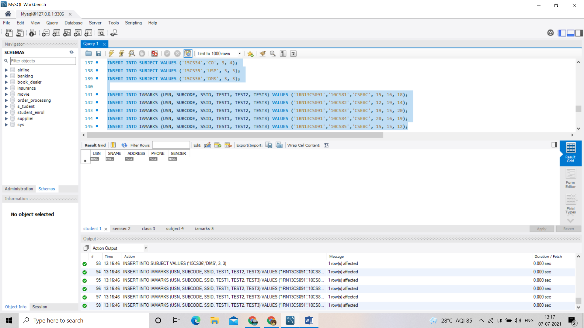

Semsec 2:

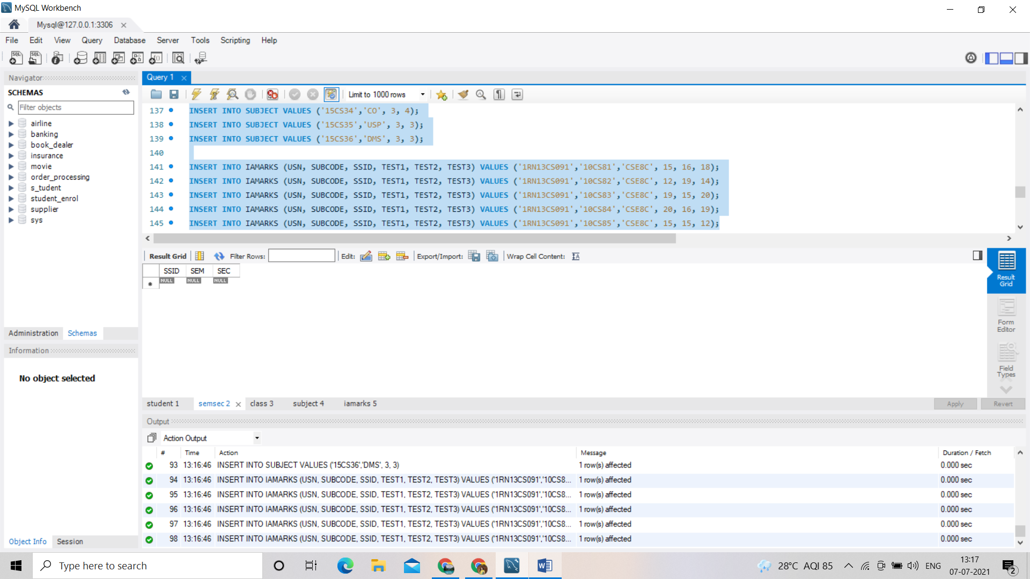

Class 3:

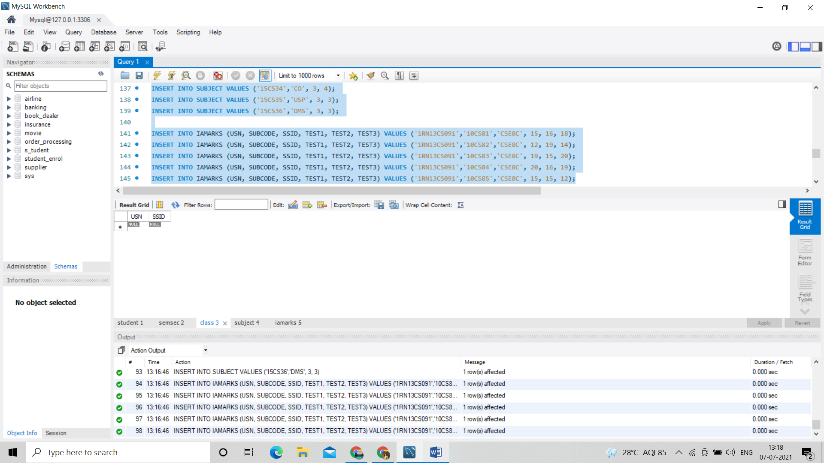

Subject 4:

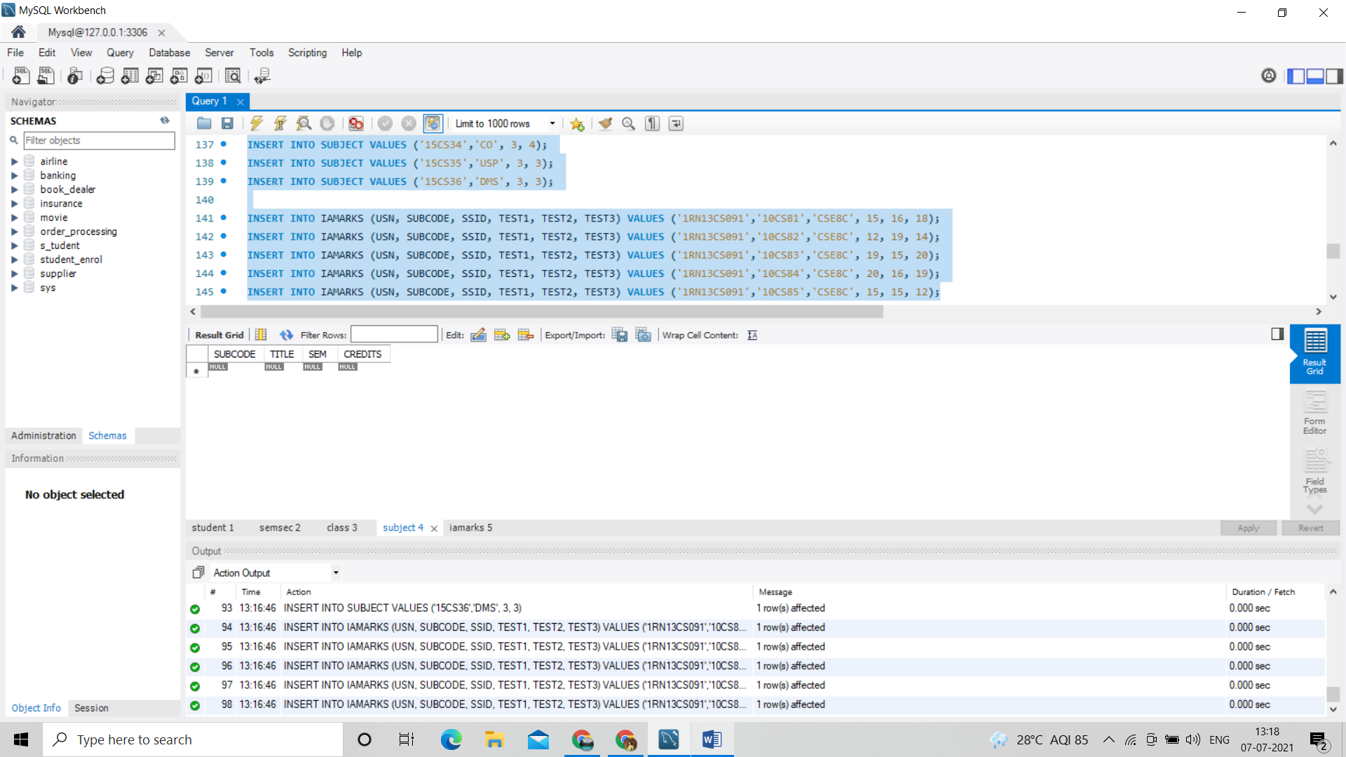

Iamarks 5:

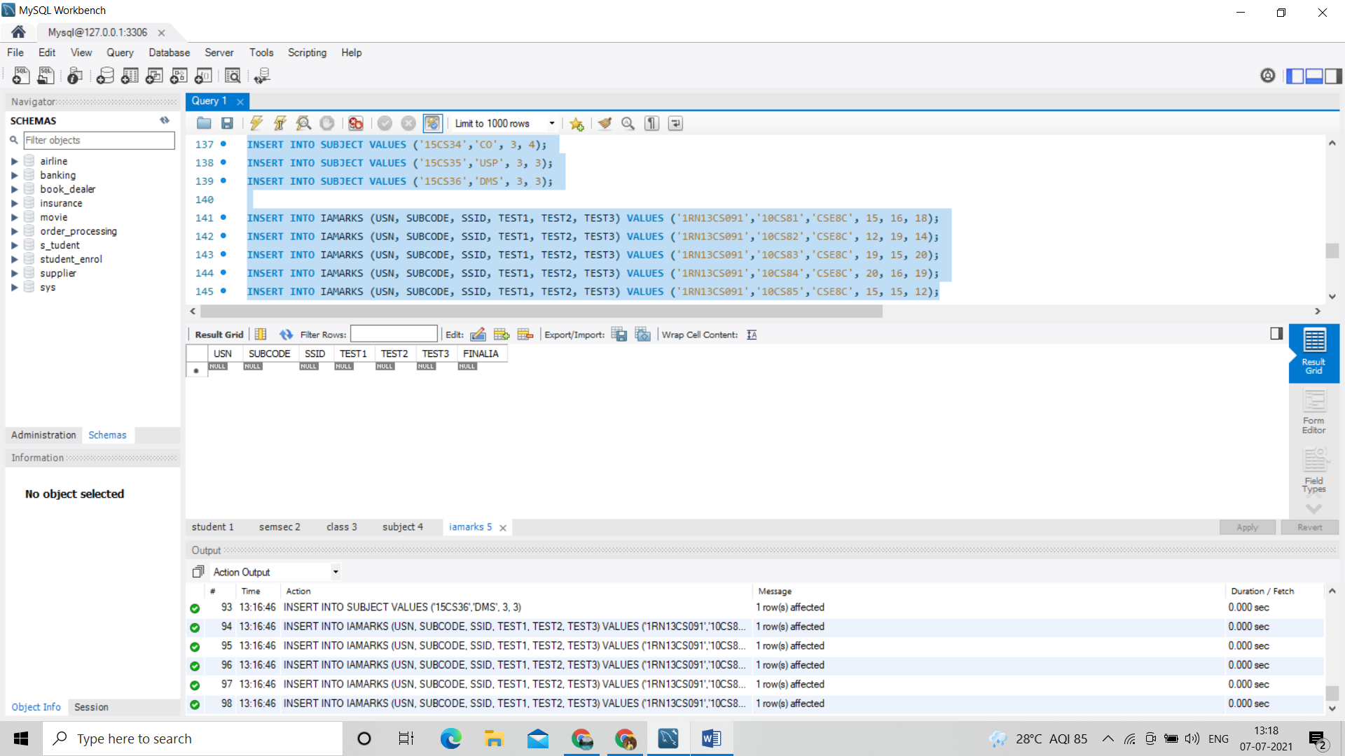

Query 1:

SELECT S.*, SS.SEM, SS.SEC

FROM STUDENT S, SEMSEC SS, CLASS C

WHERE S.USN = C.USN AND

SS.SSID = C.SSID AND

SS.SEM = 4 AND SS.SEC='C';

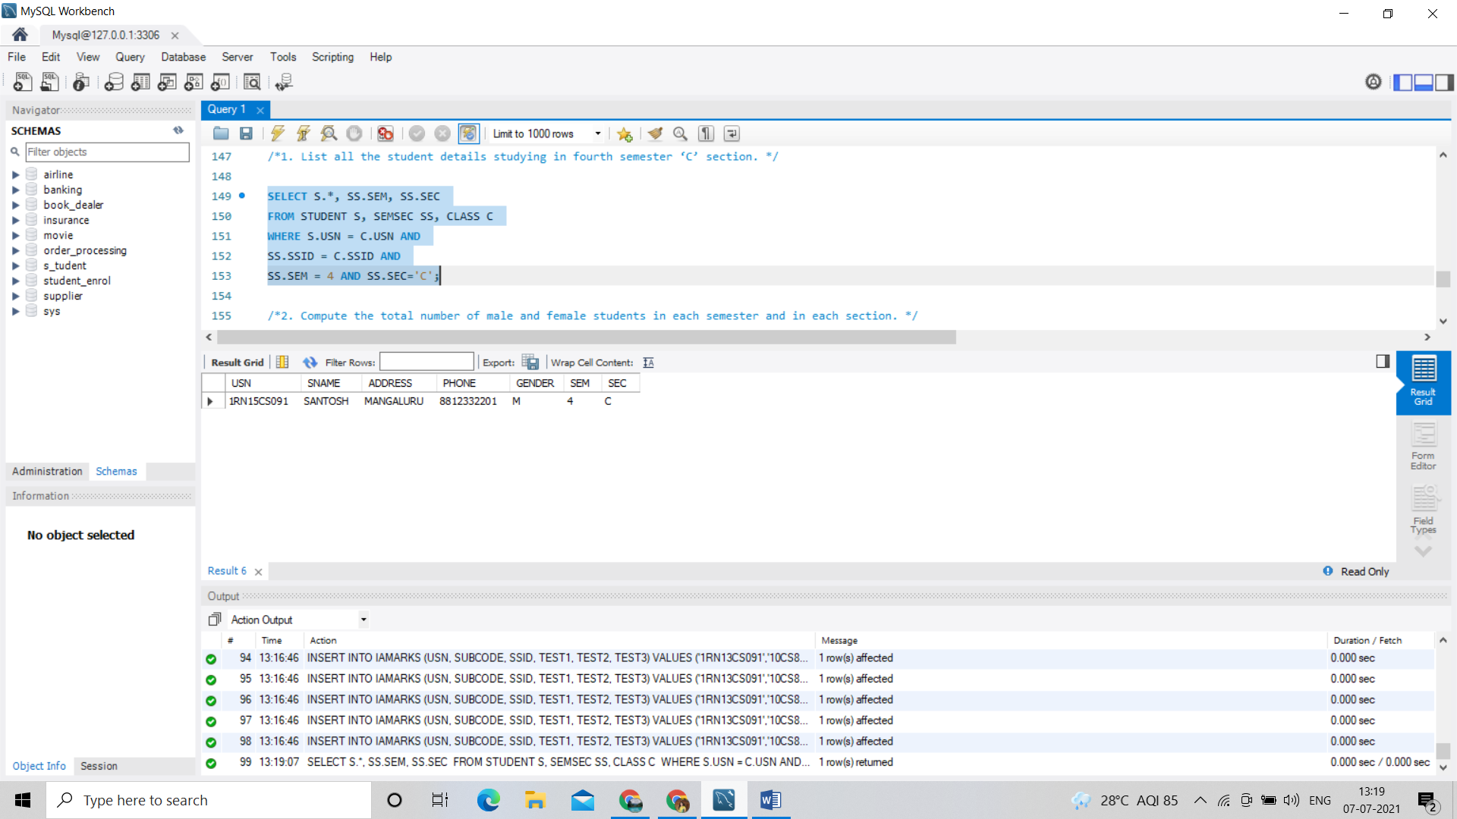

Query 2 :

SELECT SS.SEM, SS.SEC, S.GENDER, COUNT(S.GENDER) AS COUNT

FROM STUDENT S, SEMSEC SS, CLASS C

WHERE S.USN = C.USN AND

SS.SSID = C.SSID

GROUP BY SS.SEM, SS.SEC, S.GENDER

ORDER BY SEM;

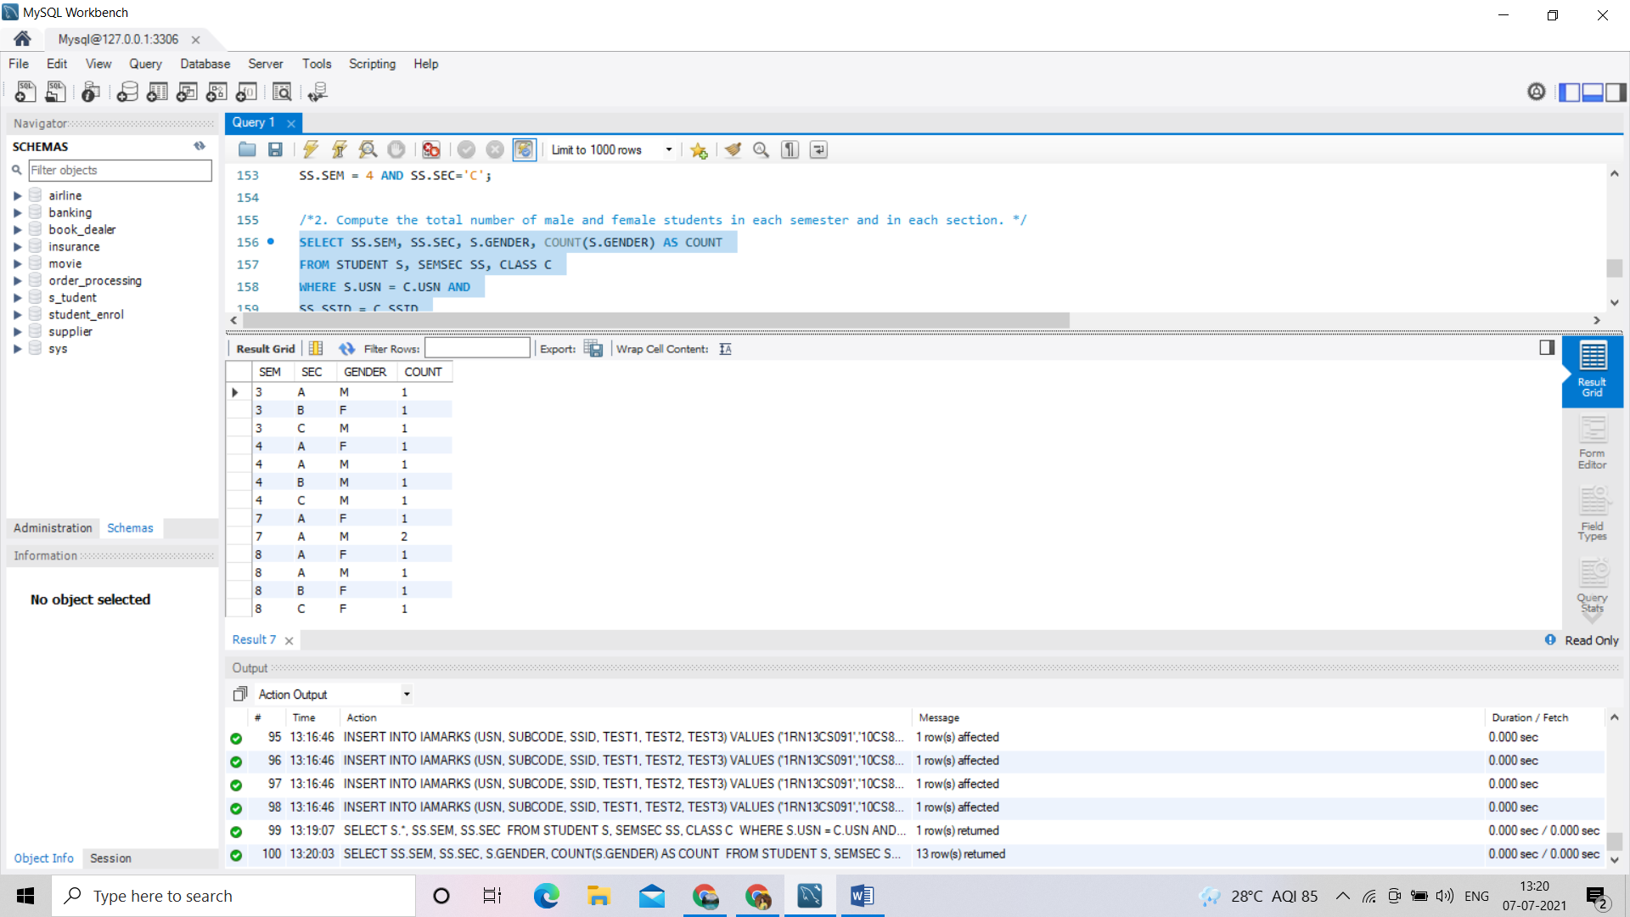

Query 3:

CREATE VIEW STU_TEST1_MARKS_VIEW

AS

SELECT TEST1, SUBCODE

FROM IAMARKS

WHERE USN = '1RN13CS091';

SELECT * FROM STU_TEST1_MARKS_VIEW;

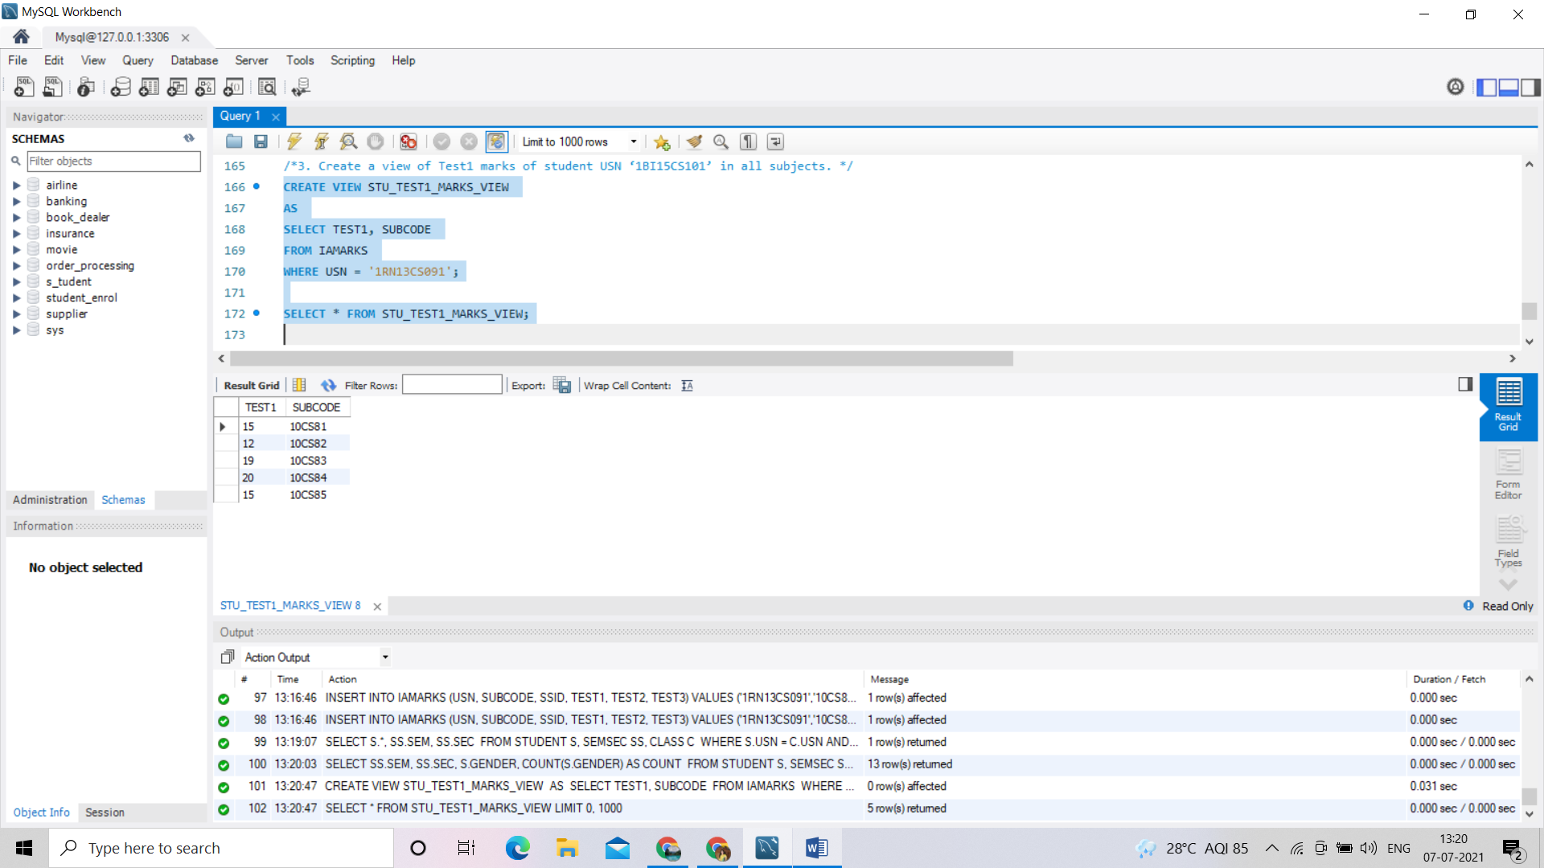

Query 4:

SELECT S.USN,S.SNAME,S.ADDRESS,S.PHONE,S.GENDER,

(CASE

WHEN IA.FINALIA BETWEEN 17 AND 20 THEN 'OUTSTANDING'

WHEN IA.FINALIA BETWEEN 12 AND 16 THEN 'AVERAGE'

ELSE 'WEAK'

END) AS CAT

FROM STUDENT S, SEMSEC SS, IAMARKS IA, SUBJECT SUB

WHERE S.USN = IA.USN AND

SS.SSID = IA.SSID AND

SUB.SUBCODE = IA.SUBCODE AND

SUB.SEM = 8;

